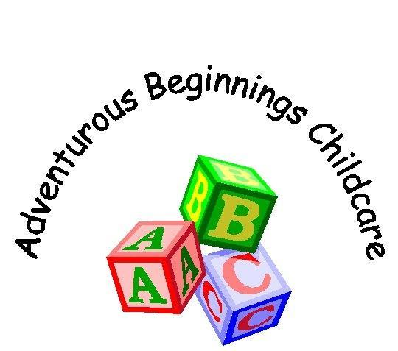
Inclusion Policy Incorporating Special Needs

What is a Special Educational Need (SEN)?

- Learning Difficulty
- Special Provision
- 20% of Children
- Makes little or no progress
- Continues working at a curriculum level substantially bellow children of a similar age
- Emotional or behavioural difficulties
- Sensory or physical needs
- Ongoing communication or interaction difficulties
Our Nursery aims to have regard to the DfEE Code of Practice on special educational needs and also to the guidelines supplied to private and voluntary providers of Nursery and Pre-school education. We aim to provide welcoming, appropriate learning opportunities for all children and offer continuous support to Parents and Carers.
- Children with special needs, like all other children, are admitted to the Nursery after consultation between parents, management and the child’s key-Person.
- Our aim is to provide for the developmental needs of each child in the Nursery.
- All children in the Nursery, irrespective of their special needs, are encouraged wherever possible and appropriate to participate in all activities.
- Our system of observation and record keeping, which operates in conjunction with parents, enables us to monitor children's needs and progress on an individual basis.
- The needs and progress of children who have special educational needs are monitored by our special educational needs co-ordinator (SENCO) who also ensures that accurate records are being kept. Vanessa Nimmo-Cameron is our nominated SENCO.
- Our key-Person system ensures that each adult is especially responsible for, and close to, their own groups, so each child receive plenty of adult time and attention.
- We work closely with the parents of all the children in the Nursery to ensure that we draw upon the knowledge and expertise of parents in planning provision for the child, and that the child’s progress and achievements are shared and discussed with parents on a regular basis, and parents know the identity of the Nursery’s special educational needs co-ordinator.
- Our staff attends whenever possible in-service training on special needs arranged by the Pre-school Learning Alliance and other professional bodies.
In advance of a child with special needs admission to the Nursery we will meet with the parents/carers to discuss practical needs and confidentiality issues including the involvement of other external agencies.
We would discuss with parents matters such as diet, skin and hair care, routines, special words, comforters, family names, religion, health and medical conditions, likes and dislikes.
We will review staffing levels and look at equipment needs and access arrangements before a child starts. Any necessary adaptations would be talked through with parents to ensure a chair bound child could gain access.
We will record such discussions and note any action to be taken if there is difficulty meeting the needs of individual children. This is likely to require sensitive communication with parents and the possible involvement of other agencies for advice and assistance. Provision of general adaptations would be discussed prior to admission with all staff being aware of limitations in terms of height of tables etc. Toilet adaptations would also need to be considered.
Our SENCO has attended training arranged by various professional bodies on the fundamental principles of the Code of Practice (1994) for the Identification and Assessment of Special Educational Needs and on the five stages leading towards statement in the Code. Our SENCO will work in cooperation with our nominated equal opportunities coordinator to ensure positive images both in activities and posters. Staff will raise awareness of the whole Nursery through topics etc.
Assessment: If concerns arose from the usual observations carried out at Nursery, the first step would be for the key person to discuss these with, and seek advice from the SENCO. A meeting would be arranged with the parents/carers to share views and seek permission to work on a one to one basis with the child for a set period of time. This would enable further evidence gathering to take place before contacting the relevant agencies.
Record Keeping – The usual documentation will be used together with records of conversations, meetings and any Individual Educational Plans (IEP’s) and Evaluations
Broad and balanced curriculum – A child with special needs will be given the opportunity to participate fully in the Nursery curriculum. It will be adapted to suit that Childs individual needs/wants or if a child feels able to participate in the organisation, they will be encouraged to do that.
Resources – External bodies will be contacted to provide additional funding and equipment needed to be able to support the child within the setting.
Links – The SENCO Mrs Vanessa Nimmo- Cameron has links with relevant agencies for advice and support and contact details are available to both staff and parents/carers.
Review – Policies and procedures for special needs will be reviewed annually or more frequently as required following training, new guidance or experience gained.
All Staff have had basic Makaton Training which was held within our setting by our Area INCO.

Reviewed 09/09/2019

