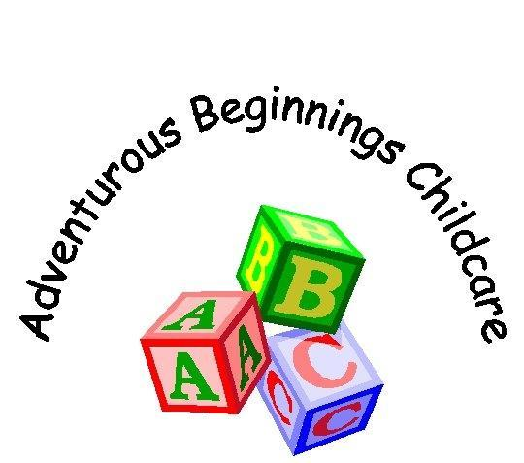

SAFEGUARDING POLICY
Introduction

Here at Merritime Nursery we believe it is unacceptable for a child or young person to experience abuse of any kind, we have a responsibility to always safeguard and protect the welfare of the children and young people in our setting, all complaints, allegations, and suspicions are taken very seriously.

As much as we will endeavour to keep confidentiality, we cannot always promise this as the matter of concern may develop in a way that this cannot be honoured, however we will always adhere to the Information Sharing Protocol in accordance with the CAF (Common Assessment Framework.)

Children and families from all cultures may be subject to abuse and neglect, and as professionals we should be sensitive to differing family patterns and lifestyles; however, as a setting we must also be clear that abuse cannot be condoned for religious or cultural reasons.

What is Safeguarding and what does it mean?

The government have defined the term Safeguarding Children as:

- Protecting Children from Maltreatment
- Preventing the impairment of Children’s Health and Development
- Ensuring that Children are growing up in safe and effective care.

Safeguarding is where we do everything in our power to stop anything else from happening to the children and young people in our care, to achieve this the staff of Merritime Nursery are made aware of and involved in the making of this policy and adhere to the aims and objectives at all times.
As a Nursery team we all share the responsibility for Safeguarding all children and young people in our care...

Our Aims and Objectives

- To provide a safe environment for all children to achieve optimum life chances.

- To ensure all staff are DBS checked (Disclosure and Barring services.), these are reviewed annually but renewed every 3 years.

- To ensure all staff are trained and educated in safeguarding matters, ensuring they are made aware of the recording and reporting protocol and what to do if they are worried about a child in their care confidently.
(A copy of what to do if worried is attached at the back of this policy.)

- To maintain confidentiality when needed.

- We carry out risk assessments and daily opening and closing checklist to avoid any hazards.

- All Students and Volunteers DO NOT work unsupervised and are made aware of all our policies and procedures on their initial inductions which is signed by a member of management and the Student/ Volunteer.

- We undertake security measures which are always adhered to, ensuring that all visitors sign in and out of our visitors register and they are always accompanied by a staff member to protect all staff and children in our setting.

- If a parent or carer is unknown to a staff member they will be asked to wait outside the nursery until they are identified by another staff member they are known by. If someone else arrives to collect a child but they are not recognised at all by any staff member and they are not on the child’s emergency contact list, then the same procedure is followed, and the Parent of the child is contacted immediately.
If the parent does not answer a call the child is not let out of our care until we have permission from the child’s legal guardian.

- We ensure that all our policies and procedures are reviewed and updated where needed annually and that any new policies are introduced to all parents/carers and staff members. (All our current policies and procedures are available to download on our website)

- We endeavour to support and supervise where needed ensuring we are never too busy to help any Child, parent/carer, or staff member within our setting.

- Accident and Incident forms are completed for any minor or major injuries sustained At Nursery or Away from Nursery, these are in place to protect you /your child and the staff of Merritime Nursery ensuring high standards of Safeguarding at all times.
As a parent of Merritime Nursery you have a duty to share any information on accidents that have occurred away from the setting.
The forms are a legal and important document which can be used as evidence in accordance with the Child Protection forms to back up any concerns a staff member may have about a child’s welfare.

- We ensure that we notify OFSTED of any major accident or incident that may affect the safeguarding of all children.

Guidelines

Physical Abuse
- Any sign of a mark or injury to a child when coming into nursery will be recorded immediately.
- If appropriate, the incident will be brought to the attention of the Parent/Carer, this will be recorded and discussed with the staff member/s involved and the Lead Practitioner: Safeguarding/Deputy Lead Practitioner.
- Should the staff involved in the discussion not be satisfied regarding the injury and reason behind the injury then the LP/Deputy LP will seek advice and notify Social Services and the Local Authority.
- All information will be kept confidential, with the team working on the situation.

Sexual Abuse
- Action will be taken if the staff witness occasions, where a child shows signs of sexual activity through words, play, drawings, or inappropriate knowledge of sexual behaviour.
- Observations will be reported and recorded with the Lead Practitioner /Deputy Lead Practitioner.
- Social Services and the Local Authority will be notified of any incident.

Emotional Abuse
- Action will be taken, if the persistent ill treatment of a child has a severe or adverse effect on the behaviour and emotional development of a child.
- Observations will be carried out and dated and will be reported and recorded with the LP/Deputy LP.

Neglect
- Action will be taken at any sign of neglect, i.e., Exposure to any kind of danger, cold or starvation that results in the failure of the child to thrive and develop.
- Concerns will be recorded and discussed with the Parent/Carer, staff member involved and the LP/Deputy LP.
- Should the staff involved not be satisfied with reasons given in the discussion then LP/Deputy LP will seek advice and notify Social Services and the Local Authority.

Lead Practitioner: Safeguarding

VANESSA NIMMO-CAMERON

Deputy Lead Practitioner

EMMA JERRARD

Useful public contacts
Child line: 0800 1111
NSPCC: 0808 800 5000 or email: help@nspcc.org.uk
Police: 999 in an emergency
Children’s services: 08:30-17:00: 0300 555 1384
Out of Hours, Children’s Services:0300 555 1373 or email: childrens.services@hants.go.uk
Data Protection Helpline: 0303 123 1113
OFSTED: 0300 123 1231

Staff only contacts
LADO (Local Authority Designated Officer) Barbara Piddington
01962 876364
Updated 09/02/2021.

Procedure for Allegations regarding a Staff Member

If a parent/Carer makes an allegation about a Member of staff, the following procedures would apply.

- The Parent/Carer/Staff member will be asked to talk to Nursery Managers and discuss the matter in depth. Minutes of the meeting will be recorded.

- The Parent/Carer/Staff member will be asked if they wish to make a formal complaint. If so this will be recorded on the appropriate complaint form, which is in the Complaint folder in the front corridor.

- The staff member(s) involved will also be spoken to separately. Minutes of this meeting will also be recorded.

- An internal investigation will be held, and all members of staff involved, or witnesses will be interviewed.

- OFSTED will be contacted, and details regarding the incident will be handed over.

- The Parent/Carer/Staff member will be informed at all stages.

- If the Nursery Managers deem the member of staff to be in an unsuitable position to continue their duties, whilst the investigations are being carried out, they will be suspended immediately until the end of the investigation.

Reviewed 01/11/2019

