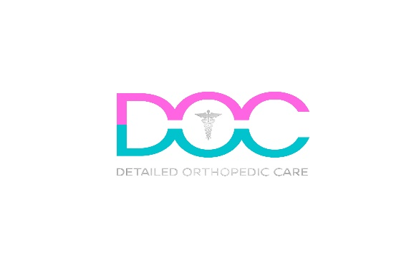

Per4orm Recovery Consent & Waiver

  - I hereby agree that by signing this document, I consent to waive certain legal rights, including the right to sue the following party, and if applicable, its owners, therapists, representatives, and facilities from any physical, mental, tangible or intangible loss or damage that may occur to me during my participation in any services provided.

Jonathan Casero, MS, ATC, LAT
DOC
Detailed Orthopedic Care
Per4orm Rx
10380 W State Rd 84 #14
Davie, FL 33324
JDCasero@gmail.com

I am voluntarily receiving recovery services from the ATC listed above.

Date: ___________
Client Name: ___________________________
Client Signature: ___________________________
Client’s Guardian’s Name (If applicable): ___________________________
Client’s Guardian Signature (If applicable): ___________________________

