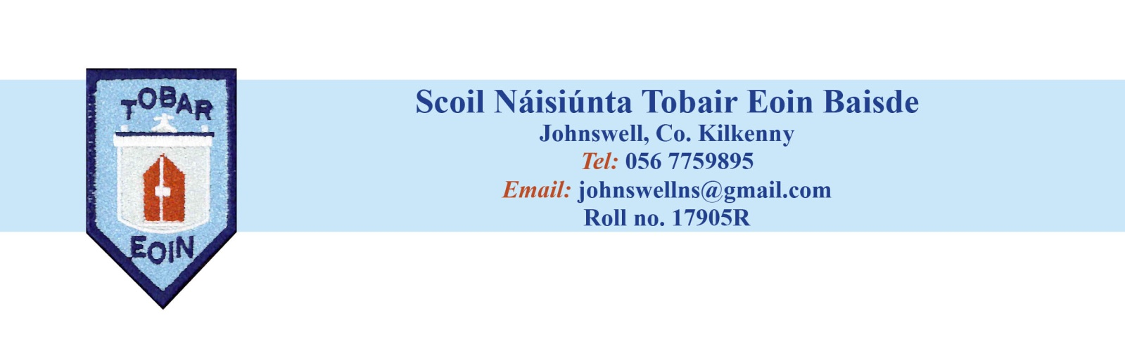School Calendar 2022 - 2023

|  |  |
| --- | --- |
| 31st August 2022 (Wednesday) | School re-opens |
| 31st October – 4th November | Mid-Term Break  School re-opens on Monday 7th November |
|  |  |
| December 21st (Wednesday) | Last day of term |
| December 22nd to January 4th | Christmas Break  School re-opens on Thursday 5th January |
| February 6th | St. Brigid’s Day Bank Holiday  School closed Monday |
| February 16th and 17th | Mid-Term Break  School closed Thursday and Friday |
| March 16th and 17th | St. Patrick’s Day  School closed Thursday and Friday |
| March 31st | Last day of term |
| April 1st to 16th | Easter Break  School re-opens Monday April 17th |
|  |  |
| May 1st | May Bank Holiday weekend  School closed Monday |
|  |  |
| June 2nd 5th and 6th | June Bank Holiday weekend  School closed Friday, Monday and Tuesday |
| June 28th (Wednesday) | Last day of term |

Dates for First Confession, First Communion and Confirmation will be communicated to you as soon as we know.

Dates for Trips will be communicated to you as they arise