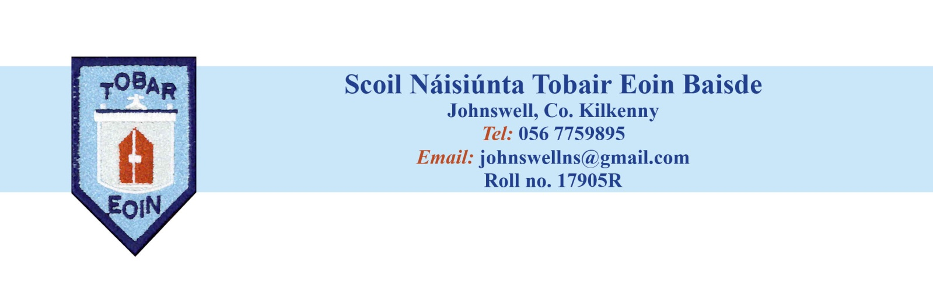School Calendar 2023 - 2024

|  |  |
| --- | --- |
| 30st August 2022 (Wednesday) | School re-opens |
| 28th October – 5th November | Mid-Term Break  School re-opens on Monday 6th November |
|  |  |
| December 22nd (Friday) | Last day of term |
| December 23rd to January 7th | Christmas Break  School re-opens on Monday 8th January |
| February 5th | St. Brigid’s Day Bank Holiday  School closed Monday |
| February 15th and 16th | Mid-Term Break  School closed Thursday and Friday |
| March 18th | St. Patrick’s Day  School closed Monday |
| March 22nd | Last day of term |
| March 23rd to April 7th | Easter Break  School re-opens Monday April 8th |
|  |  |
| May 6th | May Bank Holiday weekend  School closed Monday |
|  |  |
| May 31st to June 4th | June Bank Holiday weekend  School closed Friday, Monday and Tuesday |
| June 26th (Wednesday) | Last day of term |

Dates for First Confession, First Communion and Confirmation will be communicated to you as soon as we know.

Dates for Trips will be communicated to you as they arise