Learning Bridge  Summer Camp Themes  2018

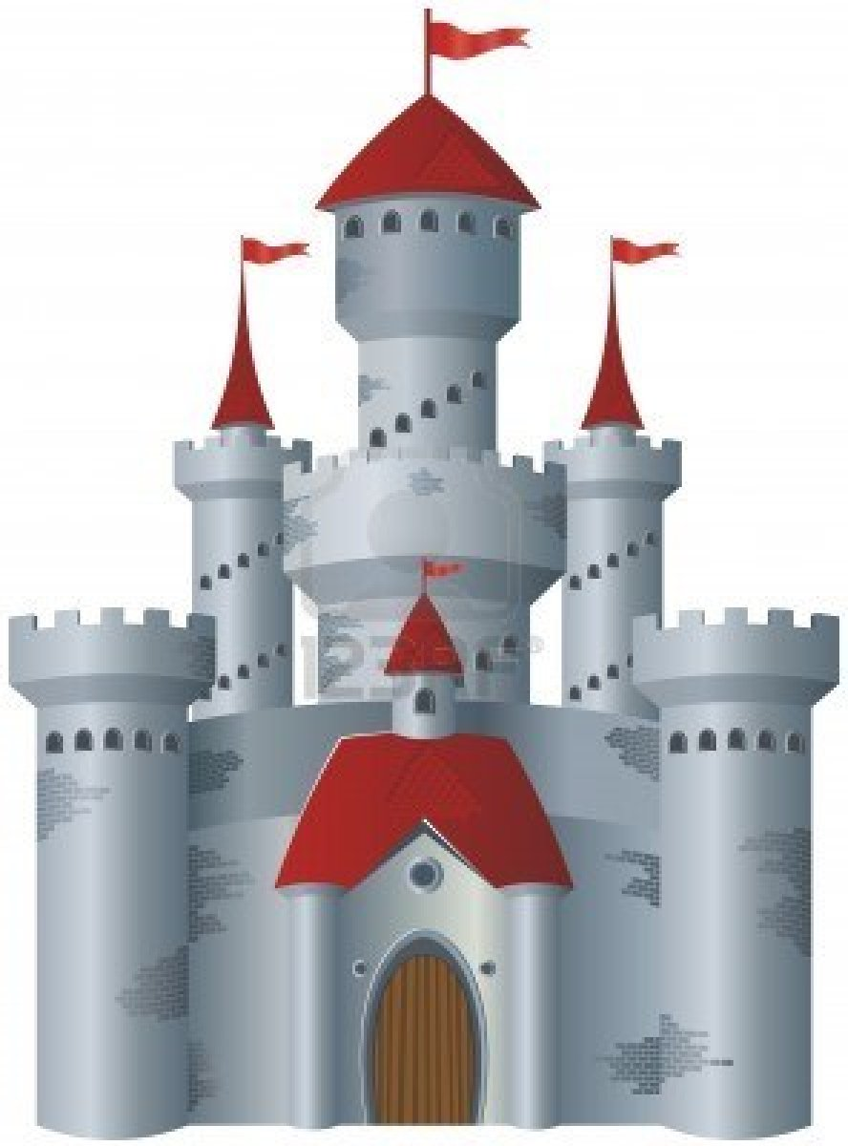

**1** (May 29-June 1) **Emergency Service Week**



**2** (June 4-8) **Dinosaur Week**

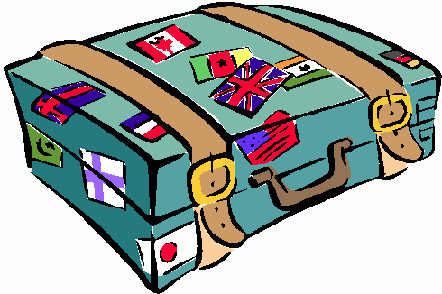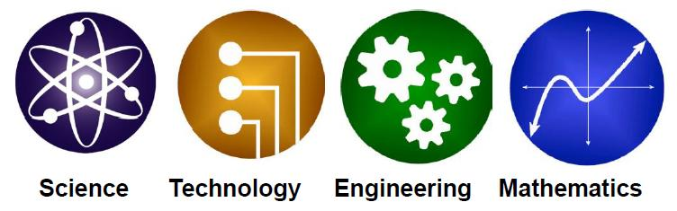

**9** (July 23-25) **Pack Your Passport**

**8** (July 16-20) **Secret Life of Pets**

**7** (July 9-13) **Sports Week**

**4** (June 18-22) **Challenge Week**

**3** (June 11-15) **STEM Week**

**5** (June 25-29) **Going Green**

**6** (July 2-3) **Culinary Creations**