Learning Bridge  Summer Camp Themes  2019

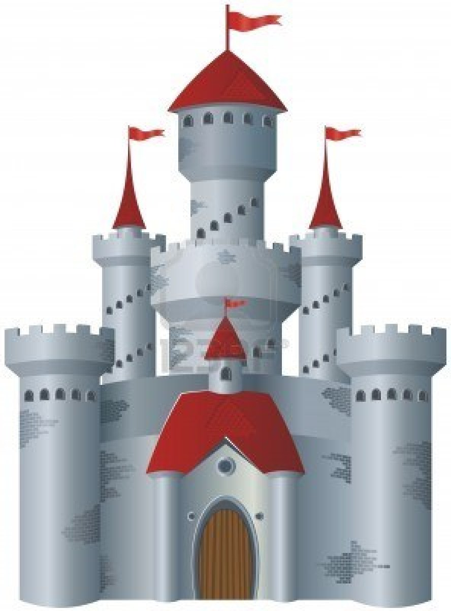

**1** (May 28-31)  **Movin’ and Groovin’**



**2** (June 3-7) **Hero’s Journey**

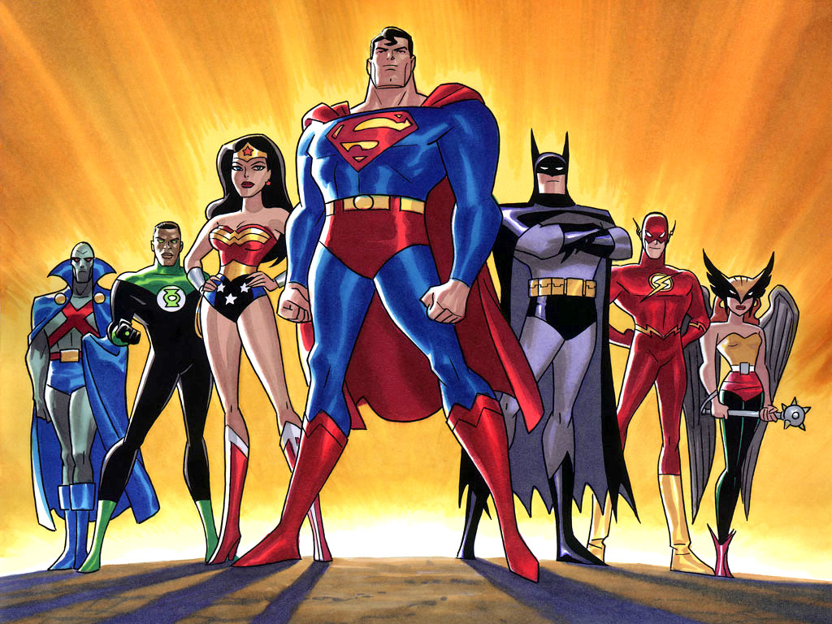

[This Photo](http://insertgeekhere.blogspot.com/2013/04/random-thoughts-justice-league-where-do.html) by Unknown Author is licensed under [CC BY-ND](https://creativecommons.org/licenses/by-nd/3.0/)

**3** (June 10-14) **Engineer Week**

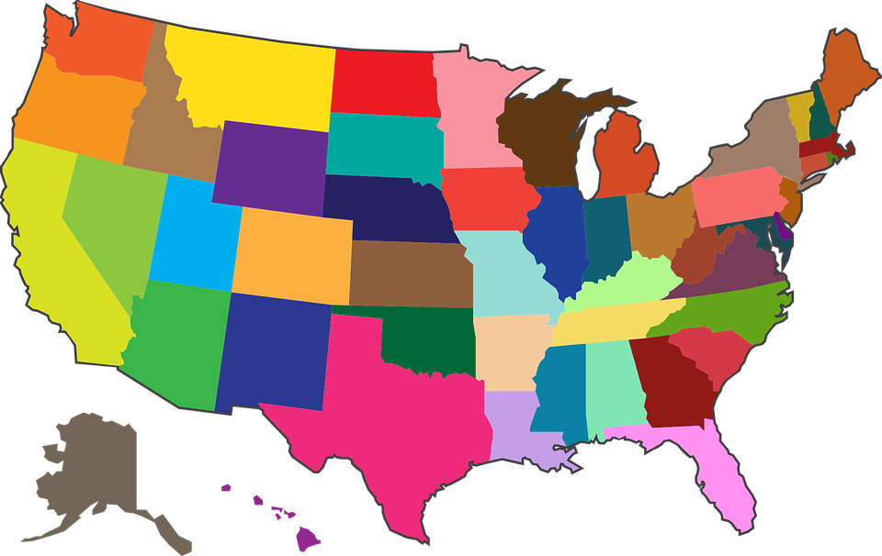

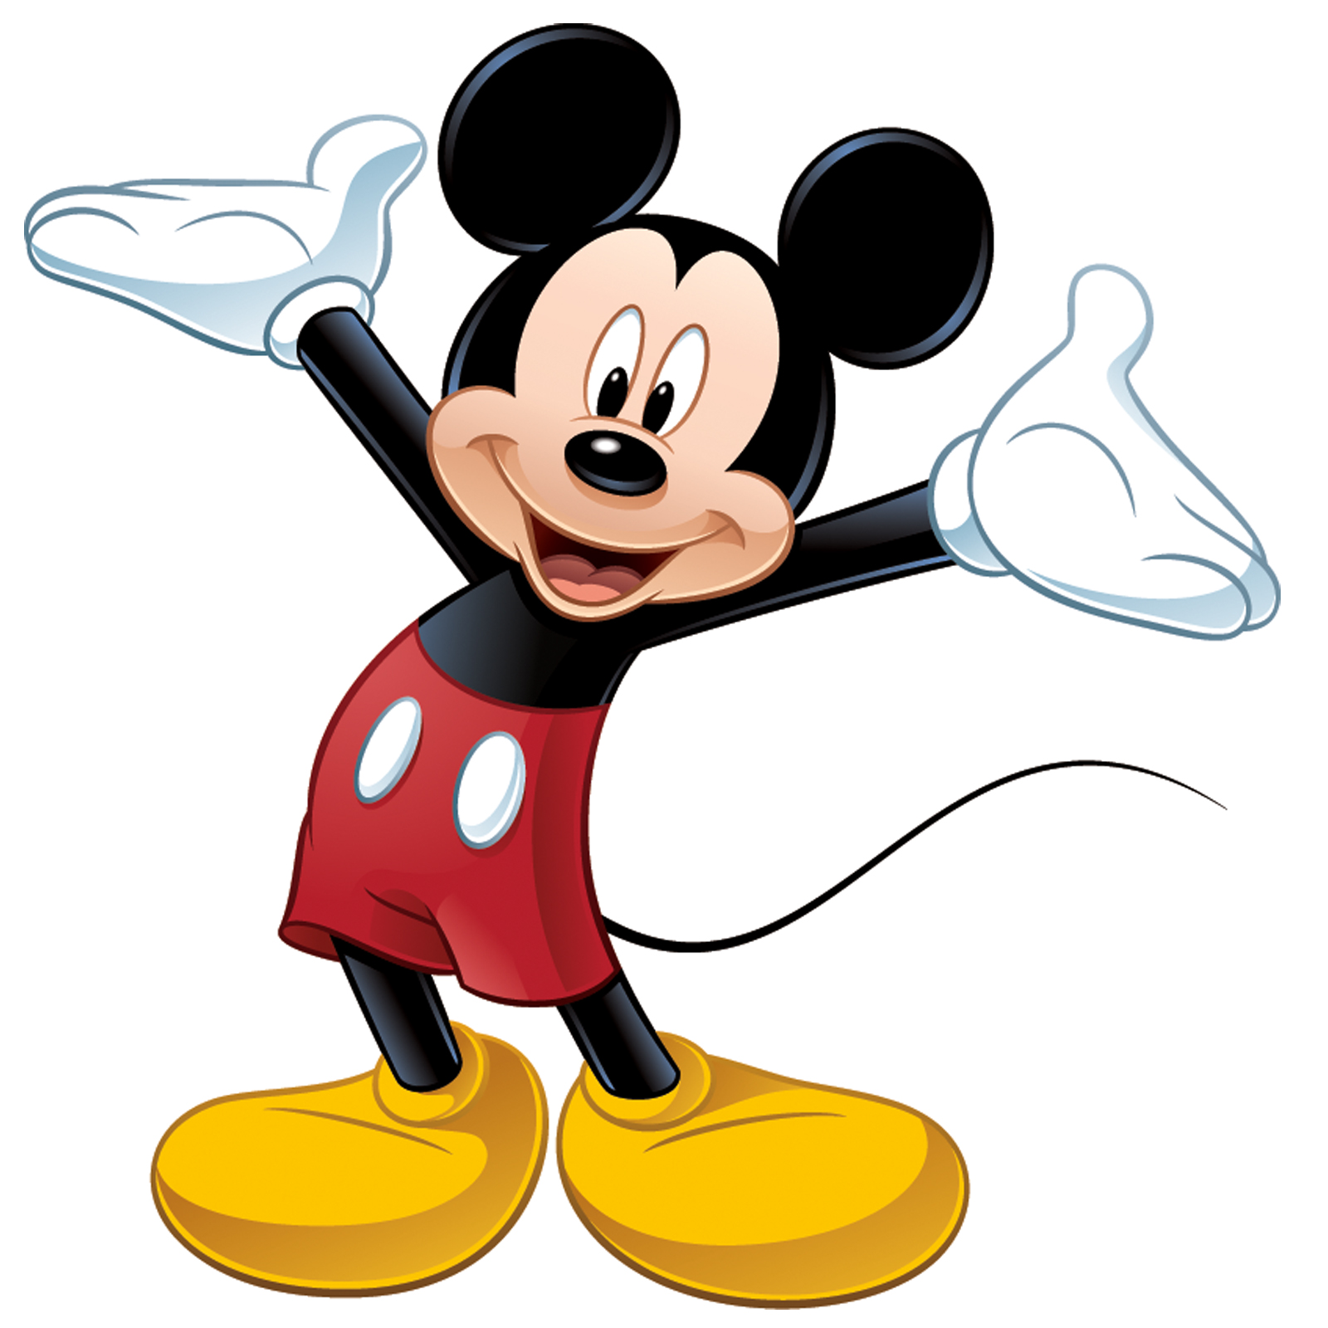

[This Photo](https://pt.wikipedia.org/wiki/Ficheiro:Mickey_Mouse.png) by Unknown Author is licensed under [CC BY-SA](https://creativecommons.org/licenses/by-sa/3.0/)

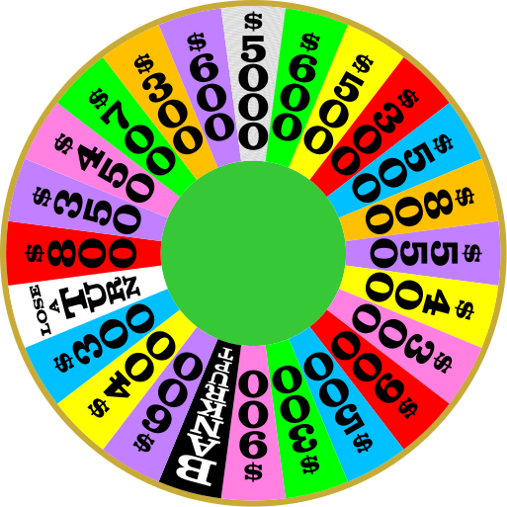

[This Photo](http://commons.wikimedia.org/wiki/File:Wheel_of_Fortune_-_Season_26_-_Round_4.svg) by Unknown Author is licensed under [CC BY-SA](https://creativecommons.org/licenses/by-sa/3.0/)

**9** (July 22-24) **Wacky Week**

**8** (July 15-19) **In the Game**

**7** (July 8-12) **State Adventures**

**6** (July 1-3) **Game Show Mania**

**5** (June 24-28) **Disney Week**

**4** (June 17-21) **Inventor’s Workshop**