Learning Bridge  Summer Camp Themes  2021

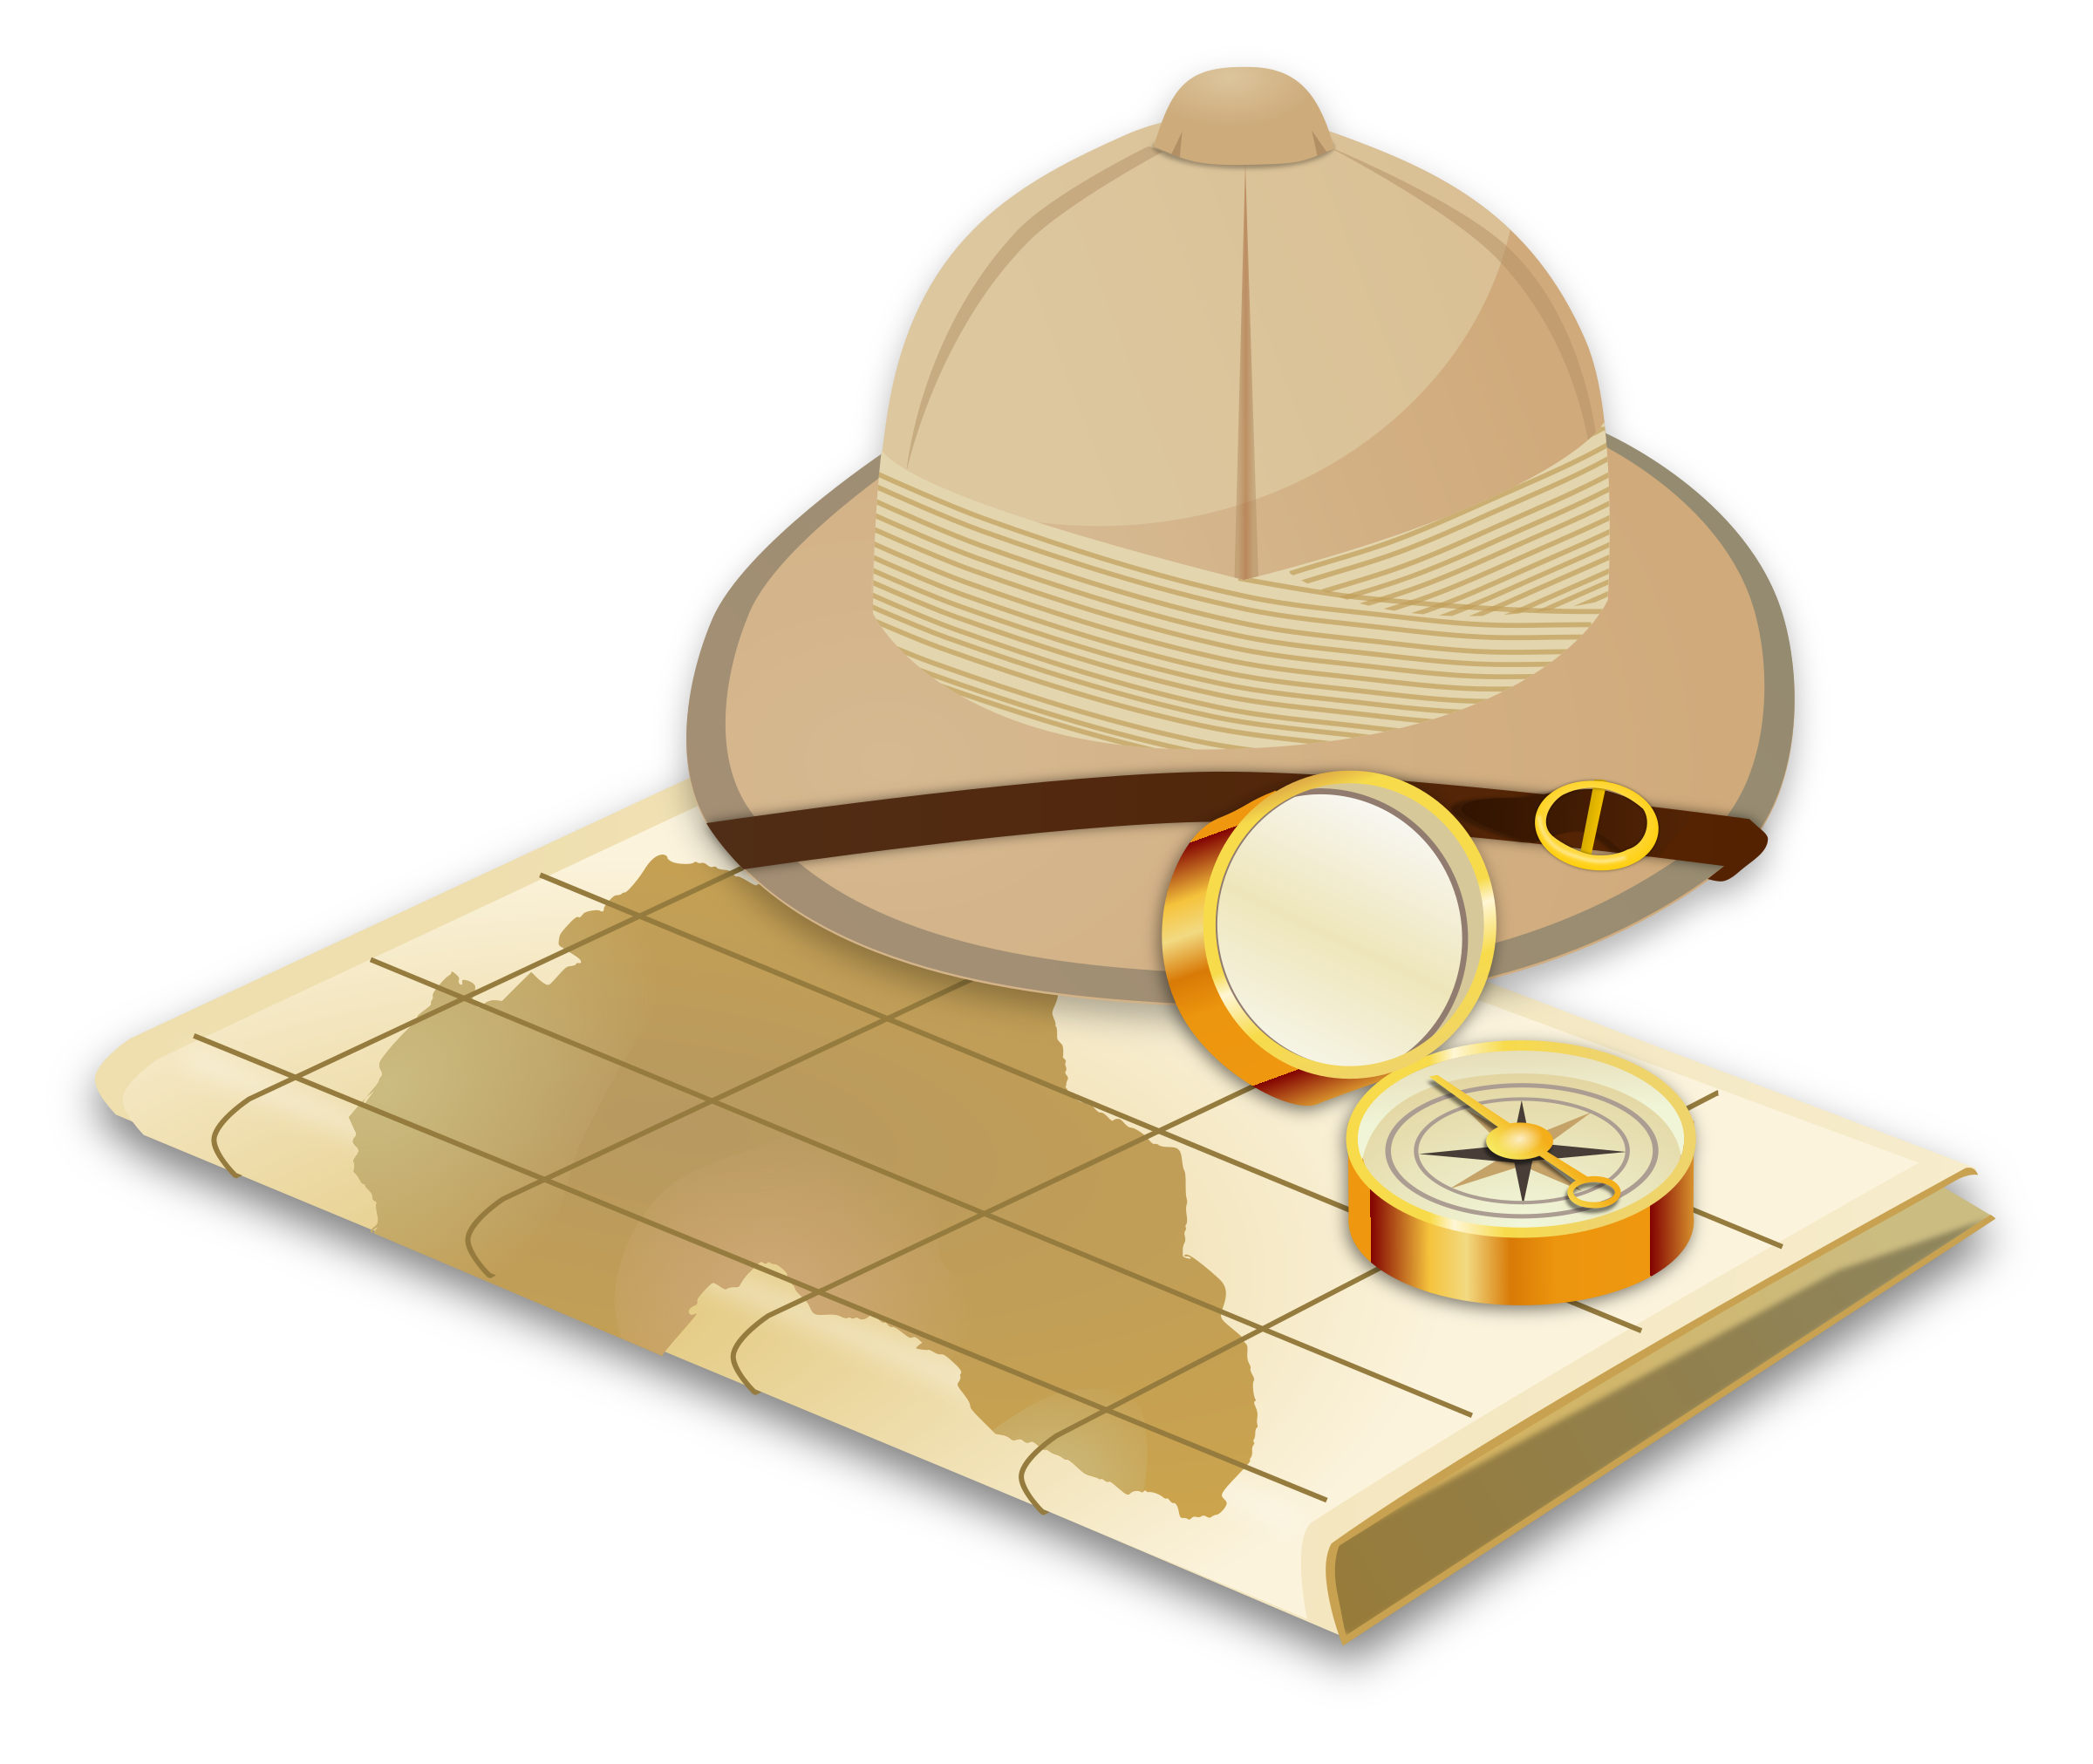

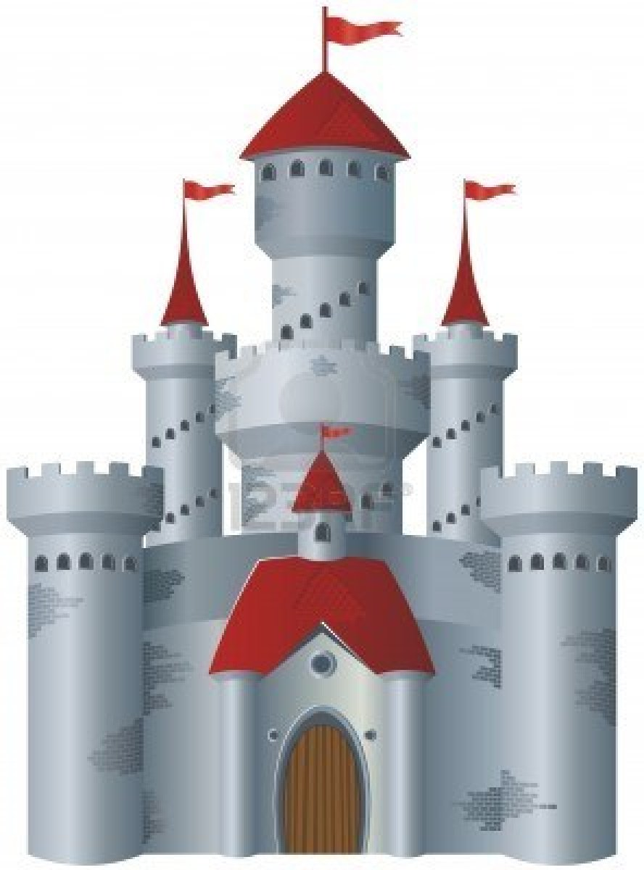

**1** (June 1-4)  **Safari Week**



**2** (June 7-11) **STEAM Week**

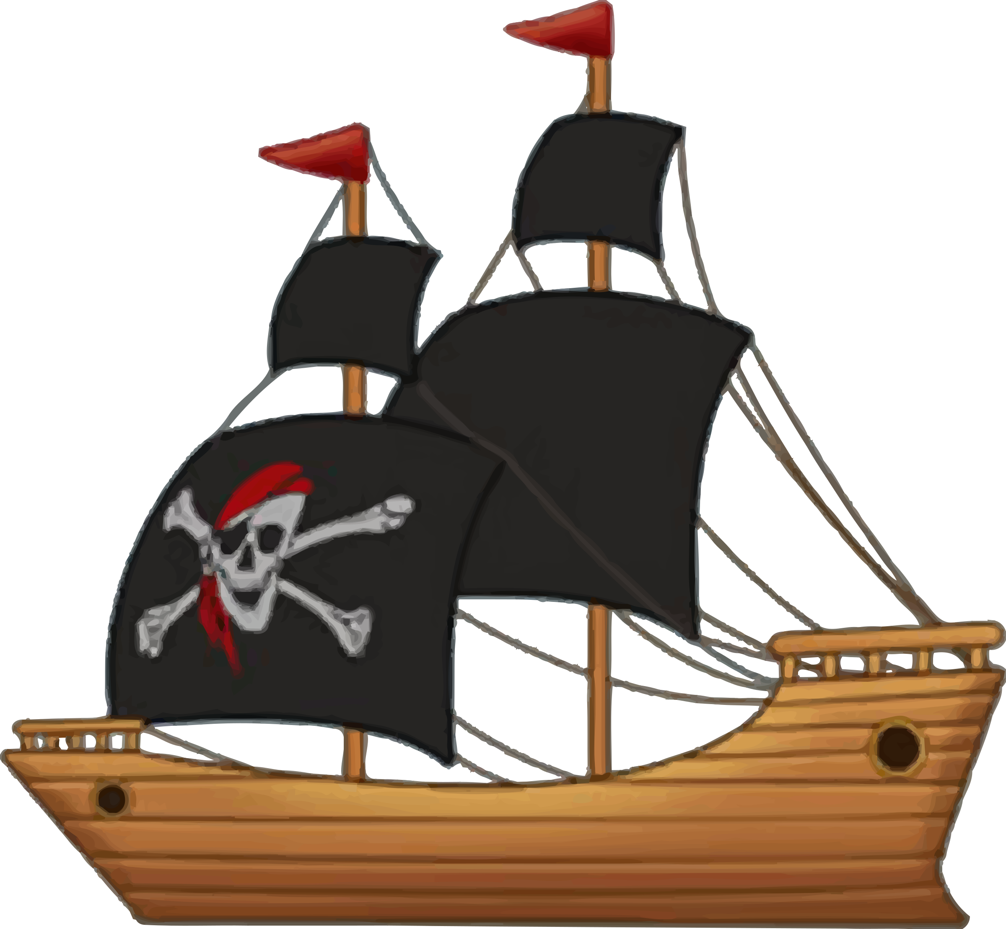



**3** (June 14-18) **Pirate Week**



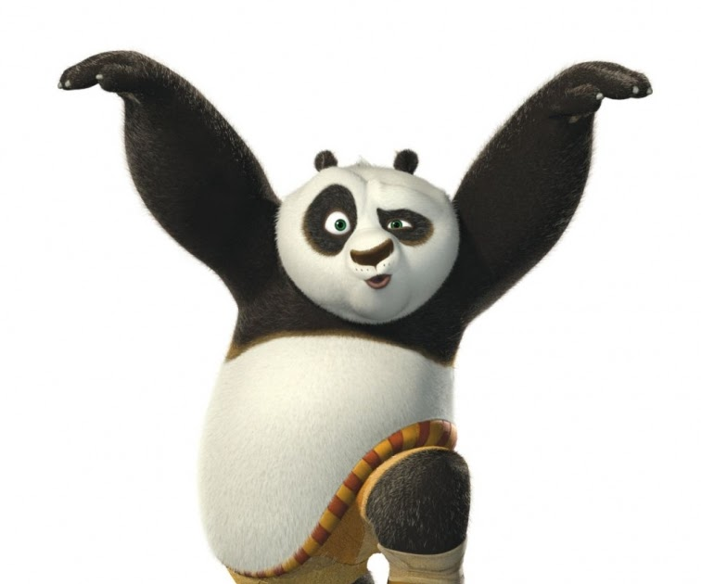

[This Photo](http://neurodojo.blogspot.com/2011/06/white-and-black-means-set-to-attack.html) by Unknown Author is licensed under [CC BY-NC](https://creativecommons.org/licenses/by-nc/3.0/)

**4** (June 21-25) **Winter Wonderland**

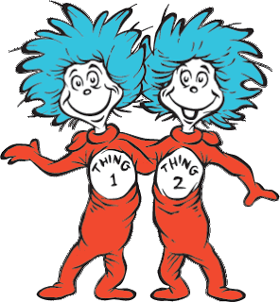

[This Photo](http://grace8484.blogspot.com/2011/03/happy-birthday-dr-seuss-day-late.html) by Unknown Author is licensed under [CC BY-SA-NC](https://creativecommons.org/licenses/by-nc-sa/3.0/)

**7** (July 12-16) **Doppelganger Week**

**8** (July 19-23) **Amazing Race**

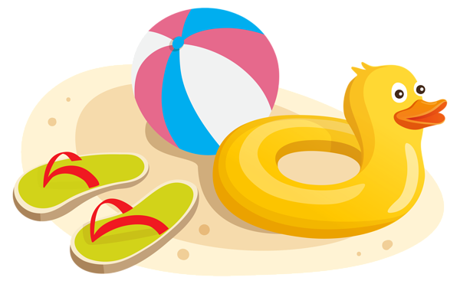

[This Photo](http://pngimg.com/download/70938) by Unknown Author is licensed under [CC BY-NC](https://creativecommons.org/licenses/by-nc/3.0/)

**6** (July 5-9) **Animation Week**

**5** (June 28-July 2) **Beach Week**