R/C FLIGHT INSTRUCTION PROGRAM
for Student Pilots
The RAMS student pilot program is intended for an individual having their own aircraft, radio system, and related flight equipment and who has not been trained/certified by a sanctioned AMA club. The student pilot must be a current member of AMA and Flagler County RAMS prior to the commencement of flight training. A student pilot is only permitted to fly when a RAMS instructor is present on the flight line with them.
The purpose of this training program is to teach a student pilot, who is new to fixed/rotary wing radio controlled aircraft, how to successfully pilot their aircraft in a safe manner while demonstrating good airmanship and proper procedures. It should be noted that the amount of time required toward learning to fly varies with each individual. Some may become proficient enough to solo in a few sessions at the field. Other students may take longer.
There are several phases in the training process. Each phase will be described in the Phase Section of this program. Each phase must be completed successfully by the student before beginning the next training phase. It is the responsibility of the instructor to determine if the student understands and can perform the required maneuvers described in each phase.
THE ELEMENTS
The philosophy of the RAMS training program is based on four essential elements:
SAFETY – There are two fundamental safety considerations for a RAM trainee.
First: Safety related to the equipment associated with the flight. Properly built, maintained and flown radio controlled aircraft are not a risk to property or people. Preflight checks of all equipment must be made prior to flight.
Second: In the hands of an inexperience/untrained pilot, an aircraft can cause considerable property damage and/or personal injury. Safety related to the environment in which the aircraft is operating and proper training regarding altitude restrictions, flight line safety, responsible airmanship while flying, tower notifications are essential considerations.
Safety will always be the primary consideration in the training program.
SUCCESS – Learning to fly R/C aircraft is a challenging undertaking, but one that can be met by almost everyone. However without an instructor and proper training, the beginner is virtually guaranteed of failure. It is the intention of the RAMS training program to progress the student successfully through the training program and the final solo.
PROGRESS – The training process is a designed set of training phases ending with a solo flight and final certification. There is a logical sequence to the various phases that allow the student to learn and accomplish basic airmanship and build on the progress as the training program proceeds. There may be times when progress may be slower than anticipated, however, with persistence comes accomplishment and success. It is important to keep a positive attitude about training and not be discouraged by periodic minor downturns in personal progress. Every pilot who has learned to fly R/C aircraft has experienced this. It is a normal phenomenon.
FUN – The whole point of this hobby is to have fun. Each time you master a new skill, if you will find personal satisfaction in your accomplishments. With this satisfaction comes enjoyment.
FINAL NOTE: Please keep in mind that the RAMS instructors are not responsible for your aircraft, per se. The individuals that volunteer their time for the purpose of teaching you to fly are competent pilots. They will check your aircraft, radio etc., and instruct you in the safe operation of your aircraft. A “Buddy Box” provided by RAMS will be used during your training sessions. It is the safest way to learn how to fly R/C. If for some reason there is a mishap, the repairs and associated costs are the student’s responsibility. Your instructor and other RAM members will be happy to provide you with advice on how best to accomplish the required repairs.
THE NUTS AND BOLTS.
Aircraft Preparation:
Use the information with your airplane to be sure it is properly set up before coming to the field. Confirm all control surfaces operate properly and the surface throws are as recommended by the manufacturer. Control surfaces must be “free and correct”. Check to verify that the aircraft CG is within the limits defined by the manufacturer. Use the information provided by the engine manufacturer to prepare your engine for flight. The more time you spend getting familiar with your airplane and the items you will need at the field, the more likely you are to have a fun and successful training session. Think ahead and be prepared. You should have spare propellers, enough fuel, fully charged batteries, etc. so that there are minimal delays in your training session.

IMPORTANT: your AMA and FAA numbers must be displayed on the exterior of the aircraft. Owner information must also be attached within the fuselage.
Read and Understand Notices, Rules and Instructions:
Prior to commencement of training, the student pilot must read and become familiar with the AMA safety code on the AMA site and the safety notice and field rules on the Flagler County RAMS web site.
The instruction program begins with an instructor inspection of your aircraft at the club field, to ensure that it is ready to fly. Any suggested adjustments or modifications must be completed prior to commencement of training flights.
If you have difficulties performing the suggested adjustments or modifications, your instructor or any of the club’s experienced pilot members can assist you. Observe and learn so that you will be able to correct aircraft deficiencies.
The Buddy Box System:
The “buddy box” system almost eliminates risk to your aircraft and provides a more relaxed and enjoyable learning experience. Two transmitters are used; your transmitter and a ‘buddy box’ transmitter. The club has “buddy box” transmitters and cables for the more popular radio brands. The instructor controls the aircraft to a safe altitude (less than 200 feet) using the primary transmitter. When the instructor depresses a switch on the primary transmitter, he will then be transferring control of the aircraft to the student. Should the student put the aircraft in an unsafe situation, the instructor will release the switch and fly it back to a safe altitude/attitude. These are line-of-sight evolutions. You must have the aircraft in sight at all times.
Instruction Time:
It is highly recommended that the student make scheduled training periods sessions with an instructor prior to going to the field. Contact information is provided for all instructors. If you are scheduled for a training session and do not show up without notifying your instructor there may be priority/scheduling issues with your future sessions.
If a student just shows up at the field without a scheduled instructor appointment, it may be possible for the student to enlist the aid of another instructor should one be available.
You are encouraged to work with different instructors. This will allow you to get differing flying perspectives and techniques.
To make your time as a Student R/C pilot more productive and enjoyable do the following:
Inspect your aircraft at home (to the best of your ability) and correct any deficiencies. It is best if you do not wait until you get to the field to correct problem areas, unless you need assistance in doing so.
The instructor will do a preflight check of your aircraft before the first and subsequent training flights.
Consider the purchase of R/C flight simulator software for your PC, if you have one. Time spent on an R/C flight simulator could greatly reduce your learning time. It is a good tool to start developing hand eye coordination before starting actual flight training using your aircraft. A simulator is also an excellent way to practice and learn new flying skills before attempting them during actual flight. Format is available for fixed and rotary wing aircraft.
A simulator is available to RAMS members at the field. The simulator is located in the shed. A flight instructor can teach you the proper operation of the simulator. The club simulator is an older version of the Real Flight software and the graphics may not be as up to date as the current generation.
Read the instruction manual for your transmitter. Instructors can’t be expected to know how all the transmitters on the market function. Especially understand how to enable the “trainer’ function on your transmitter.
Glow Engines: Read the instruction manual for your engine. Perform the break-in EXACTLY as instructed. Ask your instructor for any guidance concerning the operation of the engine. Almost all engines can be broken in while flying the aircraft. If breaking-in the engine at the field, be considerate and do so at the break-in stand at the south end of the field.
Electric Motors: Read the instruction manual for your ESC and know how to set its parameters. Read the instructions for your battery charger and know how to safely charge your aircraft batteries. It is extremely important that the battery charging be done in accordance with the manufacturer’s instructions.
Bring with you all applicable instruction manuals related to your radio, aircraft, engine, ESC and Charger as applicable. Review and become familiar with all pertinent instructions.
If you make ANY changes to your aircraft between instruction sessions, inform your instructor of these changes.
Through the instruction process and beyond, the more you put into the training process, the more you will get out of it. Join in as many of the club activities as your time permits.
R/C aviation is an enjoyable and exciting experience. By talking with other club members about their experiences you will learn a vast amount of knowledge that will help you achieve your R/C goals.
RAMS FLIGHT TRAINING STAFF
The following is a list of the current RAMS instructors. Contact one of them for more information, and an appointment:
Victor Dumet (FW)  Chief Instructor | (vdumet@hotmail.com); | 386-673-4735
Medwin Nazif (FW)  Steve Olson (FW/H) | (medwin@visitingangels.com); | 386-295-6409  386-986-9666
  Patrick Lenahan (FW)
  Brandon Orlando (FW)
  Martin Stohr (FW)
  Dave Slote (FW)
  Donald Button (FW)
  (olsonjko@cfl.rr.com);
  (plenahan16@gmail.com)
  (endlessups247@gmail.com)
  (damnpilot2000@aol.com)
  (dfslote@aol.com)
  (dcbvibes@aol.com)
  757-352-8987
  561-714-0468
  281-433-0453
  716-335-2957
  203-600-5529

Legend:
FW- Fixed wing
QC- Quadcopter/drone
H - Helicopter

INSTRUCTION Phases to be accomplished:

GROUND SCHOOL: Ground school is an informal method of teaching first time R/C pilots the basics of aerodynamics and airmanship. Discussions concerning your specific aircraft and equipment will be undertaken so that you can become familiar, and have a working knowledge of their functions. Also, club rules will be addressed and proper flight pattern requirements/altitude restrictions discussed.

AIRCRAFT, RADIO and FIELD PROCEDURES

The first time you bring your plane to the field, your instructor or a member of the RAMS Flight Training Staff will perform a thorough inspection to ensure your aircraft is airworthy. They will check that all control surfaces are properly attached and function properly. Engine/motor mounting, servo mounting and control linkages will be checked, as well as, the balance (CG) center of gravity and general integrity of the aircraft.

The staff will help with engine break-in and tuning if needed.

You will learn the operational details of your radio, including normal and abnormal operation, interference, and range checks. Your instructor will also explain the field facilities for the models and radios along with field procedures and field rules for safe and courteous operation. See the field rules and the description of the frequency control system at the field control board.

FIRST FLIGHT

During the first flight your instructor will fly your model to verify its airworthiness and handling qualities. He will then explain the controls and what kinds of reactions you can expect. If there are any deficiencies he will present you with a list of items to be corrected before the next flight. You will be expected to correct these deficiencies on your time. During this first flight and only after your instructor is satisfied the airplane will fly safely, and trimmed for straight and level flight, will he have you take the controls, for the first time. The aircraft will be at a safe altitude.

By using a “buddy box” your instructor is able to take control and prevent trouble if you become disoriented. Try to relax and get the feel of the controls. Listen to your instructor. He will “talk” you through each control function and you will observe the aircraft responses. If you get nervous or uncertain, tell your instructor immediately and he will take over aircraft control. Remember, the intent of the first flight is for you to get the feel of flying the model and begin to understand the dynamics of your model flight characteristics.

PROGRESSIVE TRAINING

After you have attained the initial feel of flying your aircraft, your instructor will teach you the five basic maneuvers/factors required for safe flight. They are:

1. Level flight
2. Banked turns
3. Straight climbs/descents
4. Gliding
5. Climbing and gliding turns
6. Power management
7. Attitude
8. Stalls

Your instructor will also explain disorientation. This is a problem that everyone experiences at one time or another while flying models. Basically, disorientation occurs when you become confused about the direction or orientation of your model. For example, when the model is coming toward you and you start a left turn, the model will turn left, but it will move to your right relative to your position facing the model! Your instructor will teach you methods to counteract this. Also in some lightning conditions, with the aircraft far away, you may not realize if the model is going away or coming towards you. Again, your instructor will show you how to resolve this.

ACCURACY MANEUVERS

Now that you can fly around and do the basic maneuvers, it’s time to start learning how to control your model with precision. Again, you will be working with the eight basic maneuvers/factors. However, now turns will have to be more exact (90 or 180 degrees) at a constant altitude. The whole idea of these lessons is to improve your skill and ability as a pilot.

ORIENTATION MANEUVERS

During these lessons your instructor will have you fly a figure-8 pattern and a rectangular pattern. The purpose of these maneuvers is to discipline your reflexes and judgments. Decide to really master these maneuvers. Their importance will soon be evident.

STALLS AND RECOVERY

“If you pull back on the stick, the airplane goes up. Pull back some more and the airplane goes down!” That’s a stall. But there’s a little more to it and in this lesson you will learn to recognize and recover from stalls. More important, you will learn how to avoid unintentional stalls. Each airplane has different stall characteristics.

TAKE-OFFS

As you gain flying experience and confidence, you will want to attempt a take-off from the runway. Take-offs are nervous times because the model is near the ground and if it’s not properly controlled, trouble can happen very fast. So, during this lesson, your instructor will explain the forces that affect a model during take-off and will assist you in making your first take-off. Once you have mastered the skill to maintain a straight line on take-off, you’ve got it made.

APPROACHES TO LANDING

In this lesson you instructor will discuss how to land your model. You will fly a rectangular pattern again, but this time you will learn how to make a descent in preparation for landing. You’ll get to practice this maneuver up high until you become comfortable with it, the altitude will get lower. A good landing is always preceded by a good approach. As with full size airplanes, attitude controls speed and power controls altitude.

LANDINGS

At the time the approaches are fully under control you keep getting lower and lower and all of a sudden you are landing. Only this time you need to remember to flare at the last moment. If at anytime things don’t look good, go around and try again.

SUPERVISED SOLO

At some point you will become proficient in all preceding phases of flight. It is time to solo. You will conduct a flight starting with getting your transmitter from impound **, and ending, after you fly, with your transmitter back in impound. Your instructor will monitor this lesson and assist you when necessary. All you have to do is demonstrate good judgment, observe the field rules, and conduct your flight in a safe manner. Your instructor may have you do several supervised solo flights before you are signed off as successfully completing the solo phase. When it is complete, check your logbook for the names of all your instructors. Search them out and thank each one. This is the only pay they receive.

** Impound is not necessary for 2.4 GHz systems.

MANEUVER Detailed Procedures:

GROUND STEERING PRACTICE

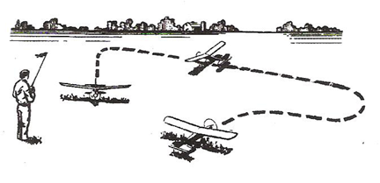

For a couple of hours, practice taxiing the model around at low speed. This is a very helpful step in making you feel more at ease in controlling the model.
Do not rush it. Use a parking lot rather than a street where you are likely to run into a curb and damage your model. Practice taxiing in light breezes or when the air is calm; as strong or gusty winds can catch a wing and flip your plane over. Apply minimum throttle that just keeps the model moving at a walking pace.
With the rudder stick and rudder trim in neutral position, the model should move straight ahead. If it constantly turns left or right, the nose wheel is not pointing straight forward and should be adjusted by loosening the steering arm.
When the plane is pointing at you, the steering will seem "reversed." When you give right rudder, the plane turns to your left-but the model actually is turning to its right. With practice, you will become accustomed to this.

The more familiar you become with the behavior of the model, as you control it on the ground, the better prepared you will be when flying it.
After taxi runs are completed, thoroughly examine the model and tighten any loose screws, etc. Checking your aircraft after each and every flight is an important habit to form, as loosened parts are the frequent cause of crashes.

GENERAL FLIGHT TECHNIQUES

In flying, it is very important to make all your control movements slow and measured. Rapid movements tend to throw the model out of control. Try to make all turns gentle, not tilting (banking) the wing very much.
If you increase the bank, making the turn steeper, there will be a corresponding weight increase and reduction of lift. Therefore, when you bank your plane, it will start to descend. To maintain altitude in a turn, add enough back stick (up elevator) to hold the nose "up" through the turn.
First flights should be made on a day that is not very windy or gusty. There should be very few people or other distractions around; you will need to concentrate.
Your success doesn't depend on following the instructions here to perfection, but you should have a flight sequence in mind. Think ahead of the model; don't chase it around the sky, always one thought and one control command behind it.

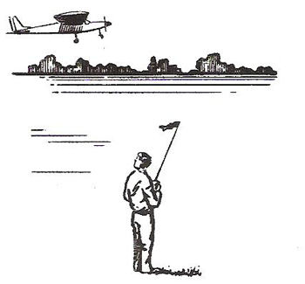

While learning to fly, you may feel more comfortable looking over your shoulder (with your body in the same direction as the model) as the plane comes toward you. Simply push the stick left or right, in whichever direction the ship is turning. . "Head-on disorientation" is dangerous in the air, where things can happen pretty quickly. Before flying, it is wise to spend some time familiarizing yourself with orientation by operating the controls, with the plane set on a table, while you view it from different positions.

FIRST FLIGHT

There is no way to fully explain the principals of flight and the techniques of flying in a few pages. Entire books have been written about apparently simple subjects, such as the shape of the wing. Furthermore, there is no substitute for an experienced R/C flight instructor. The following information is not intended to replace your instructor, but to help give you understanding of basic flight concepts and techniques.
As stated earlier, choose a day on which there is little or no wind and the flying field is relatively quiet.

One of the most important, yet sometimes forgotten pre-flight checks is to always make sure the wing is securely attached to the fuselage; and the control system is 100 % operational.

Remember "A model, engine, motor, or radio that is not prepared and working properly on the ground before takeoff, will not improve in the air - it will get worse! There is no point in attempting to fly until everything is 100% correct."

Plan to make your first flight a short one. You will be surprised how exhausting beginning flights can be. Plan to spend no more than 2-3 minutes in the air the first few times you fly.

TAKE-OFF

First, point the model directly into the wind. Switch the motor on (or slowly advance the throttle) and gently steer the model straight with rudder as the model gains speed rapidly. After it rolls about 50-75 feet, add slight back stick (up elevator) pressure, so that the model rises smoothly from the ground. Only hold as much back stick as necessary to keep the plane in a 5º to 10º gentle climb. Be patient; let it climb slowly, as a steep climb will cause it to stall. (If you try to pull the model up too steeply, it may slow down and then stall and crash.)

LEVEL FLIGHT

Most crashes are due to moving the controls too much, so once again, be slow and gentle on the controls during throughout the whole flight. Over-controlling tends to throw the plane out of control and wastes power.
When achieving a safe altitude after "climb out", reduce power and trim the aircraft for level flight.
Keep the wings level, adding just a touch of left or right aileron.

BANKED TURNS

Apply a little right or left (aileron) stick pressure until the model begins a very shallow turn in the direction you want to go. Then “neutralize” the stick position. If loosing altitude apply some back stick pressure (up elevator) until the descent is arrested.
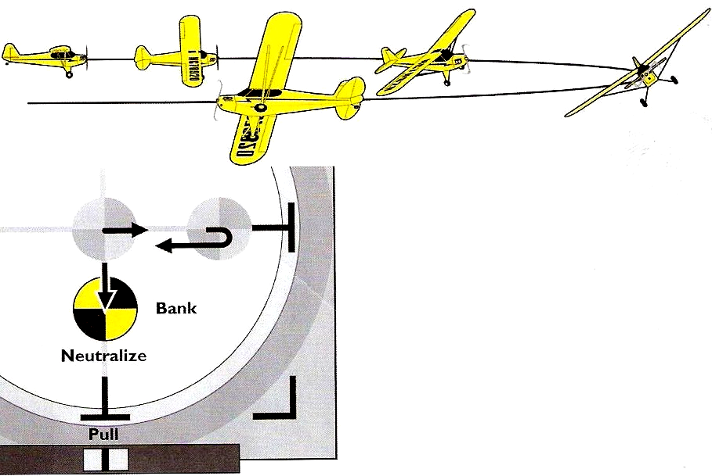

At the point at which you want to exit the turn, neutralize the elevator and smoothly apply opposite aileron to level the wings.
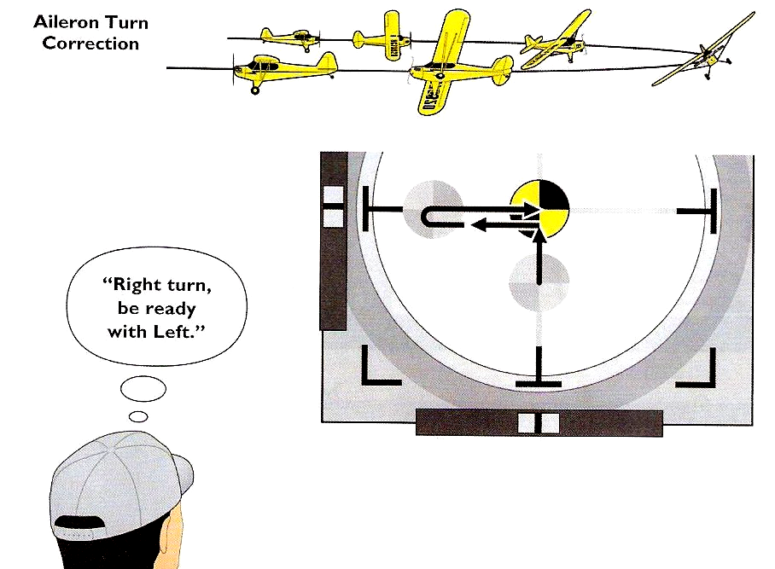
During windy conditions, try to maintain shallow turns. Do not let the turn get too steep.
The wind will tend to blow your plane further downwind. Try to keep it upwind at all times. It is more difficult to fly a model when it is downwind, and if a mistake is made, the model will end up further away, making it harder to fly back to the field. To compensate for wind, continue making upwind turns shallow, but make downwind turns a little steeper.

OVER-STRESSING THE AIRFRAME.

Spirals occur, as explained earlier, when the bank angle increases and up elevator (back-stick) is added to keep the plane flying level.
If the bank becomes too steep, the model will spiral downward at an increasing rate of speed. Trying to “pull” the aircraft out of the spiral by pulling back on the elevator only makes things worse. This sequence of events happens very often.
Abrupt control changes can stress ANY airplane, even those designed for aerobatic competition.
If you find yourself in a steep, high-speed dive, immediately level the wings and gently pull the stick back (add up elevator) pressure to recover.

STALLS.

Your model’s movement through the air keeps it flying. If you fly too slowly, there is a point where it will stop flying and fall out of the sky. This is called a stall.

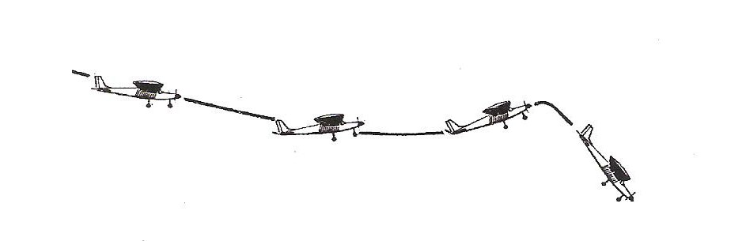

When the nose drops, the plane will gain some speed. Give it a little more power as you gently give the plane up elevator to bring the plane nose level with the horizon.

SETTING ADJUSTMENTS

As you get used to the controls, you probably will notice the model turning somewhat, or climbing or descending, without any stick pressure on your part. Bear in mind that airplanes have forces that must be balanced in order to fly straight and level.
These tendencies can be corrected in the air by moving the trim tabs on the transmitter. Usually when you change power settings be ready to “trim” the aircraft for nose up or down.

FLYING A PATTERN

At most flying fields, models fly in a rectangular path around the runway. This is called the "pattern." The most important reason for flying the pattern is that, as the model flies in different directions in the wind, the pilot will be better prepared for landing conditions when the flight ends. Full-scale aircraft fly a landing pattern for this same reason. Another important reason for flying the pattern is to organize the take-off and landing traffic, reducing confusion.

The "traffic" pattern consists of an upwind leg, crosswind leg, downwind leg, base leg and final leg.

LANDING

In preparation for landing, plan to enter the pattern upwind, at about 120 - 150 feet altitude. Continue to CROSSWIND LEG (position 4) at the same altitude

Make the Downwind Leg far enough away to allow for gentle turns to Base Leg and Final Approach. Avoid tight "panic" turns, particularly when landing.

When the model is in the Downwind Leg reduce power (when the model is straight across from you at position 5) to establish a gradual descent until it is about 45º downwind of the landing area, turn to Base Leg. When you have reached an altitude of about 100 feet (position 6), add just a touch of left or right stick until the model begins a very shallow turn. Try to maintain this shallow turn, keeping it gentle, and not tilting (banking) the wings very much.

From now on if you increase the bank, making the turns steeper, there will be a corresponding weight increase and reduction of lift. The combination of low airspeed and reduced lift can result in a spin which will (most likely) panic new pilots into flying the model right into the ground!

Reduce power again. How much depends on the airplane’s altitude and rate of descent.

For your FINAL APPROACH & LANDING (position 7), make a gentle turn to point the model in the direction of the landing area. Keep the nose of the plane slightly down, so you don't stall.

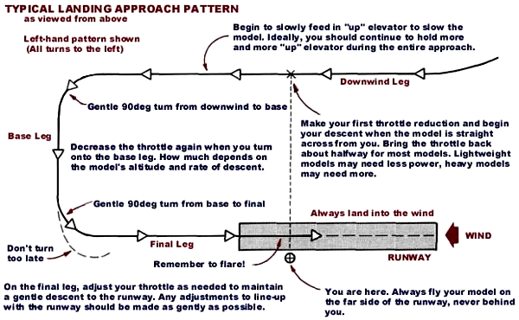

This is your decision point, if everything looks good, continue your descent, letting the model slowly lose more altitude. (If you are not happy with the approach, turn the power back on, climb out, and set up for another pass.) Remember "good approach results in a good landing." Consequently don't rush it.

For your first landings, don't be concerned about trying to land in a particular spot. Just land safely, without damage to your model. At first, concentrate on flying a gradual descent straight into the wind.
Steer the plane into the wind as it glides, keeping the wing level. Let the model settle in toward the ground and land. Just before the model touches down, you can add just a bit of back stick (up elevator) to "flare" and soften the landing.

After landing is complete taxi your aircraft to the pits, walk over to your plane and turn off the receiver first, and then the transmitter. Congratulations! You've just completed your first flight.

GLOSSARY OF MODELING TERMS

RUDDER CONTROLS “YAW”
(SIDE TO SIDE MOTION)

ELEVATOR CONTROLS “PITCH”
(UP & DOWN ATTITUDE) AILERONS CONTROL
“ROLL” (BANKING)

ARF: Almost Ready to Fly
AILERON: the control surface on the wing that rolls the plane
AIRFOIL: the shape of the wing as seen from the end
ANGLE OF ATTACK: the angle at which the wing meets the air flow
CONTROL HORN: a device attached to each control surface to provide an attachment point for the pushrod
COWL (COWLING): the nose section of the fuselage that encloses the engine
DECALAGE: the difference between the incidence of the wing and stabilizer
DIHEDRAL: the inward angle of the wings, as seen from the front
ELEVATOR: the moveable part of the horizontal tail, which controls pitch
EMPENNAGE: the tail of the plane
FIN: the fixed vertical part of the tail
FIREWALL: the hard wooden former at the front of the fuselage, to which the engine is mounted
FORMER: a piece which shapes the fuselage; and to which the sides of the fuselage are attached.
INCIDENCE: the angle of the wing or the tail in relation to the thrust line
LAMINATE: to glue two thin sheets of material together to form a thick sheet
LEADING EDGE (L.E.): the edge of the wing that first meets the airflow
OUTPUT ARM: the piece that attaches to the servo and connects it to the pushrod
PITCH: an up and down movement of the nose of the plane, which is controlled by the elevator
PUSHROD: the long, stiff dowel or plastic piece that connects the servo with the control horn
RTF: Ready to Fly
RIB: the airfoil-shaped piece that connects the leading edge, spars and trailing edge of the wing together and holds them in shape
RETRACTS: devices for extending and retracting the wheels on command
ROLL: tilting of the plane as viewed from the front, controlled by the ailerons
RUDDER: the moveable vertical tail of the plane,
SERVO: the part of the airborne radio system that moves the control surfaces
SPAR: a wooden stick running lengthwise through the wing that serves as its backbone
SPINNER: the rounded cone that fits over the propeller hub
STABILIZER (STAB): the fixed horizontal part of the tail
STALL: a situation in which the plane is flying too slowly to move sufficient air across the wing to produce lift
THRUSTLINE: a line drawn from the center of the propeller hub straight through the airplane
TORQUE: a rolling tendency caused by the spinning propeller
TRAILING EDGE (T.E.): the edge of the wing that faces the rear of the plane
TRIM: small adjustments made to the control surfaces to cause the plane to fly straight and level by itself
WASHIN: a twist in the wing that makes the trailing edge lower than normal
WASHOUT: a twist in the wing that makes the trailing edge higher than normal
WING SADDLE: the shaped part of the fuselage in which the wing rests
WHEEL COLLAR: a metal ring that holds the wheel on the axle
YAW: a right-to-left movement of the nose, controlled by the rudder

ACKOWLEDGEMENTS:

Flagler County RAMS would like to thank the following entities for allowing us to use their text and/or graphics for which portions of this document are based upon:

“District of Columbia Radio Control Club. Flight Training Program documentation © 2013, all rights reserved.”
training@dc-rc.org

“Dave Scott 1st RC Flight School, Mastering Procedure & Rudder Turns.” http://www.rcflightschool.com

“Hobbico’s Carl Goldberg Products General Information Manual.” questions@carlgoldbergproducts.com

“SIG Mfg. Company’s RC Basics Handbook”
mail@sigmfg.com

