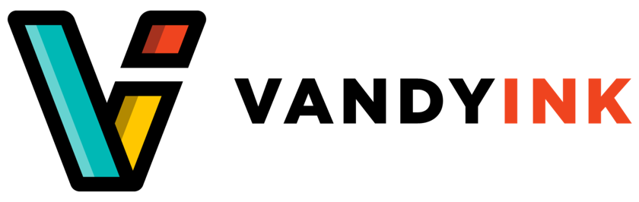

FOR MORE INFORMATION:

**Jess Vandenburg**

**Founder jessvandyink.com**

**@jvandyink**

**About Vandyink**

Vandyink was founded in 2015 in Memphis, Tennessee as a freelancer illustration and design company whose mission is to bring “other people even the smallest bit of joy” through expressive illustrations and designs that are heavily inspired by pop-culture, video games and tv – brought to life through emphasis on the use of primary colors.

Jess Vandenburg, founder of Vandyink, began their company over a decade ago after graduating from Memphis College of Art then undergoing an internship under the instruction of Andrew Lebowitz. The entrepreneur saw a need for more representation of independent and LGBTQ artists in their community. The design company works with organizations such as More for Memphis, First 8 Memphis, Literacy mid-South, MLK50, Indie Memphis and Knowlege Quest. They also work in collaboration with community and public relation firm Power Solutions.

After nearly 10 years in the industry, the business has grown exponentially, with a physical location underwork and a growing list of services including design, animation and illustrations specializing projects such as involve branding, icon sets and motion graphics.

**Information Gap**

The backgrounder lacked numerous things that could have been retrieved in an interview with the company and its founder. Things such as the process of developing the company, how Vandenburg began in art, the company’s values and more about policies and product specifics. It would have also been beneficial to have more specific information as to where the physical store is planning to locate and how the company further plans to expand and capitalize by staying in the Memphis area.

**Sources**

*Jess Vandenberg (@Jvandyink) • Instagram Photos and Videos*. https://www.instagram.com/jvandyink/.

Reeder-Young, Chris. “Crafting Courage: A Conversation with Designer Jess Vandenberg.” *Focus LGBT+ Magazine*, 19 Jan. 2023, https://focuslgbt.com/blog/crafting-courage-testing-waters-for-big-splashes-a-conversation-with-designer-jess-vandenberg/.

Struttin' Fancy Print $16.00, et al. “Store.” *Vandyink*, https://www.vandyink.com/store.