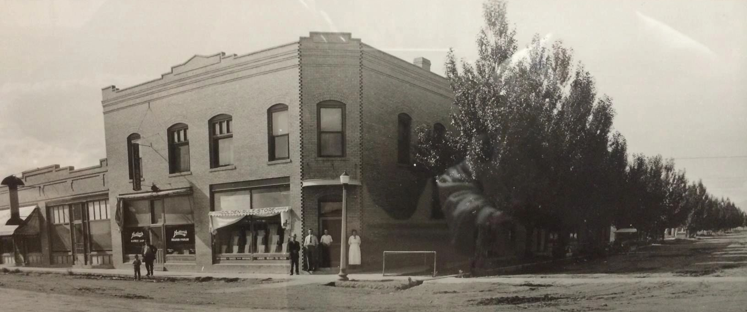
Conference Room Use Guide

This conference room is available for use by businesses and the public. All scheduling must go through Lisa Brozovich at (406) 593-0590. An online calendar can be viewed at www.bordenshotel.com to check availability, but reservations must be made through Lisa.
Cleaning: Renters are responsible for the cleaning of the conference room upon completion of the usage. If additional cleaning, repair, or property replacement is required, the appropriate amount will be billed to the renter. The renter may also lose the opportunity to rent the Conference Room in the future.
  - Chairs and tables must be straightened and returned to original position
  - No used materials, decorations, or trash to be left in meeting rooms.
  - All used paper, plastic ware; bottles and cans must be place in trash receptacles along with any leftover food
  - Trash must be removed and placed in city trash cans in the alley behind the building. Clean trash liners must be placed in trash cans.
  - Wipe down all tables and counter tops
  - Close doors to the hallway
  - No smoking in or around rental facility
  - No Candles

Building Modifications: No building modifications will be allowed to include the permanent or temporary fastening of boards or other materials on any walls, ceilings or floors with nails, tacks, glue, or other adhesive devices without written permission.

A cleaning checklist must be completed and initialed to indicate compliance with all cleaning procedures. Cleaning checklists are printed for your convenience and available in the conference room. Failure to do so may lead to the loss of conference room privileges.
The user is responsible for deciding ahead of time if screens, projectors, monitors, conference call set-up, or other special requests are needed.
Wi-Fi is available. To log on to the Borden’s network, the password is Hilda103.
The Borden’s Hotel building is home to businesses on the first floor and apartments on the second. Please respect the tenants—keep all noise at a reasonable level.
Conference Room Cleaning Checklist

All cleaning must be completed within the reserved timeframe. As you complete the checklist, initial each item, and sign the bottom of this form. Leave this checklist on a table in the conference room for Borden’s Hotel LLC staff.
Thank you

  - Chairs and tables must be straightened and returned to original position
  - No used materials, decorations, or trash to be left in meeting rooms.
  - All used paper, plastic ware; bottles and cans must be place in trash receptacles along with any leftover food
  - Trash must be removed and placed in city trash cans in the alley behind the building. Clean trash liners must be placed in trash cans.
  - Wipe down all tables and counter tops
  - Close doors to the hallway

Signed: ___________________________________________

