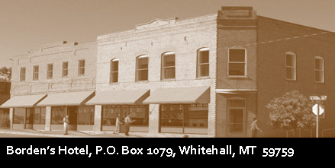

**Conference Room Use Guide**

This conference room is available for use by Borden’s businesses and the public. All scheduling must go through the extension office. Please call Erin at 287-3282. An online calendar can be viewed at www.bordenshotel.com to check availability, but reservations must be made through the office.

**Always leave the conference room the way you found it**. If you use decorations, they must all be removed—no tacks or tape left on the walls. Cleaning supplies and the vacuum are stored in the conference room, trash bags, are in the janitor closet. Please remove all trash. City trash cans are in the alley behind the building. A cleaning checklist must be completed and initialed to indicate compliance with all cleaning procedures. Cleaning checklists are printed for your convenience and available in the conference room. **Failure to do so may lead to forfeiture of deposit and/or loss of conference room privileges.**

The user is responsible for deciding ahead of time if screens, projectors, monitors, conference call set-up, or other special requests are needed.

Wi-Fi is available. To log on to the Borden’s network, the password is Hilda103.

The Borden’s Hotel building is home to businesses on the first floor and apartments on the second. Please respect the tenants—keep all noise at a reasonable level

**Conference Room Cleaning Checklist**

**COVID -19 UPDATE**

**All cleaning must be completed within the reserved timeframe. As you complete the checklist, initial each item, and sign the bottom of this form. Leave this checklist on a table in the conference room for JLDC staff. Please use the provided disposable wipes to thoroughly sanitize.**

**Thank you**

__Wipe down all tables and counter tops

__Wipe down all handles and push bars

__Wipe down arm rests on chairs

__Wash and put away coffee pots and filter basket (if you use them)

__Empty garbage cans

__Reset tables and chairs

__Close doors to hallway Signed: ___________________________________________