KNIFE RIVER LUTHERAN CHURCH CONFIRMATION CONTENT OVERVIEW

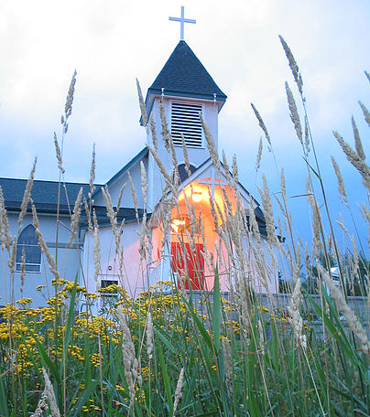

Confirmand Name _______________________________
Email _________________________________________

Here We Stand – Bible year (24-25)
Unit | Month | Here We Stand Topic | Facilitator | Meeting Date
1 | September | Intro to the Bible
2 | October | Prehistory and Patriarchs
3 | November | Moses
4 | December | Israel Becomes a Nation and  Message of the Prophets
6 | January | Jesus Birth and Early Life
7 | February | Jesus’ Ministry
8 | March | Jesus Teaches in Parables
9 | April | Holy Week and Easter
10 | May | Pentacost

Here We Stand – Small Catechism Year
Unit | Month | Here We Stand Topic | Facilitator | Meeting Date
 | September | Martin Luther & Reformation
 | October | Lord’s Prayer
 | November | Faith in Life Part 1
 | December | Apostle’s Creed
 | January | Faith in Life Part 2
 | February | 10 Commandments
 | March | Faith in Life Part 3
 | April | Sacraments
 | May | Faith in Life Part 4

Church Participation
 | Activities (Total of 3 required from 3 different categories) | What did you do?  What did you learn? | Date completed
 | Acolyte/Communion Assistant
 | Lector
 | Children’s Church
 | Special Music
 | Greeter
 | Serve Coffee
 | Church Fall Dinner
 | Assist in baking of communion bread
 | Church Picnics
 | Other

Service to Others
 | Activities (2 required) | What did you do?  What did you learn?  Attach Summary of activities | Date completed
 | Julebyen
 | Food Shelf
 | Neighbor 2 Neighbor work day
 | Other Possibilities | Outside Reading  Movies … How does it relate to Christianity and/or Lutheran Doctrine?  - Write and submit brief summary  - What did you learn  - What did you already know  - Would you recommend it to others?  Yard work for members . . . members donate to church, Barnyard, etc.

Activities
 |  |  | Date completed
 | Obtain monthly requirements from KRLC website | Review monthly requirements  - Answer questions  - Provide overview information
 | Complete 4 sermon note summaries. Recommend in person, but can also review streamed services available on the WEBsite | - Complete sermon note worksheet and submit to confirmation coordinator. Worksheet can be obtained from KRLC website | 1.  2.  3.  4.

Make up sessions: In the event a confirmand must miss an in person session, a parent will send written confirmation to the facilitator and coordinator that the lesson was completed.

Note: Bring materials to monthly meetings. Church participation and service activities may be completed in any order. Once completed, send to coordinator. Explore and enjoy the activities of KRLC. Thank you for your participation.

