KNIFE RIVER LUTHERAN CHURCH CONFIRMATION

General Information

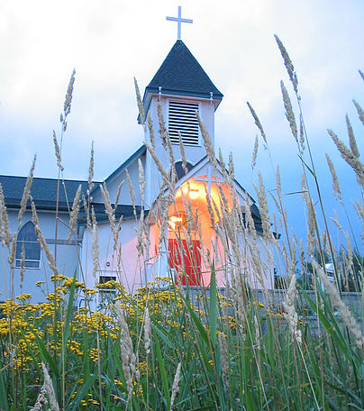

Team Members
Helene Hedlund, Program Coordinator | hhedlund.dl@gmail.com
Lawrence Burkhard, Christian Ed Chair | lawrenceburkhard@yahoo.com
Pastor Susan Berge | kniferiverchurch@gmail.com
Pastor Phil Berge | philip.berge@gmail.com
Nancy Dent, Tech Coordinator | nanid740@gmail.com

Program Overview

KRLC will host its’ own confirmation program
- Utilize Hear We Stand curriculum
- Cost:
  - Church Endowment will provide materials to each student
- 2-year format
- Target age: 7th, 8th and 9th Graders, adults welcome
- Utilize flexible delivery format, including but not limited to:
  - In person (preferred)
  - ZOOM meetings
  - Telephone Conference
- Meetings once each month
  - 3rd Wednesday of month at 6:30
  - Meeting location: KRLC
- Parent support encouraged and welcome
Church Service Requirements.
Confirmands are required to attend (in person or via livestream) 4 worship services. Confirmands can access worship and sermons on KRLC website. A sermon worksheet is required for applicable services. The sermon take away is located on KRLC website.
Outside Activities
- Confirmation activities will be enhanced with reinforcement activities, including but not limited to:
  - Church participation
  - Service to Others
  - Other as determined by Team
Process:
- Students will receive topic information/activities each month prepared by monthly facilitator. Materials will be available by the 1st week of each month on KRLC website, www.kniferiverlutheran.church/confirmation
- Facilitator will . . .
  - Facilitator will post lesson requirements. Questions about posted materials should be addressed to facilitator assigned for that specific month.
- Students will meet with topic facilitator monthly (dates TBD) and other interested persons to discuss monthly information
- Confirmands need to bring sermon notes to class

Contact kniferiverchurch@gmail.com or hhedlund.dl@gmail.com with questions and/or to express interest in participating.
​

