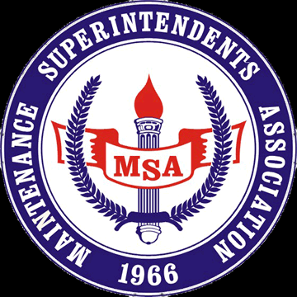

Redwood Empire Chapter
SAVE THE DATE- May 4th, 2022
TO OUR VALUED MSA VENDORS:
It's that time of year when the Redwood Chapter of the MSA will be hosting the 35th annual Vendor Appreciation Day & Equipment Show. Participating will be our local county, cities & utility district employees.
Our expanded vendor display area has been secured at the Rohnert Park Community Center 5401 Snyder Lane, Rohnert Park, CA (please see attached overview map). Vendors will have plenty of room to display their products and equipment. We expect approximately 75-100 various agency employees to be in attendance, so don't miss this opportunity to participate and show your products. Mark your calendars for May 4th, 2022.
The MSA Vendor Appreciation Day is a free event to our registered vendor membership. The MSA sponsors scholarships for college bound students of our membership and your donation of $150.00 will help keep this scholarship funded and would be most appreciated. Your day will include a delicious BBQ lunch prepared by the MSA.
Be prepared to supply your own tables, chairs, canopies, sun screen, electricity & power cords, as we are not able to supply these items. Bring your equipment to display, nothing is too large or too small and all is welcome. Attached is our registration form with a requested RSVP date of April 30th, 2022. Please send registration form & check to MSA C/O Bryce Newell, 4634 Mayhew Rd, Sacramento CA 95827.
Equipment set up time will begin at 9:00am with the event starting at 11:00am with breakdown after 1:00pm. The Raffle table is always a hit and with your help it will continue to be. If you are able to bring something to contribute as a raffle prize it would be most appreciated.
Again, we would like to thank you for supporting the Redwood Chapter of the Maintenance Superintendents Association and for any questions regarding this event please contact Bryce Newell at Bnewell@source-mme.com

Thank You,
Bryce Newell
Vendor Representative

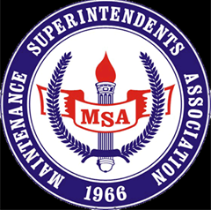

REDWOOD EMPIRE CHAPTER MSA
VENDOR REGISTRATION FOR
May 4th VENDOR APPRECIATION DAY
VENDOR REGISTRATION INSTRUCTIONS: Please fill out all information for our records and return by April 30th, 2022.
DATE:___________________
COMPANY NAME & ADDRESS: _____________________________________________________
_____________________________________________________
_____________________________________________________
BUSINESS PHONE: ___________________ EMAIL: ____________________________________
NUMBER OF LUNCHES NEEDED: __________________________
NAMES OF ATTENDEES: ____________________________________________________________
____________________________________________________________
SPACE SIZE: 20'X20’ FOR SINGLE - PLEASE ADVISE US IF YOU REQUIRE A LARGER DISPLAY AREA.
MAKE ALL CHECKS PAYABLE TO: MSA REDWOOD EMPIRE CHAPTER & MAIL TO:
Redwood Empire MSA
C/O Bryce Newell
4634 Mayhew Rd
Sacramento, CA 95827

*MSA supplies the space & lunches only. Please remember to bring your own tables, chairs and any other supplies you may require along with a RAFFLE prize.
Thank you for your participation and we look forward to seeing you on May 4th in Rohnert Park.

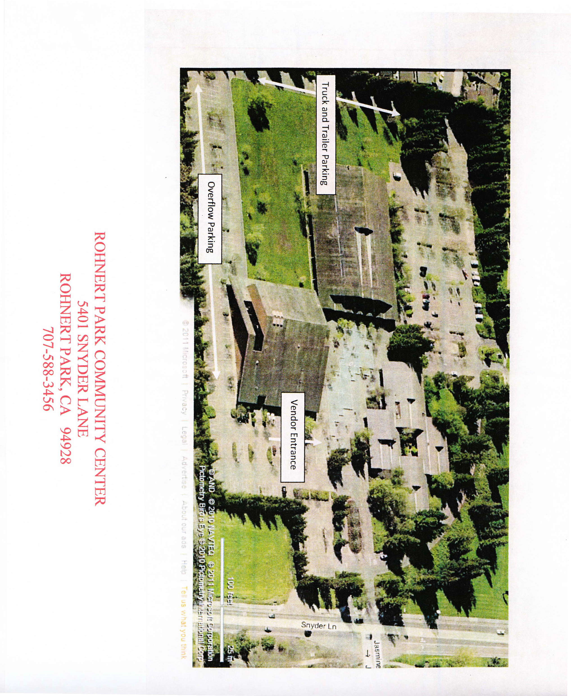

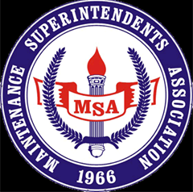

REDWOOD EMPIRE CHAPTER
MEMBERSHIP APPLICATION
(Online Registration available at redwoodempiremsa.org)

MEMBERSHIP TYPE AND ANNUAL FEE (PLEASE CHECK ONE BELOW)

REGULAR MEMBER ($50.00 PER YEAR) Public employees and supervisors
SUSTAINING MEMBER ($50.00 PER YEAR) Manufacturer's representative or vendor

INSTRUCTIONS: PLEASE FILL IN ALL INFORMATION FOR OUR RECORDS
NAME:________________________________________ DATE:___________________________
AGENCY/COMPANY:____________________________________________________________________
TITLE: ________________________________________________________________________________
CITY:____________________________________ State:________________ Zip:__________________
BUSINESS PHONE: __________________________________________
EMAIL ADDRESS:___________________________________________
MAKE CHECKS PAYABLE TO MSA REDWOOD EMPIRE CHAPTER
MAIL TO: MSA REDWOOD EMPIRE CHAPTER
C/O Bryce Newell
4634 Mayhew Rd
Sacramento, CA 95827

PLEASE CONTACT BRYCE NEWELL AT BNEWELL@SOURCE-MME.COM WITH QUESTIONS

