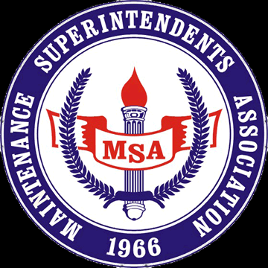

Redwood Empire Chapter
SAVE THE DATE - MAY 6th, 2020
To our Valued MSA Vendors,
It's that time of year and the Redwood Empire Chapter of the MSA will be hosting the 34th annual Vendor Appreciation Day & Trade Show/Training Symposium on May 6th in Rohnert Park. Participating will be our local county, cities & utility district employees.
Our expanded vendor display area has been secured at the Rohnert Park Community Center 5401 Snyder Lane, Rohnert Park, CA (Please see attached overview map). Vendors will have plenty of room to display their products and equipment. Last year we had a tremendous turnout and this year we expect approximately 125-150 various agency employees to be in attendance, so don't miss this opportunity to participate and show your products. Mark your calendars for MAY 6th, 2020.
The MSA Vendor Appreciation Day is a free event to our registered vendor membership. The MSA sponsors scholarships for college bound students of our membership and your donation of $150.00 will help keep this scholarship funded and would be most appreciated. Your day will include a delicious BBQ lunch prepared by the MSA.
Be prepared to supply your own tables, chairs, canopies, sun screen, electricity & power cords, as we are not able to supply these items. Bring your equipment to display, nothing is too large or too small and all is welcome. Attached is our registration form with a requested RSVP date of April 15th, 2020. Please send registration form & check to MSA C/O Veronica Brierley 922 Machin Ave, Novato CA 94945. You can also pay on May 6th!
Equipment set up time will begin at 9:00am with the event starting at 11:00am with breakdown after 1:00pm. The Raffle table is always a hit and with your help it will continue to be. If you are able to bring something to contribute as a raffle prize it would be most appreciated.
Again, I would like to thank you for supporting the Redwood Empire Chapter of the MSA. Please don’t hesitate to contact me with any questions about this event. I hope to see you all in May!

Sincerely,
Bryce Newell, Chapter President
(916) 396-0880 or bnewell@source-mme.com
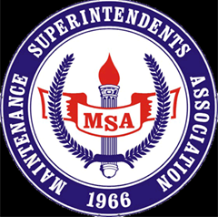

REDWOOD EMPIRE CHAPTER MSA
VENDOR REGISTRATION FOR
MAY 6th VENDOR APPRECIATION DAY
VENDOR REGISTRATION INSTRUCTIONS: Please fill out all information for our records and return by April 15th, 2020.

DATE: ___________________
COMPANY NAME & ADDRESS: _____________________________________________________
_____________________________________________________
_____________________________________________________
BUSINESS PHONE: ___________________ EMAIL: ____________________________________
NUMBER OF LUNCHES NEEDED: __________________________
NAMES OF ATTENDEES: ____________________________________________________________
____________________________________________________________
SPACE SIZE: 20'X20’ FOR SINGLE - PLEASE ADVISE US IF YOU REQUIRE A LARGER DISPLAY AREA.
MAKE ALL CHECKS PAYABLE TO: MSA REDWOOD EMPIRE CHAPTER & MAIL TO:
City of Novato Public Works
922 Machin Avenue
Novato, CA. 94945
Attn: Lyle Waite/Veronica Brierley

*MSA supplies the space & lunches only. Please remember to bring your own tables, chairs and any other supplies you may require along with a RAFFLE prize.
Thank you for your participation and we look forward to seeing you on May 6th in Rohnert Park.

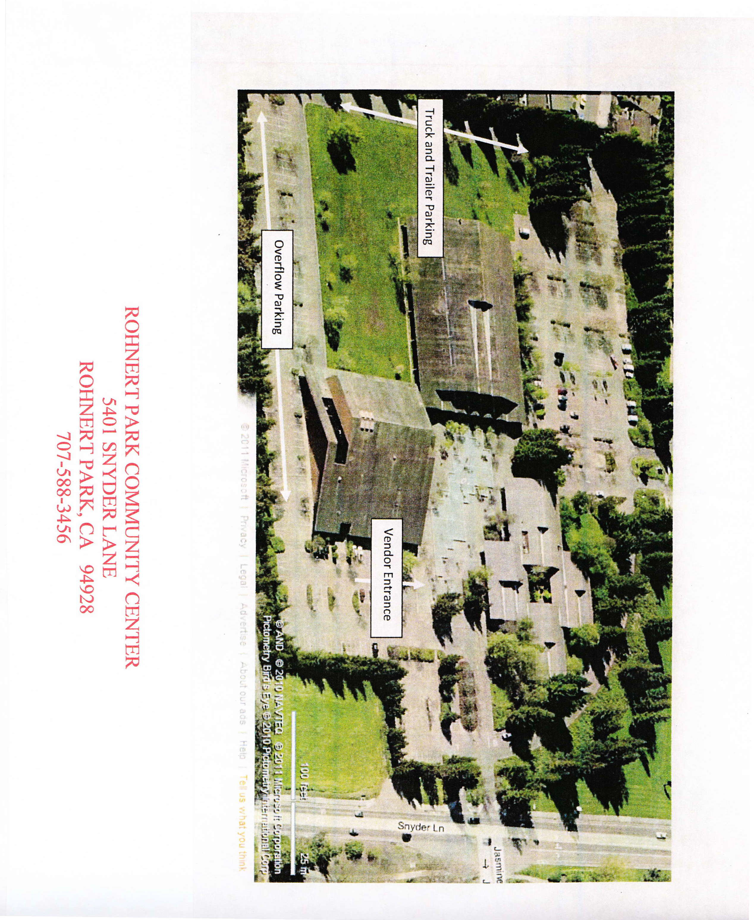

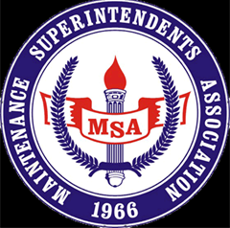

REDWOOD EMPIRE CHAPTER
MEMBERSHIP APPLICATION
MEMBERSHIP TYPE AND ANNUAL FEE (PLEASE CHECK ONE BELOW)
REGULAR MEMBER ($50.00 PER YEAR) Public employees and supervisors
SUSTAINING MEMBER ($50.00 PER YEAR) Manufacturer's representative or vendor

INSTRUCTIONS: PLEASE FILL IN ALL INFORMATION FOR OUR RECORDS
NAME: ________________________________________
DATE: ___________________________
AGENCY/COMPANY: ____________________________________________________________________
TITLE: ________________________________________________________________________________
CITY:____________________________________ State:________________ Zip:__________________
BUSINESS PHONE: __________________________________________
EMAIL ADDRESS: ___________________________________________
MAKE CHECKS PAYABLE TO: MSA REDWOOD EMPIRE CHAPTER
MAIL TO: City of Novato Public Works
922 Machin Avenue
Novato, CA. 94945
Attn: Lyle Waite/Veronica Brierley

SHOULD YOU HAVE ANY QUESTIONS PLEASE CONTACT GREG D’AMBROGI AT Gdambrogi@aol.com

