Art in The Garden*
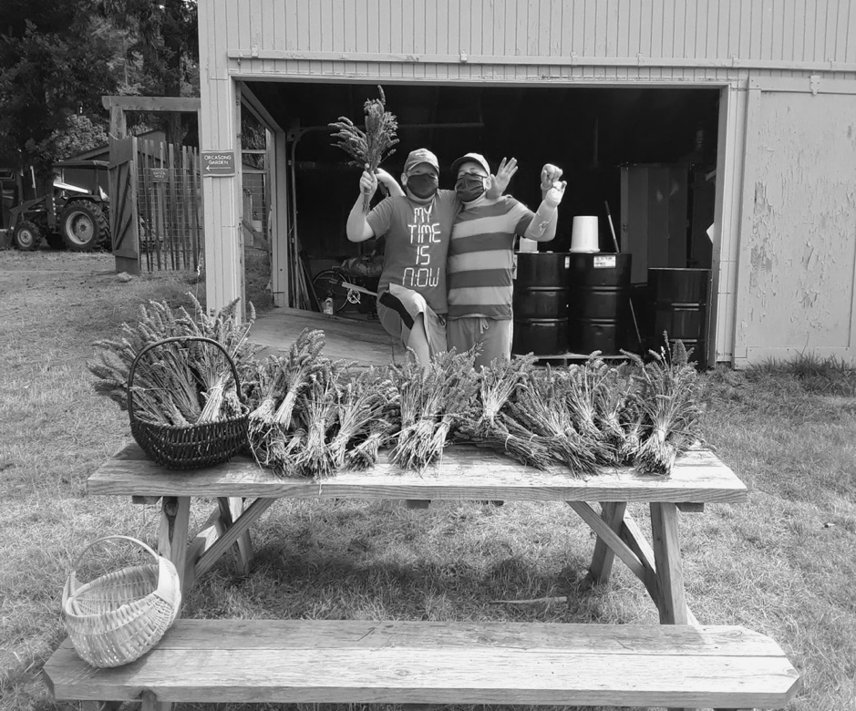
Grade Level
6 - 8 (Can be adapted for Elementary or HS)

Lesson Length
2 hours for all four lessons (or broken down into shorter sessions)

Choose your own garden, park, forest or public garden. This is a good chance for a field trip and an opportunity to explore and observe nature. Allow about 2 hours to include all 4 lessons. It can be done separately if your garden or park is close and your time is limited. Dress for the weather and be ready to sit on the ground. Bring blanket or pad if desired. And good walking shoes if you are hiking.
Materials Needed:
- Pencil, eraser, and pen.
- Unlined paper. Drawing paper or pad is best.
- Otherwise copy paper will do. (Cut in half and clip to notebook or clip board. (A good chance to recycle).
- Magnifying glass
- Camera or phone that takes photographs.
Resources:
The following are some resources to improve drawing skills. These can be viewed prior to art walk through the garden or park.
Note: Replace with other videos if these videos aren’t accessible in your region.
Ted Talk "Drawing from Nature”, Ralph Ammer: https://www.youtube.com/watch? V=Za/TSCVP-ZO
“Mother Nature Decoded” New York Times: http://https//opinionator blogs.nytimes.com/ 2010/10/14/mother-nature-decoded/

If you are including Assemblage in this field trip view this video of Andrew Goldsworthy before: https://www.youtube.com/watch?v=FPDH8yCniko

Lesson One: A Close-up View
Objective: Students will learn how an artist uses her/his observation skills to draw natural details in a garden, forest or park. Like Georgia O'Keeffe, they will explore a close up of their natural object.
Procedure:
- Using a magnifying glass, have the students closely examine their object. Then ask them to sketch EVERYTHING they see in their magnified frame. If they do not have magnifying glass, they can look through a tube or their hands cupped as a looking glass. Another technique is using a phone camera if available to zoom in on the object. Tip: taking a picture might be helpful for later.
- Using pencils or illustrator pens, students should draw EVERYTHING they see in their magnified frame. They can use different lines to show texture and detail. Once students have completed 3 or 4 of these drawings, they are ready to move on to the next step, Lesson Two.

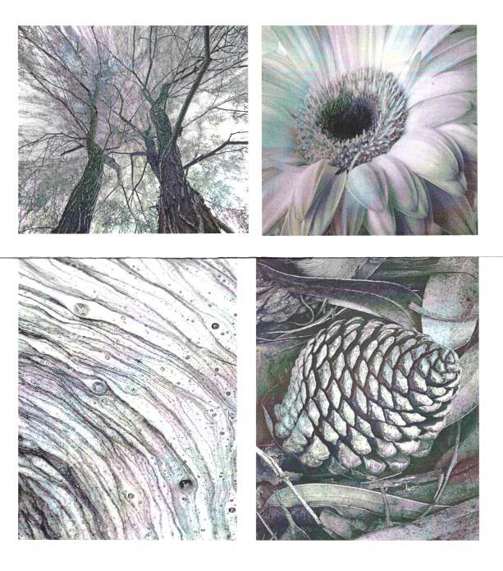
Lesson Two: Moving Back

Objective: Using their observation skills, students will carefully render a drawing that includes the whole plant.

Procedure:

- Now move back and try to capture a broader view of your favorite close-up. Example would be
the whole plant that includes your close-up flower, whole tree that includes your close-up leaf.

- Using pencil or illustrator pen draw from actual object. Show all of the parts of the plant.
Tips: Direct the students to spend more time with their eyes on
plant from farther back. This drawing and photograph can be used
as reference for Identifying the Parts of a Plant.

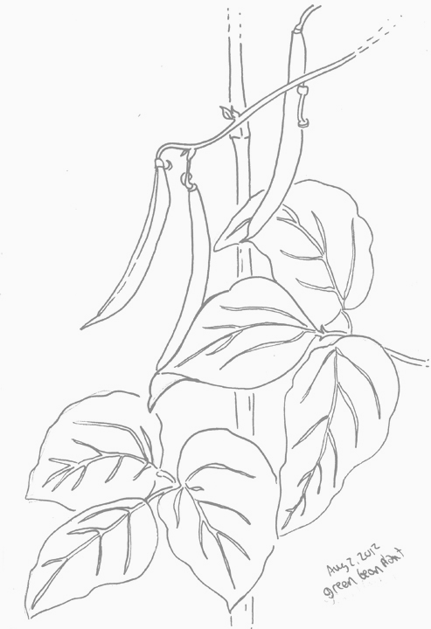
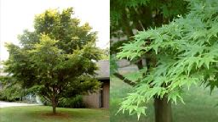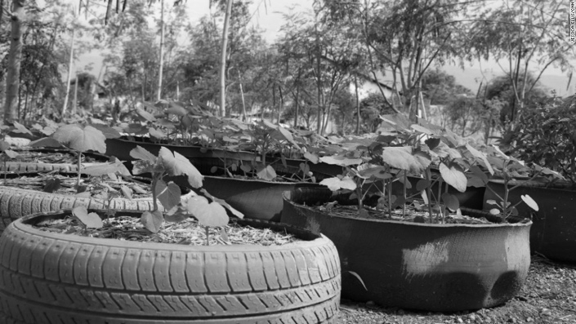

Lesson Three: Landscape
Objective: Students will photograph the environment in which their plant lives (the garden, park, forest etc. They will learn about horizon line, foreground and background.
Procedure:
- Stepping back even further, frame the environment in which your plant is living.Take several photographs from different views. Take at least 6 landscapes photos that you can reference later for painting.

- Note the horizon line, the foreground, and background and how these change as you alter your position as photographer.
Tip: Ideally your plant would nestle somewhere in this landscape. But you might find a more interesting landscape elsewhere in the garden or park.
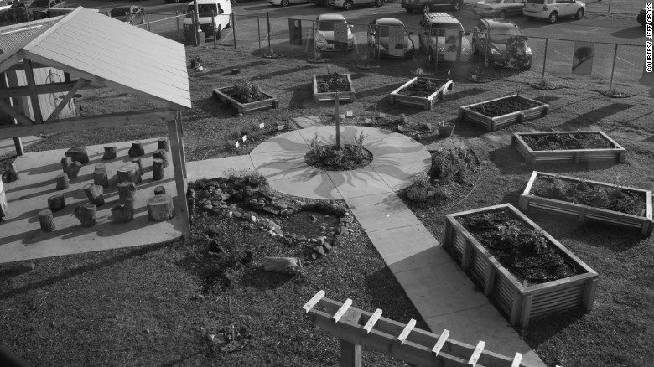

Lesson Four: Create an Assemblage or Temporary Sculpture
Using moveable objects in your natural environment create an assemblage. Use seeds, leaves, twigs, petals, stones, anything that will not disrupt the growing environment. This will be harder in a formal garden setting. Take several photographs. Then return objects to their original place.
Tip: Check out the artist Andrew Goldsworthy for inspiration.
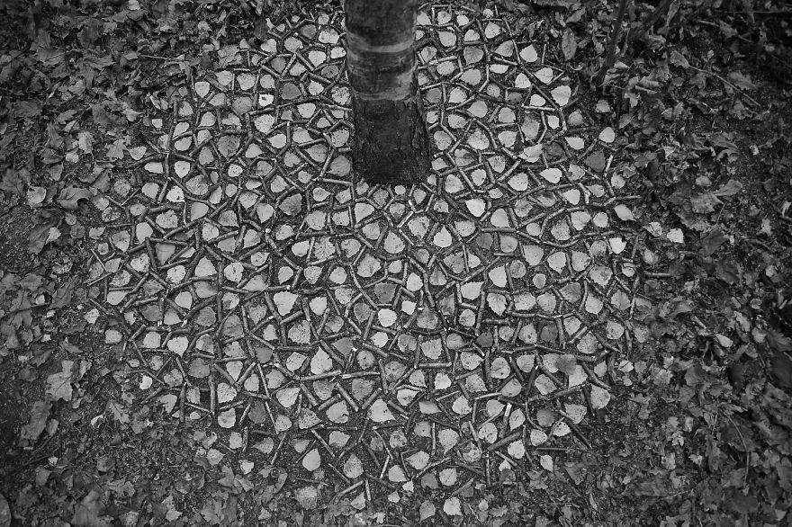

Connections to Social Action: Students all over the world are taking a major role in Climate Change. Using online resources, find showing how three examples of how youth and schools have supported this movement, particularly through the arts, (posters, murals, videos).

* A Kathy Calwell Lesson Adapted for FEAST

