Fun with Natural Plant Dyes!*

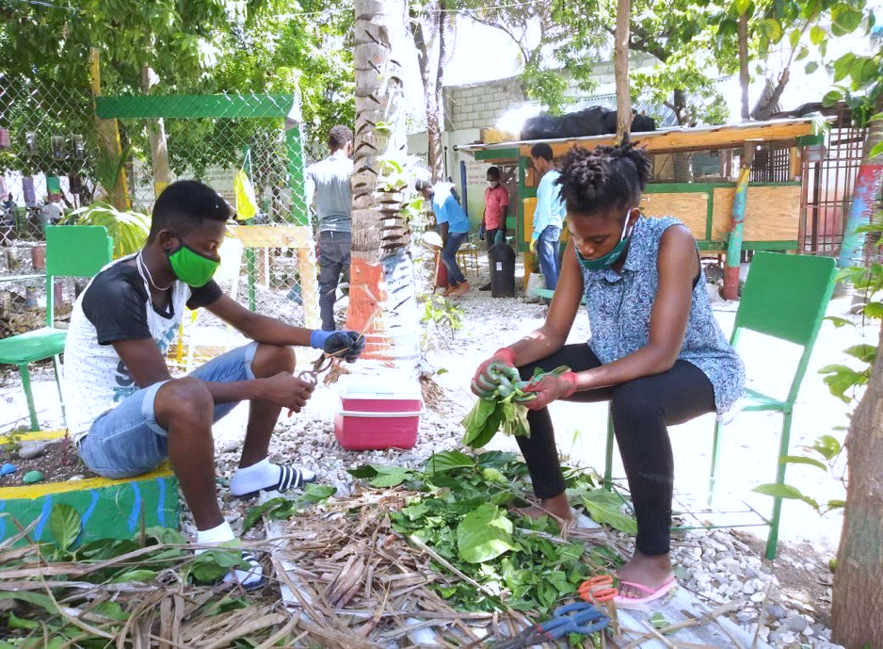
Grade Level
6 - 8 (Can be adapted for Elementary or HS)

Lesson Length
Multiple Days

Subjects:
Art, Math, Science

Objective:
Students will learn about natural plant dyes that can be found in nature and use inquiry-based science to see the evolution of dyeing.
Advance Preparation:
• Collecting plant materials and supplies, soaking plants
• Natural Plant Dyeing – 2-3 hours (get enough supplies for the following days)
• Dyeing with Heat – 1-2 hours

Tip: This activity needs access to water, electricity, and stoves

Introducing this Project: Start off activity by asking the students:
What is dye? Where can we find dyes?
Discuss the background/history of plant dyeing to get their minds warmed up. • When you think of tie dying you think bright, fun colors! I would remind the youth that the colors are going to be in the range of yellows, oranges, greens, and browns. Ask them why they think the colors are this way and not like traditional dye used for tie dyeing. This will start up conversations about the history of dyeing and how’s it’s evolved over the years.

Natural Plant Dyeing:
Objective:
The objective is to process dyes from plant materials in a natural way, use the dyebath to tie-dye a piece of cloth and record their results.
Materials:
• Containers to put the dyebath in (one for each plant material)
• An item to dye – small t-shirt, socks, cloth, bandana, etc.
• Plant material of your choice:
Examples are spinach, beets, red cabbage, strawberries, black walnuts, onion skins, blueberries,
and blackberries. Black walnuts and onion skins will have to be soaked the night before (the black walnut husks should be used).
• A mortar and pestle or rocks (for time’s sake a blender may be used)
• A stirring rod or spoon
• Cheesecloth or a sieve
• A measuring cup for water
• Access to water
• Knife to cut the plants
• Plastic or rubber gloves (some dyes may be staining)
• Rubber bands or string to tie up the cloth
• Disposable/plastic/washable tablecloths
• Plastic bags to carry the item home in (one per participant)
• Permanent markers (optional)
• A piece of extra cloth (optional - one per participant)
• Straws or eyedroppers (optional)
Procedure:
1. Explore some of the history of using plants as dyes. Talk about what it means to naturally extract plant dyes like they will be doing today.
2. Introduce each plant to the youth. Ask them what plant it is? Ask them what color dyes do they think they will produce?
3. Have students take the item that they brought in to dye and get it ready to be dyed. Use the rubber bands and the string to fashion patterns in the cloth. Let them be creative! (it’s good to do this step early before they get their hands messy with the plant dyes)
4. Now split the students into groups (depending on how many plants you have). Hand out the gloves. Let them get started smashing up the plants with the mortar and pestle or help them with the blender. Add water to the plants while smashing to make a dyebath.
o Note: If you are using black walnuts or onion skins, you will use the dye that extracted overnight.
o Smashing up beets may be hard if you have actual beets. Cut them up and place them into the blender or buy canned beets.
5. Smash up the plants until you have a liquid, smoothie-like mixture. You will want to strain the plant material out before dyeing your item. Pour the dyebath into the extra containers using the cheesecloth or the sieve. Line these up and get ready to dye!
6. Optional - A fun activity is to have them make a color chart before starting. They can use the eyedroppers or straws to put a small dot of the dye onto the extra piece of cloth. They can write the name of the plant next to the sample. This is an important tool for comparisons with other activities and as a reference for later.
7. In order to dye, students need to take turns using the dyebaths. They can dye different parts different colors or soak their whole item in one container. Let them be creative with the design.
8. Wring out excess dye and let it soak in for a while before you take the rubber bands off. (soaking it in water with salt helps). Eventually rinse it out and see the results. Allow to hand dry.
Check for Learning:
Where do dyes come from? Historically, how did people use plants as dyes? Why do you think that the dyes that we made with the natural process didn’t work very well?
Plant Dyeing with Heat:
Objective:
The objective is to process dyes from plant materials with heat, use the dyebath to tie dye a piece of cloth, and record their results.
Materials:
• A stove
• A pot that can hold 4 gallons of water (stainless steel will give the best results) • An item to dye – small t-shirt, socks, cloth, bandana, etc.
• Plant materials: Examples are black walnuts, onion skins, goldenrod, Queen Anne’s Lace,
blackberries and Zinnia, marigold, or coreopsis flowers.
• A stirring rod or spoon
• Cheesecloth or a sieve
• A measuring cup for water
• Access to water
• Knife to cut the plants
• Plastic or rubber gloves (some dyes may be staining)
• Rubber bands or string to tie up the cloth
• Disposable/plastic/washable tablecloths
• Plastic bags to carry the item home in (one per participant)
• Permanent markers (optional)
• A piece of extra cloth (optional - one per participant)
Check for Prior Learning:
What is dye?
How do you think heat will affect the outcome of our dye?

Black Walnut ~ Preparation for dyeing:
- Go collect nuts when the fall from the trees in the fall. Collect about a bushel of nuts. They will be bright green still. It’s advised to wear gloves when harvesting black walnuts.
- The nuts need to be broken open either by a hammer or placing them in a location where they can be run over by cars for a couple days (do not allow the youth to partake in this). Collect the broken husks until you can fill a pot 12 quarts or larger around two-thirds of the way with husks.
- Pour water over the husks so they’re completely covered and let them steep overnight. Place the pot on the stove and boil for an hour or longer. You need to watch the pot as to replace water as needed. The dyebath will be complete when the liquid is extremely dark brown. Let cool and strain out the husks from the dyebath.
Dyeing:
- Place the pot back on the stove and bring it to a boil.
- While waiting for the dyebath to boil, have the youth get their cloth ready for dyeing by using the rubber bands and string again to make patterns. 6) Soak your cloth in water before placing the clean, fully wetted cloth into the dyebath. Simmer for about a half an hour. Gently stir the dyebath with a rod/spoon from time to time.
- Remove the cloth on a rod and let it drip over the dyebath.
- Let the dye soak in and then take off the rubber bands/string and rinse.
- Hang in the sun to dry.
Goldenrod ~ Preparation for dyeing:
- Collect a paper grocery bag full of flowers. You should harvest goldenrod when the flowers are almost in full bloom.
- To create a dyebath, wrap the flower heads and stems in cheesecloth, cover this with water.
- Simmer 2 pounds of flower heads and stems for ½ hour. Be careful not to get leaves in with the flowers and stems. Boil till the dyebath is golden yellow!
- Remove the cheesecloth and plant materials and add enough hot water to make the dyebath 4 gallons.
Dyeing:
- While waiting for the dyebath to boil, have the youth get their cloth ready for dyeing by using the rubber bands and string again to make patterns. Soak your cloth in water before placing the clean, fully wetted cloth into the dyebath. Simmer for about an hour. Gently stir the dyebath with a rod/spoon from time to time.
- Remove the cloth on a rod and let it drip over the dyebath.
- Let the dye soak in and then take off the rubber bands/string and rinse.
- Hang in the sun to dry.
Onion Skins ~ Preparation for dyeing:
- Collect 2 pounds of onion skins. You can usually get them from the produce managers at grocery store if you smile and say please ☺
- To create a dyebath, wrap the skins in cheesecloth, cover this with water.
- Simmer for ½ hour. Boil till the dyebath is yellow.
- Remove the cheesecloth and plant materials and add enough hot water to make the dyebath 4 gallons.
Dyeing: (follow Goldenrod steps)
Blackberries ~ Preparation for dyeing:
- Collect 2 pounds of full ripe berries.
- To create a dyebath, wrap the skins in cheesecloth, cover this with water.
- Simmer for ½ hour.
- Remove the cheesecloth and plant materials and add enough hot water to make the dyebath 4 gallons.
Dyeing: (follow Goldenrod steps)
Zinnia, Marigold, or Coreopsis ~ Preparation for dyeing:
- Collect 2 bushels of flower heads.
- To create a dyebath, wrap the skins in cheesecloth, cover this with water.
- Simmer for 1 hour.
- Remove the cheesecloth and plant materials and add enough hot water to make the dyebath 4 gallons.
Dyeing: (follow Goldenrod steps)
Queen Anne’s lace ~ Preparation for dyeing:
- Collect 1 bushel of heads and stems.
- To create a dyebath, wrap the skins in cheesecloth, cover this with water.
- Simmer for 1 hour.
- Remove the cheesecloth and plant materials and add enough hot water to make the dyebath 4 gallons.
Dyeing: (Follow Goldenrod steps)
Expand activity:
• Plant a dye plant garden – have the children research which plants they would want to include in their garden, which plants can grow in their area, and make the layout.

• Go on a plant hunt! Allow the children to think of other plants that they think might make good dyes. What colors would they make? How should we prepare the dye? • Try dying with a commercial dye and compare its results (ex. Rit® Dye).

*A Cornell University Cooperative Extension Lesson adapted for FEAST

