Why Does Organic Matter Matter?*

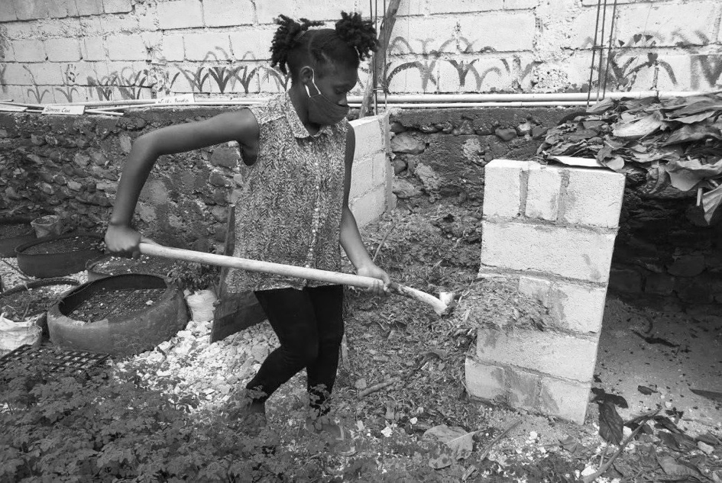
Grade Level
6
Lesson Length
Rotating stations
60 + minutes

Subjects: Science, Math, Language Arts

Objective: Describe soil as consisting of weathered rocks and decomposed, organic material.
Essential Question: What is organic matter, and what is its role in soil?
Teacher Note: This lesson plan is a lab experiment in which students learn about organic material in soil by conducting a series of small experiments and observations. It should take place after they have been introduced to the components of soil.
Tip: Some of the experiments might be better as demonstrations.
Lesson: Review rules for working and learning in the school garden. Demonstrate each learning station (described below), and establish clear rules for each, as well as how students will rotate through them. Hand out student worksheets.
Learning Activity: (student hand-outs below)
Station 1 - Hands-on Organic Soil: At this station, students will describe the physical attributes of organic soil. They will compare texture, color, and smell of each soil. Set up two containers; one containing poor soil, and one high in organic matter (or simply compost). Set out several magnifying glasses.

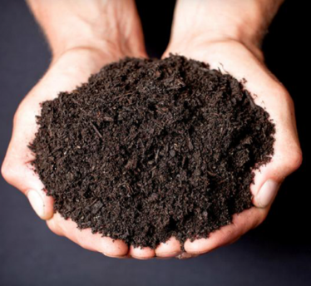
Station 2 - Field Test for Organic Soil: Here, students will learn how to complete a field test for organic matter in soil using hydrogen peroxide. Hydrogen peroxide reacts with carbon in organic soils and will bubble when added to soil. The intensity of bubbling and length of the reaction indicate the quantity of organic matter. This works best with several soil samples, so that students can compare levels of organic matter.
Students will need samples of at least two soil types, one poor in organic soil and one rich in it. If possible, have more than two samples: pick soils different locations such as a forest, school garden, school grounds.
Each group of students will need enough of each sample to fill approximately ¼ of a paper cup, cups for each group, smaller cups with 3-4 tablespoons of hydrogen peroxide (enough for each group to have one for every soil sample), coffee stirrers (or other tool), and a timer.
Students will add hydrogen peroxide to each soil sample, begin timer, and stir to mix materials. Test results will be recorded on their worksheets.
Station 3 - Organic Soil Has High Water-holding Capacity: At this station students will learn that soil with more organic matter has more moisture holding capacity. This station will need samples of the soils used at station one (each group will need 1 cup of each soil type), two Styrofoam cups with 5-6 holes punched in the bottom, and two measuring cups.
Students will fill a Styrofoam cup with one cup of soil. While holding the Styrofoam cup over measuring cup #2, students will use measuring cup #1 to pour 1 cup of water into the soil. As soon as water stops dripping heavily from the bottom of the Styrofoam cup, students will record the amount of water in measuring cup #2 and calculate how much water the soil absorbed.
Station 4 - Organic Soil is Fertile: Here, students will learn how organic material affects the fertility of soils. Provide small pots, potting soil, a soil poor in organic material, and a quick sprouting seed such as a bean or sunflower. Simply have students fill two pots, one with each soil type, and plant one seed in each. Water, and put in sunny window or greenhouse. Students will make predictions about which will grow better, and track progress of each plant.
Station 5 - Organic Soil Has Better Structure: At this station students will examine the porosity of various soils and make inferences about soil structure. Fill two 5- gallon flowerpots with the same soils from station 1 (both types: poor soil, and one high in organic matter or compost). Cut two-inch diameter PVC pipe into two 4-inch pieces. Place one in each pot, opening facing up, 2 inches deep.
Supply a 2-liter bottle, a water supply, and a timer. Students will fill the 2- liter bottle with water, and as one student place the bottle spout side into the PVC pipe, the other student will begin the timer. They will stop the timer when the bottle is empty.
Generally organic soils have better structure, thus higher porosity. Thus, in this experiment, the organic soil should allow the bottle to empty quicker because of higher percentage of air in the soil.
Tip: This experiment can be messy. It may be better to complete this experiment as a demonstration.
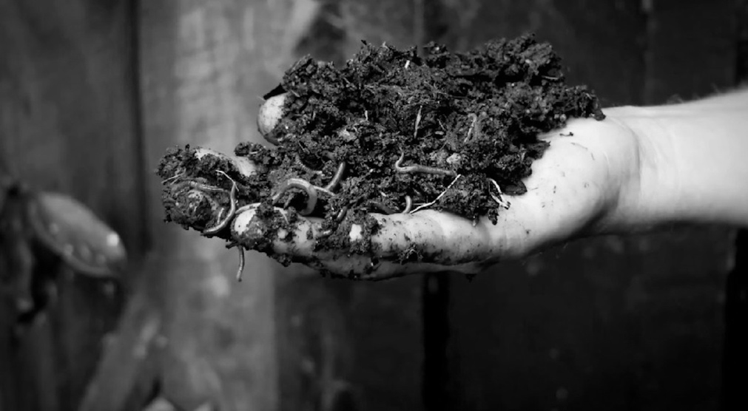
Station 6 - Organic Soil Is Alive: At this station, students will look for evidence that the garden soil is “alive.” Allow students access to the school garden or compost area (preferable) to look for earthworms, pill bugs, and other insects that live in healthy soil.

Check for Understanding:
Discuss student experiments for each station, data collected, and implications about organic soil. Continue to collect data for the fertility test began at station four. Grade papers as a formative assessment.

Why Organic Matter Matters / Student Handout
Station 1: Look at the two soil samples. Compare and contrast below. How does each soil look, feel, and smell?
Station 2: Sometimes scientists complete field tests to gain quick information when it is not convenient to complete lab tests. A field test to measure how much organic material is in soil can be completed with hydrogen peroxide. The hydrogen peroxide reacts with carbon (organic matter) in the soil; a gas (carbon dioxide) is released which makes the soil fizz and bubble. Scientists determine a rough estimate about the levels of organic matter in soils by noting the intensity and length of bubbling.
Procedure: Start the timer as you pour the hydrogen peroxide into the soil sample. Stir with coffee stirrer to mix well. Record the time elapsed before fizzing stops. Record observations; was there a notable reaction? how fast or slow did the reaction happen? Repeat for each soil sample.
Sample 1: Soil Description:________Time:______
Observations:___________________________________________________________________________________________________________________________ __________________________________________________________________
Sample 2: Soil Description:________Time:______
Observations:_____________________________________________________________________________________________________________________________________________________________________________________________

Sample 3: Soil Description:________Time:______
Observations:_____________________________________________________________________________________________________________________________________________________________________________________________
Which soil do you think had the most organic matter? _________
Why? _____________________________________________________________ __________________________________________________________________ _________________________________________________________________
Station 3: At this station, you will test the role of organic matter in affecting soil water-holding capacity (the ability of soil to soak up water). First, fill one of the empty Styrofoam cups with one cup of a sample soil. Next, while holding the cup over measuring cup #2, pour 1 cup of water from measuring cup #1 into the cup of soil. When water stops dripping from the bottom of the cup, measure the amount of water in measuring cup#2. Repeat this for each soil sample.
How much water was absorbed in the soil with high organic material? (hint, subtract the amount of water in measuring cup#2 from the original 1 cup of water) __________
How much water was absorbed in the soil with minimal organic material? ________
What do you think is the effect of organic material on soil’s water-holding capacity? _____________________________________________________________ _____________________________________________________________ _____________________________________________________________ _____________________________________________________________ _____________________________________________________________
Station 4: At this station you will conduct an experiment to determine if organic matter effects fertility. Fill one cup 3⁄4 of the way with soil high in organic matter, and the second cup 3⁄4 of the way with soil low in organic matter. Plant a seed in each cup and water. You will observe these over a couple of weeks and see if either one is growing significantly more than the other is.
Do you think one plant will grow better than the other? Why?
_____________________________________________________________ _____________________________________________________________ _____________________________________________________________

Week 1:
Plant 1 - _____ cm./in.
Plant 2 - _____cm./in.
Week 2:
Plant 1 - _____ cm./in.
Plant 2 - _____cm./in.
Week 3:
Plant 1 - _____ cm./in.
Plant 2 - _____cm./in.
Station 5: Quality soils are porous, meaning that there is space (air) in between the soil particles. Plants need this space to grow properly and be healthy. At this station you will test to determine which soil is more porous. Fill the water to the top of the label with water. As one member of your group begins the timer, turn the bottle over into the PVC pipe in the first container. Stop the timer when the water has drained out of the bottle. Repeat with the second container of soil.
How long did it take for the water to drain into the container with organic soil? ______
How long did it take for the water to drain into the soil that is low in organic matter? _____
Which soil is more porous? _________________________________
Why do you think porous soil is good for plant growth?
_____________________________________________________________ _____________________________________________________________ _____________________________________________________________
Station 6: Organic matter is decomposed by a variety of species, some visible and too small to see. Decomposers often attract predators, creating a lively ecosystem. Use trowels and magnifying glasses to find evidence of soil life in the school gardens and compost bins. Sketch pictures of what you find below.

* a UGA extension lesson adapted for FEAST

