Precipitation, Evaporation, and Condensation in the Garden*
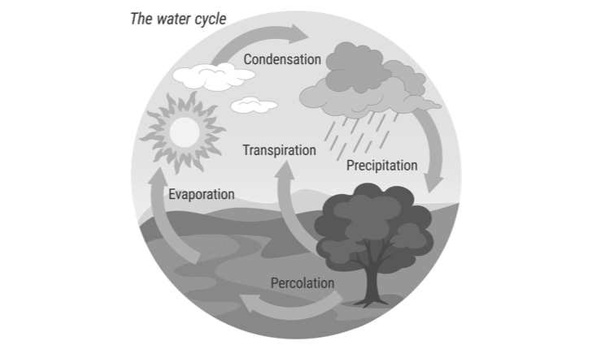
Grade Level
6
Lesson Length
60 minutes

Subjects:
Science, Art

Objective: Students will recognize the significant role of water in earth processes.
Essential Question: What are the parts of the water cycle?
Lesson Overview: Students will learn about the water cycle through an indoor modeling exercise, and then transfer the knowledge to a garden situation.
Interest Approach:
Review and ask class about where water is located on earth
How much of earth is water? 80%
How much of that is saltwater? 97.2%
How much of earth’s water is fresh water? about 3%
Out of that, how much is frozen? 2.15%
How much is water in lakes, rivers, groundwater, and in the atmosphere? .65%
How much is available for our use? Less than 1%
After review, ask students, “If we have less than 1% of water to use, why don’t we ever run out?”
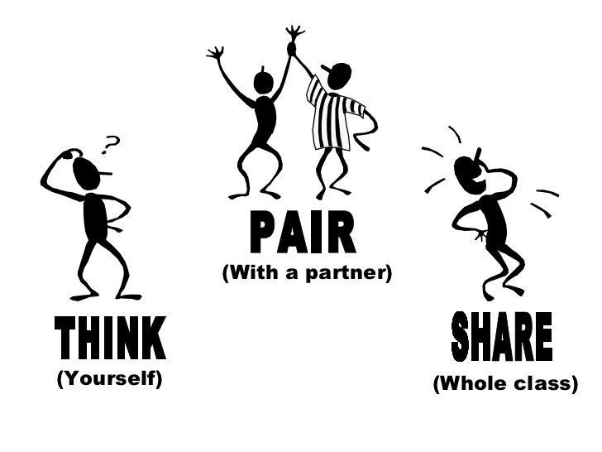
Think Pair Share: Let students discuss as a class, in pairs, or write and answer in their science notebooks
Discuss answers as a class and explain that today they will be learning why we don’t ever run out of water – the water cycle (you may have to explain that some places temporarily run out of accessible water, but the Earth always has the same amount).

Lesson:
Tell students that water does not run out because it is always in a cycle, in rains, the sun evaporates the water, eventually that water collects in clouds, and then it rains again. The water cycle affects weather and climate and makes life on earth livable.
As you explain the concepts of precipitation, condensation, and evaporation, and the water cycle make sure student have following information. You may have students to create a chart. Below is an example, but you may have students use the definition from their books, come up with a simpler definition as a class, and use their own and class examples.
Evaporation:
Technical Definition: to pass into vapor from a liquid state.
Classroom definition: when water turns into steam.
Examples: steam from boiling water, sweat evaporating to keep you cool, puddles on concrete drying up.
Part in the Water Cycle: Water evaporates from oceans, lakes, ponds, the ground, and even plants.

Modeling Activity (optional):
To quickly and effectively demonstrate precipitation, evaporation, and condensation, create a mini-model of the earth with a boiling pot of water. Use a glass pot so students can see what is going on inside. Tell students the Bunsen burner represents heat from the sun, and the water in the pot represents all the water on Earth.

The excess air and the lid represent the atmosphere. As the water in the pot boils, students should be able to see both evaporation and condensation with ease and point out water droplets forming on the lid and dropping down into the water as an example of precipitation. Have water warming during the lesson portion, so that is ready for students to see.
Learning Activity: Go over class rules for working and learning in the garden.
- Take students outside equipped with a white sheet of construction paper, color pencils, and clipboard or other firm surface (if there are not picnic tables or an outdoor classroom near the garden).

- Ask students where evaporation is happening in the garden. Go over student answers and point out garden beds, and plants, and, if it is a sunny day, even sweat from students!

- Ask where condensation would occur (clouds), and how precipitation happens (rain).

- Have students sit somewhere in the garden and draw a model of the water cycle based on the garden. This can be done individually, in pairs, or small groups (with bulletin board paper) depending on class needs.
- Encourage students to go into details, such as precipitation going into rain-barrels and nearby catchment ponds in addition to watering the plants. Make sure students draw and label each part of the water cycle and have arrows to direct the order of the steps.
Check for Understanding: At the end of class, have a few students or all the groups present their depiction of the water cycle. Option to do a gallery walk of each group’s depiction of the garden’s water cycle.

- * A UGA Extension lesson adapted for FEAST

