Worms!*
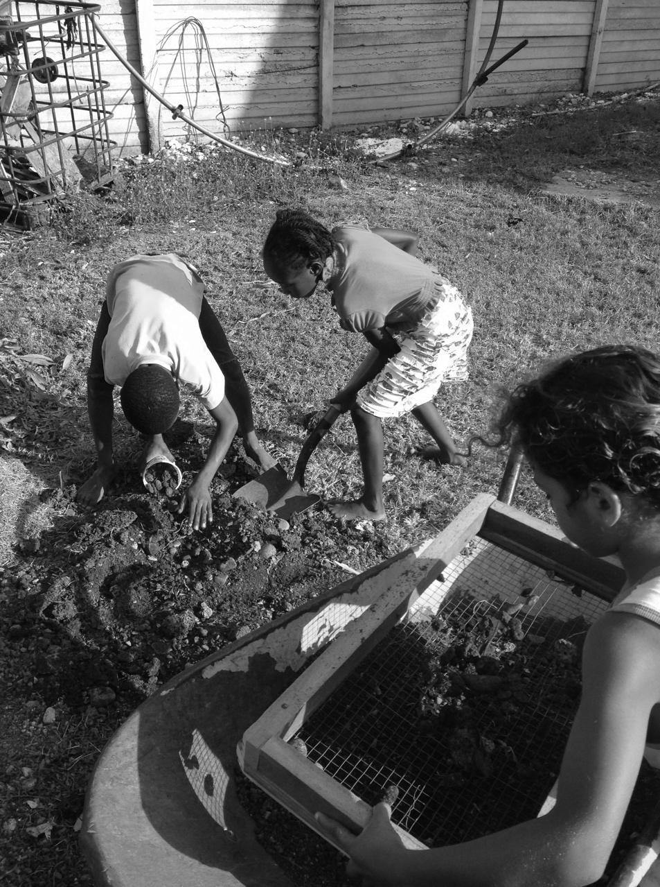
Grade Level
6 - 8 (Can be adapted for Elementary or HS)

Lesson Length
40-60 minutes

Subjects: Science, Math, Language Arts

Vocabulary:
Matter, nutrients, invertebrate, decomposer, habitat
Materials:
∙ Plates or lids
∙ Hand lenses
∙ Worms
∙ Worm observation sheet (see materials section)
∙ Worm bin materials (optional)
∙ Animal classification cards (optional)
∙ Trowels and gloves

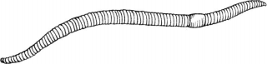
Objectives:
Students will be able to….
1. Identify the role worms play in the movement of matter.
2. Explain the importance of worms and decomposers in the garden habitat.
3. Describe a healthy garden ecosystem.
Through observation, games and compost building, students explore the role of worms in moving matter through their environment!
Garden soils are crawling with life. It’s all this life that makes the soil healthy and nutritious for the plants we grow. Garden creatures take organic matter, eat it, and then create waste that puts nutrients back into the soil where plants’ roots can access them. This is decomposition in action. Without it, no new soil could be created. Bacteria, fungi and hundreds of tiny invertebrates live in the soil. They not only create new soil, but also burrow through it, keeping the soil aerated, or in kid’s terms - light and fluffy. Of all of these creatures the easiest to spot and the most squeal- inducing is the worm!
Our common garden worms, or earthworms, are part of a huge phylum (or category) of animals called the Annelids (segmented worms). There are around 17,000 different types of segmented worms. These worms live all over the world, including marine environments. Even just the earthworms have 2,700 different species, but the three most common types are:

o Anecic (“up from the earth”) also known as Nightcrawlers - These worms build permanent burrows deep in the soil and take organic matter from the surface down into their burrows.
They are the longest of our garden worms with an average length of 18 centimeters (or 7 inches) and usually have a very distinct clitellum.

o Endogeic (“within the earth”) - These worms are very small with no coloration. They rarely come up to the surface of the soil and live in non-permanent burrows.

o Epigeic (“upon the earth”) also known as Red Wigglers - They live on the soil surface in decaying organic matter, which is also what they eat. They don’t make burrows, are reddish in color and are an average length of 4”.

Preparation:

Collect or purchase red wiggler or other worms.
Many of these types are actually not native to the US (though there is a lot of disagreement in the scientific community over how many are introduced). The nightcrawler for example was introduced from Europe. There is some worry that the introduction of worms has changed the landscape of native habitats in ways we don’t yet understand, but for the purposes of gardening, worms are a great creature to have around!
Worm anatomy is fairly simple in comparison to ours but makes them amazingly well adapted for life in the soil. For more information about worms, some great resources are Worms Eat Our Garbage and “The Adventures of Herman” http://urbanext.illinois.edu/worms/ through the University of Illinois Extension Service. Both are full of kid-friendly facts about worms.
Procedure:

Explain that today you are focusing on a very important garden creature. Let students think, pair and share a brainstorm of everything they know about worms.

As students share information, be sure to capture the following concepts:
∙ Their habitat is in soil
∙ They help plants by making tunnels for air and water to travel through as well as adding nutrients to the soil
∙ They eat dead and decaying matter (they are decomposers) and turn it into compost which feeds the plants
∙ There are many types of worms in the world
∙ Worms have no bones, thus they are invertebrates
Worm Observations:

Explain to students that they are going to be observing worms scientifically. (They will be making observations and hypotheses based on those observations so they can learn about their worms.) Inform students that worms are pretty fragile creatures and so it is very important that they be gentle with them while observing them. Pass out a plate with a worm, and a magnifier to students. Following the Worm Observations sheet (found in the materials section) go through the questions and answers with students.
Next, ask students what worms eat. Many believe that worms eat soil but this is only partially true. Worms eat organic matter within the soil rather than inorganic matter such as minerals (rocks). Worms are so important because they consume dead and decaying matter and take it down to the roots of plants through their stomachs and deposit it as useable compost. The plants, in turn, absorb this transformed matter and the cycle continues.
Game Option 1: Worm, Centipede, Bacteria (based on Bear, Salmon, Mosquito)

During this game students will be modeling the movement of matter through the garden habitat. This game is an action version of rock, paper, and scissors:
- Worm beats Bacteria
- Centipede beats Worm
- Bacteria beats Centipede
These mimic the lifecycle of these compost creatures. Worms eat bacteria as they feed on organic matter, transforming it into energy and compost. Centipedes are worm predators and turn them into energy and transform their matter into their own bodies. When centipedes die, bacteria break them down into more useable matter which feed worms and once again, becomes compost. Teach students the hand signals for each of the creatures:

- Worm: one wiggly finger or wavy arm
- Centipede: antenna made with both hands
- Bacteria: an “O” shape made with both hands

Have students practice these hand signals and review who eats who, emphasizing the movement of matter between each of the creatures. Once students are clear on the “food-chain” and symbols you can begin the game.
Split into two teams. Each team will first pick whether they want to be Bacteria, Worm or Centipede. Everyone in the team needs to be the same thing. Once they have decided, they will come to stand at the starting line, back to back with the other team. When you say, “Invertebrate!” they will turn around and show their hand signal. Whichever team beats out the other, will chase the losing team back to their safe zone (a few yards away). For example, if one team was Centipede and the other was Bacteria, the Bacteria team will chase the Centipedes. Anyone who is tagged will go to join the team who tagged them. Then they play again. Eventually, everyone will be on one team and that team wins. If both teams pick the same creature for a round, it’s a draw and they both pick again.
Game Option 2: Decomposer Tag

In this game there are vegetables, people, and worms as the decomposers. Pick two students to be people and two to be worms. Everyone else is a vegetable. Within the playing area you set up, the people chase and try to tag the vegetables. Once tagged, the veggies sit down. They can only get back up to play more if a worm comes and “decomposes” (tags) them. Complicate this by allowing the people to tag worms too or adding in a worm predator like a robin. If worms are tagged, they too must sit down and can only be revived by another worm.
To wrap up either game, have students share with you how the food chain works with these decomposers. How is matter moved and cycled through this system?
Matter Matters! Building Soil with Decomposers:

Students can work on improving habitat for worms in their garden. A few options for garden work include sheet mulching, turning or adding plant matter to the compost pile, adding in nutrients to the soil, or fluffing any compacted areas in the garden. This is a great time to reinforce the idea of matter moving throughout the habitat: Plants gather matter from the soil and grow, then produce food or foliage which is consumed by animals or humans. The waste is then deposited once more on the soil, consumed by bacteria which feeds the worms, and is turned into available nutrients to feed plants once more.

Wrap Up:

To wrap up the day, gather back as a whole class. Ask students to share what they learned this day and what was their favorite part of the lesson. Next ask for someone to share how matter moves through the garden.

Adaptations:

To simplify: Work as a whole group doing worm observations indoors. Next come out into the garden and have groups simply work on garden related tasks and playing a game.
To add complexity /Scientific Classification: Get more into scientific classification and scientific names. Why do we classify things? Before you start the worm observations, give each group a set of cards with different animals on them. Give the students a limited amount of time to work together to group the animals however they think is best. This will help them start thinking about the differences and similarities between animals and their bodies.
Building a Worm Bin:

Bring in or build a small worm compost system with the students so they can see worms in action breaking down food waste. For this activity you will need a small Tupperware container with holes drilled in the lid, coconut coir or newspaper, and food scraps for feeding worms. To add even more complexity, you can bring in a scale and weigh the food scraps before adding them into the worm bin. After a few weeks you can dig out any remaining food scraps and weigh them with students to see how much of the food has been turned into compost.
Rainy Day:

This is a good activity for bad weather days as long as you go and collect the worms ahead of time. Start with the classification activity, then do the worm observations. You can finish out the time by having students draw up a cartoon or act out an explanation of how worms transform matter and contribute to the ecosystem through decomposition.

*A School Garden Project of Lane County adapted for FEAST

