MAKING SENSE OF CONFLICTING SIGNALS

JOBS DATA:

June 2025 ADP Jobs Data

June 2025 ADP Report: Private Sector Sees First Job Loss Since 2020.

In a surprising turn, the U.S. private sector shed 33,000 jobs in June 2025, according to the latest report from ADP. This marks the first monthly job loss since the early days of the pandemic in 2020, signaling a significant cooling of the labor market.

The service-providing sector bore the brunt of the losses, with a total decline of 66,000 jobs. The most significant drops were seen in professional and business services, which lost 56,000 jobs, and education and health services, which saw a decrease of 52,000. Financial activities also experienced a decline of 14,000 jobs.

In contrast, the goods-producing sector showed continued resilience, adding 32,000 jobs. Manufacturing led this growth with an increase of 15,000 jobs, followed by construction with 9,000 and natural resources and mining with 8,000.

Several service sectors still saw job growth, with leisure and hospitality adding 32,000 positions. Trade, transportation, and utilities added 14,000 jobs, while the information and other services sectors each saw a modest increase of 5,000.

Here is a breakdown of the sector-level changes in a bar

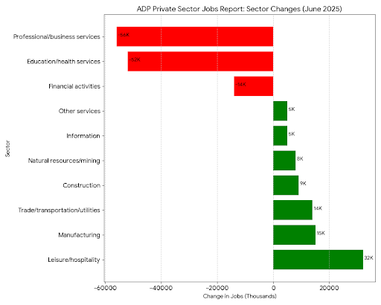

United States Non Farm Payrolls:

US nonfarm payrolls rose by 147K in June 2025, following an upwardly revised 144K in May and well above forecasts of 110K. The reading was also in line with the average monthly gain of 146K over the prior 12 months. Government employment rose by 73K, namely state government (47K), largely in education (40K). Employment in local government education continued to trend up (23K). On the other hand, job losses continued in federal government (-7K), where employment is down by 69K since reaching a recent peak in January. Also, health care added 39K jobs, similar to the average monthly gain of 43K over the prior 12 months, led by hospitals (16K) and nursing and residential care facilities (14K). Employment also increased in social assistance (19K).

Conclusion:

The June NFPR report continues to underscore a fundamentally resilient labor market in contrast to the ADP Report which focuses on Private Jobs Numbers Alone. Although NFPR numbers beat expectations, a slowdown could happen soon as uncertainty surrounding tariffs, trade, and immigration policies may lead many private employers to adopt a more cautious hiring stance.