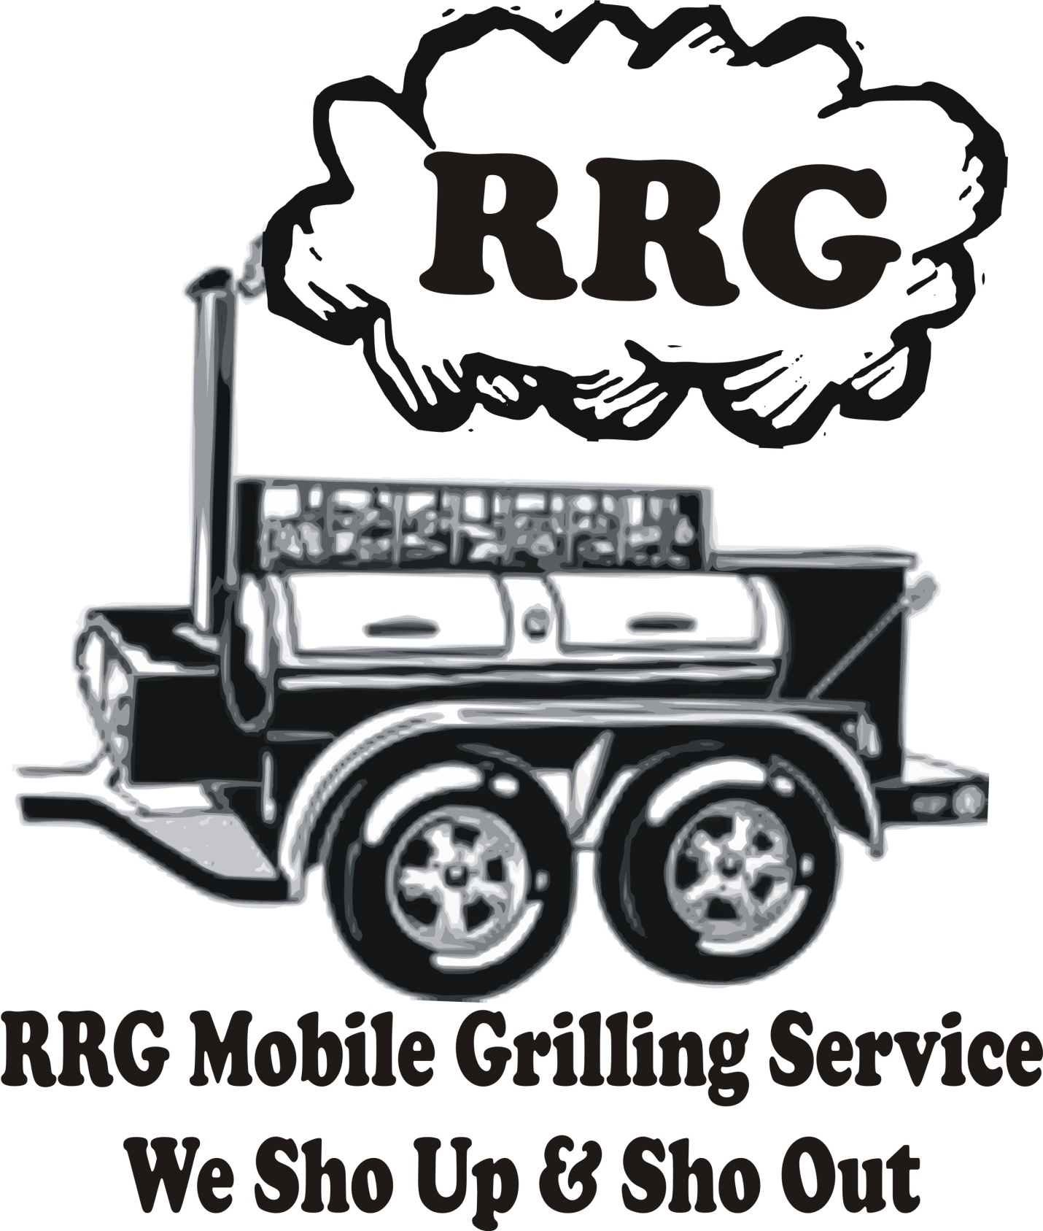

**678.614.2093**

**THE BEST SMOKED HAMS & TURKEYS YOU WILL EVER TASTE!**

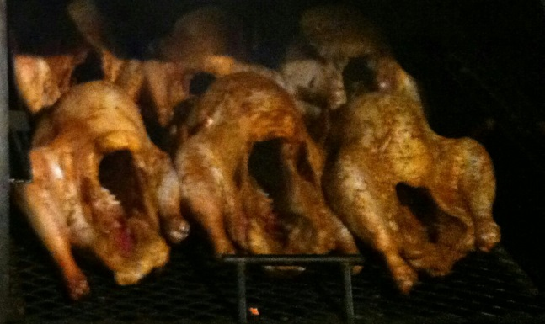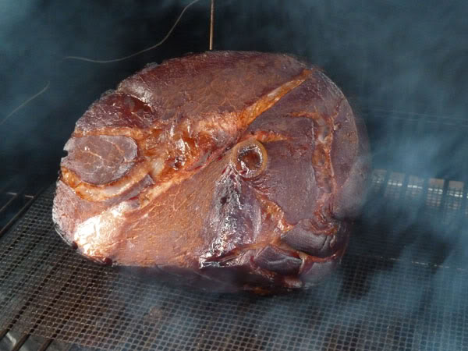

**PRICE (We Provide Meat): $50 PRICE (You Provide Meat): $35**

**ORDERS: Call or email at** [**rrggrillmasters@yahoo.com**](mailto:rrggrillmasters@yahoo.com) **to place orders. A 50% non-refundable deposit is required for all orders.**

**Thanksgiving orders will be taken up to Nov. 22th. Pickups and deliveries end on Nov. 25thby 9 am.**

**Christmas orders will be taken up to Dec. 20th. Pickups and deliveries end on Dec. 25th by 9 am.**

**There will be an additional $10 delivery fee for all deliveries within 25 miles**

**Any deliveries over 25 miles will be an additional $20 charge**