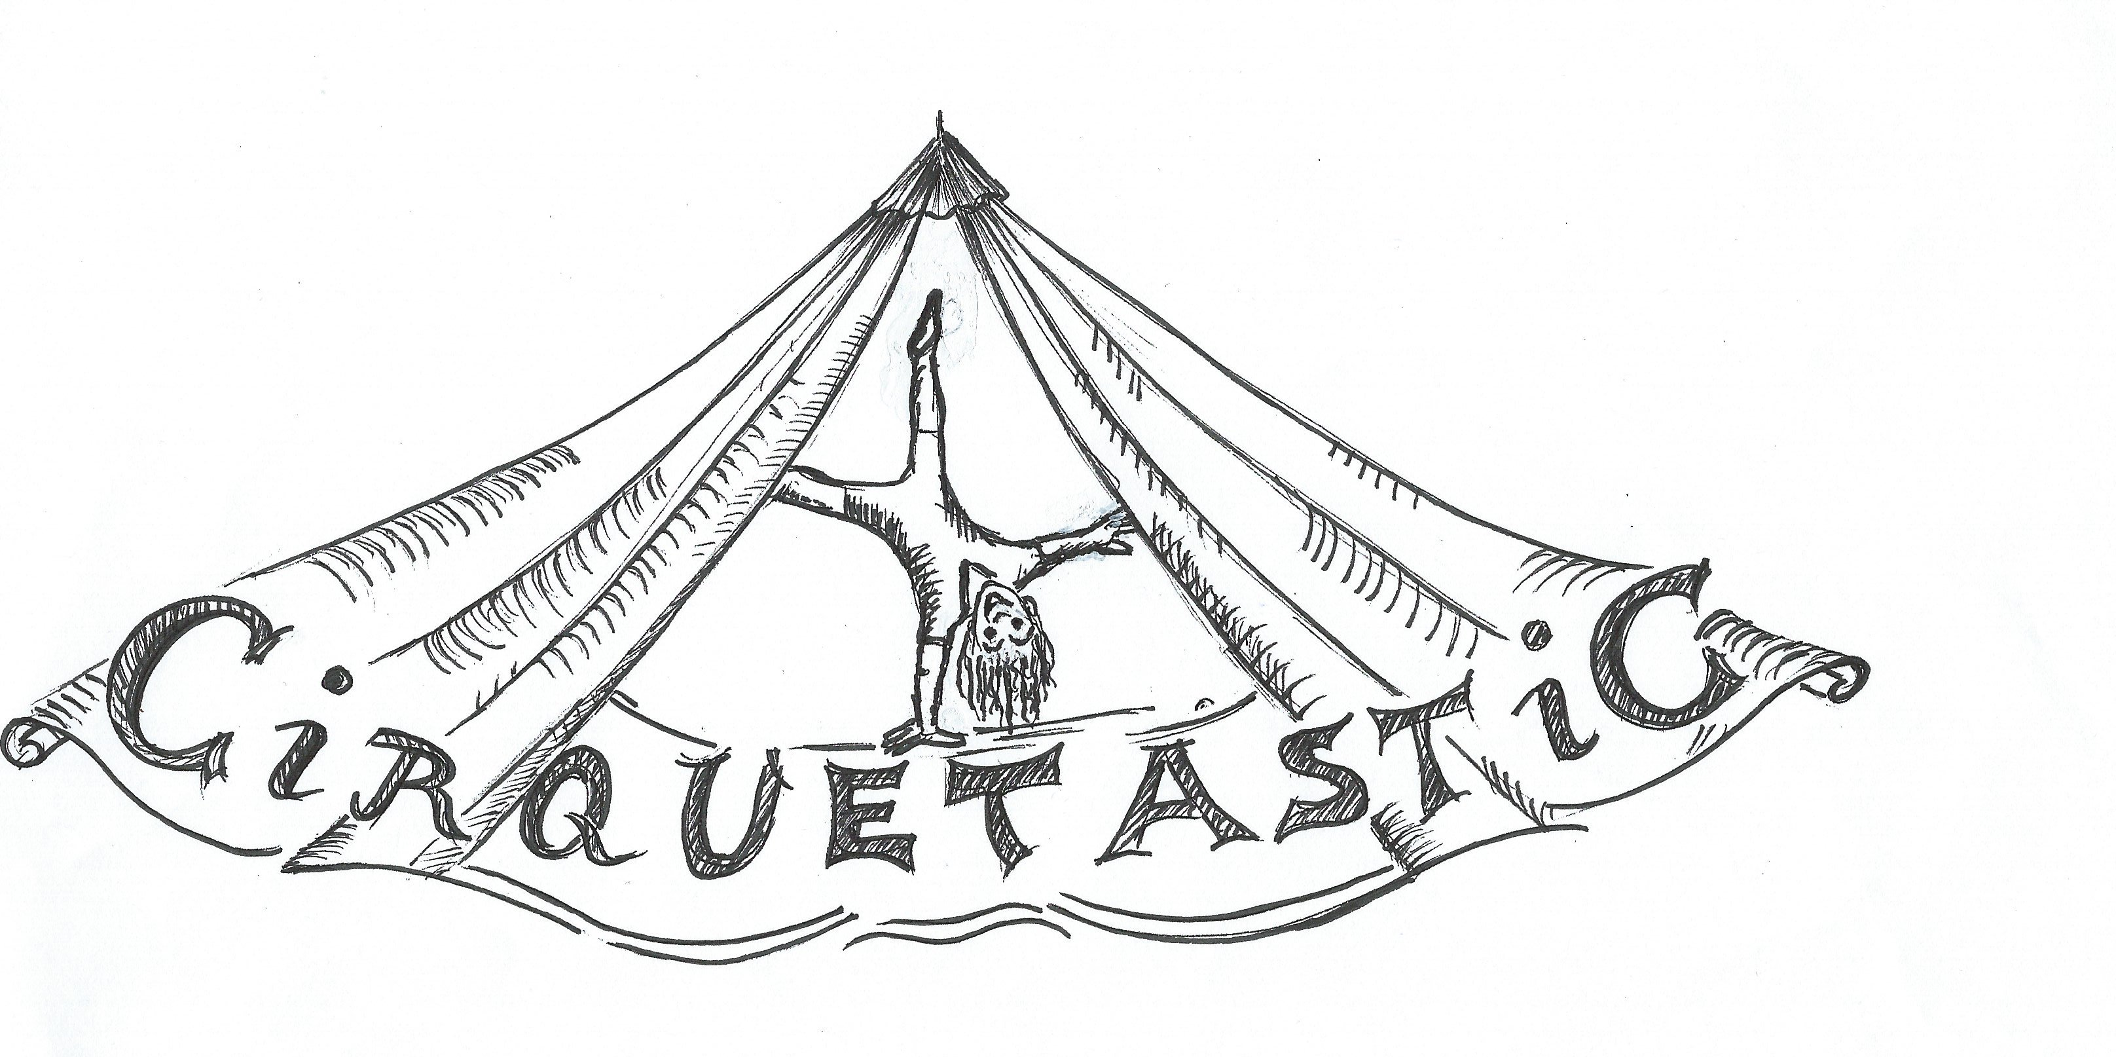
Participants Name:
Phone:
Email:

Waiver Release and Indemnity. This is a legal document, please read thoroughly.
Warning: By signing this form you relinquish your right to bring court action to be compensated for any injury or loss to yourself as well as the right of your personal representative to compensate for your death.

I, the Undersigned, understand and acknowledge that I am aware of the risks associated with or related to participating in Cirquetastic Circus and Acrobatic Ltd. programming.

IN CONSIDERATION OF __________________________________________________________ being permitted to participate in or observe aerial arts, acrobatics, balancing, circus stunts, trapeze and other disciplines (the "Activities") offered and/or coordinated by Cirquetastic Circus and Acrobatics Ltd. (the "Operator") at 6820,50th street, Edmonton, Alberta (the "Lands"), the undersigned, for ourselves, and our personal representatives, heirs and next of kin (collectively the “Undersigned”), acknowledge to and agree with the Operator that:

I acknowledge that circus, fitness and other activities offered at Cirquetastic Circus and Acrobatics Ltd., may involve an element of risk, which may result in bodily injury (including the risk of severe or fatal injury) to myself or my child/ward. I also acknowledge that circus activities may require the coach/staff to perform some manual spotting which involves direct physical contact and is designed to assist the participant in the safe performance of the program skills. I confirm that I, or my child, am/is fit to participate in circus activities including but not limited to climbing, tumbling, balancing, and activities both on aerial equipment and on the ground. I, for myself and, if applicable, my child/ward, and each of our respective heirs, executors, administrators and assigns, release Cirquetastic Circus and Acrobatics Ltd., and its servants, agents, directors, officers and employees (collectively Cirquetastic) from any claims, demands, damages, actions or causes of actions arising out of or in consequence of any loss, injury or damage to my person or property (or, if applicable, to my child’s / ward’s person or property) incurred while attending at or participating in any activities offered at Cirquetastic, notwithstanding any such loss, injury or damage may have arisen by reason of the negligence of Cirquetastic or any person for whom it is at law responsible. I have read this waiver in full, fully understand its terms, and understand that I am giving up substantial rights, including my right to sue. I also acknowledge that I am unaware of any physical or mental condition or impediment, which would prevent or hinder myself or my child from participating safely in the programs at Cirquetastic. I confirm that I have accurately reported and disclosed any medical information (physical and mental) to Cirquetastic Circus and Acrobartics Ltd., which is necessary for the proper program involvement and care of the above-mentioned participants. I acknowledge that I am agreeing to these terms and conditions freely and voluntarily, and intend by my agreement for this to be a complete and unconditional release of all liability to the greatest extent allowed by law. I, as the parent/guardian of the minor participant(s), have explained to my son/daughter(s) the aforementioned stipulated conditions and their ramifications, and I consent to their participation in the programs conducted under by Cirquetastic Circus and Acrobatics Ltd.

In Witness Whereof I have executed this document at the City of Edmonton in the Province of Alberta, this ________day of _________, 2020

Participants or Guardian ( sign) _____________________ Witness ( sign)________________

Participants or Guardian ( Print)_____________________ Witness ( sign)________________

