**Levels of Sponsorship for Logan’s Laps for Love:**

$1,000-**“Arlo” sponsor**. 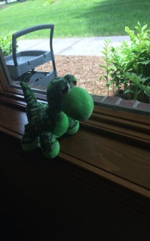 Name of sponsors will be on T-shirts (large print) and displayed at Event site Banner

$500- “**Ninja Turtle” Sponsor** 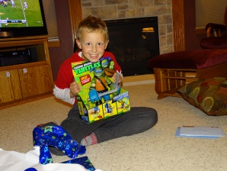 sponsors will be displayed on T-shirts (smaller print) Also name to be displayed at Event site Banner

$250-“**Electronics”Sponsor**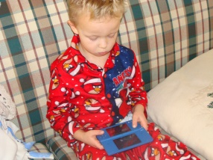 Name of sponsor will be displayed along race course and at Event site Banner

$100- “**Spiderman” sponsor**- 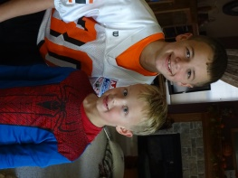Name of sponsor will be displayed at Event site Banner

$50 “**Light saber” sponsor** 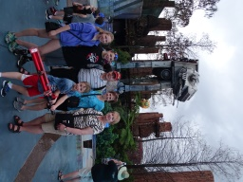Name of sponsor will be displayed at Event site Banner