Levels of Sponsorship for Logan’s Laps for Love:
$1,000-“Arlo” sponsor. 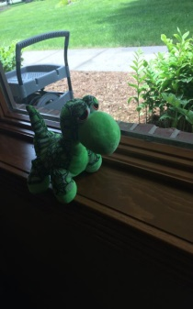 Sponsors will be displayed on T-shirts (larger print), advertised at event via 18x24 sign, listed on sponsorship banner and website.

$500- “Ninja Turtle” Sponsor 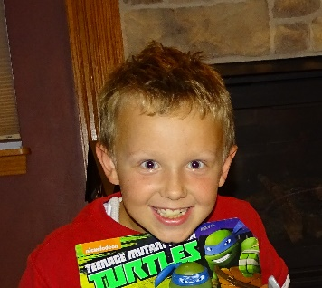 Sponsors will be displayed on T-shirts (medium print), advertised at event via 18x24 sign, listed on sponsorship banner and website.

$250- “Swim” Sponsor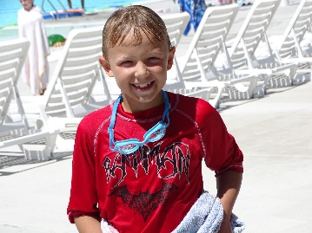 Sponsors will be displayed on T-shirt (smaller print), advertised along race route with 12x18 sign, listed on sponsorship banner and website.

$100- “Spiderman” sponsor- 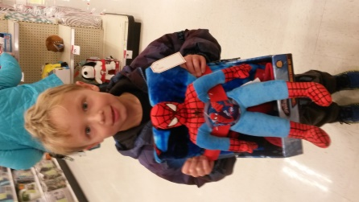 Name of sponsor will be listed on sponsorship banner and website.

$50 “Light saber” sponsor 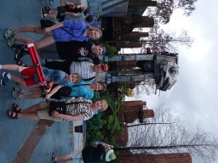 Name of sponsor will be displayed on website.

