**Levels of Sponsorship for Logan’s Laps for Love:**

$1,000-**“Arlo” sponsor**. 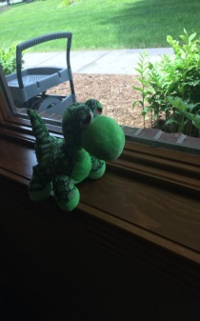 Sponsors will be displayed on T-shirts (larger print), advertised at event via 18x24 sign, listed on sponsorship banner and website.

Sponsors will be displayed on T-shirts (medium print), advertised at event via 18x24 sign, listed on sponsorship banner and website.

** Sponsors will be displayed on T-shirt (smaller print), advertised along race route with 12x18 sign, listed on sponsorship banner and website.

$100- “**Spiderman” sponsor**- 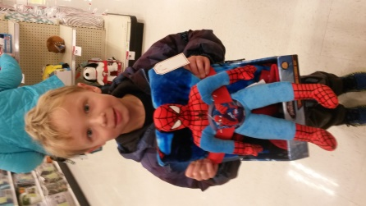 Name of sponsor will be listed on sponsorship banner and website.

$50 “**Light saber” sponsor** 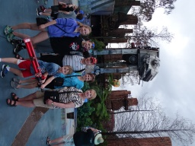 Name of sponsor will be displayed on website.