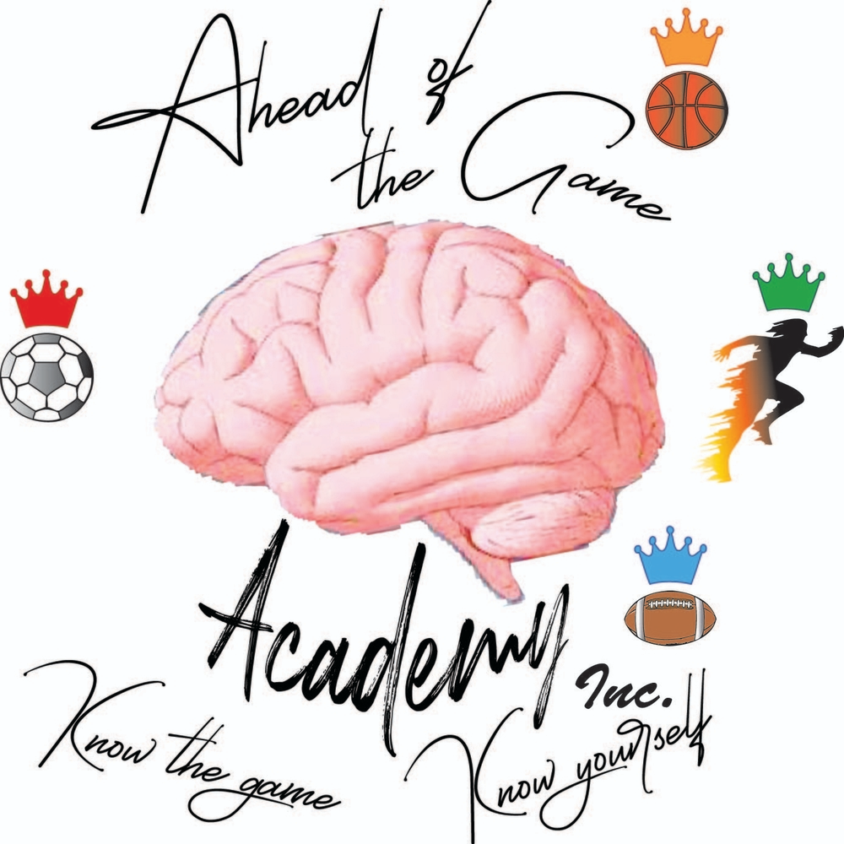

**Ahead Of the Game Academy**

**REGISTRATION FORM**

**Ahead of the Game Academy Inc., and Our Kings are having a youth basketball summer camp for kids in grades K-10. An outdoor clinic, league, and camp will be held on _____________, 2022 and kids amongst age groups will be competing and training against each other. Games, camp, clinic, and training session will be on the week of __________________, 2022 at Rohr Park in Bonita, California. Our Kings will be helping with provided snacks and lunch.**



**Player Information**



## **Medical Information/Authorization**







Athlete Player Fee: $250.00 (required of all players) Payment is due at time of electronic registration.

Questions? Please contact Lester Mayo at: [info@aotgame.org](mailto:info@aotgame.org) or (619)259-4028