Arrival in BKK: MUST HAVE 600$ in crisp bills as proof for entry
--Fill out Thailand digital arrival card 3 days before (THIM)
Thai Baht: basement level at BKK exchange booth (follow rail link signs)(SUPERRICH)
In bkk proper: Vasu Exchange (BTS Nana) Siam Exchange (near MBK)
BRING 100/50$ bills, CLEAN
ATM-220 baht fee (6$) (use local currency setting, “Accept without currency conversion”)
Food at the airport: Magic food point food court
Exit airport: grab/bolt / AIRPORT RAIL
airport rail link TAKES CREDIT CARD TOUCH PAY (‘city line”, basement area, runs 6am-midnight (makkasan connector to Phetchaburi)*NEED THAI BAHT 15-45 baht
BANGKOK hotel: stay:
Hua Chang Heritage Hotel
2 trains, Independent: https://www.youtube.com/watch?v=cL6Hhk-Y7OE
BTS Skytrain -coins only, get a card (or bind with rabbit card to CC), tap on turnstile, insert card to exit
150 baht one day pass, ticket booth with passport

MRT Blue line (6am to midnight) – use credit card!
Underground subway system -blue purple yellow pink 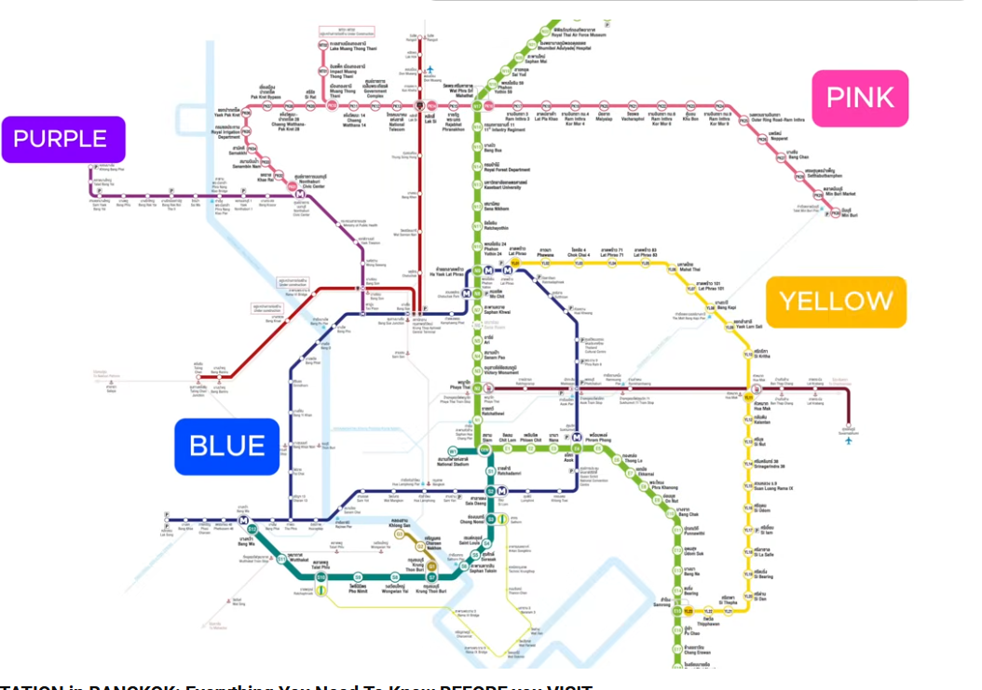
--Blue is a loop that connects major tourist stops (Chatuchak weekend market, Chinatown (wat mangkom) and grand palace.
Purple and yellow is suburban, pink as well
EACH COLOR NEEDS A NEW TICKET, can pay with bills, uses tokens to enter and exit
RUSH HOUR 7-9 AM AND 5-7PM
FERRIES
RAJINEE MRT STATION GOES TO FERRY
COLOR SYSTEM
ORANGE FLAGS 16 BAHT RUN ALL DAY
YELLOW GREEN RED GOLDEN -EXPRESS FERRIES STOP AT MAIN PIERS
BLUE ARE SIGHTSEEING WITH GREAT VIEWS
CROSSING FERRY 4 BAHT
KHLONG FERRIES (RUNS PARALELL TO SUKUMVIT ROAD)

TUKTUKS – use MUVMI app

Esim card (airalo.com) ( Whats app instead?)
Cash
Tile trackers
Exit cost for BKK 34$ (built into flight ticket)
Download offline maps

🌶️ The Spice Scale (Crucial)
- Not spicy at all: "Mai pet" (Mee-pie pet)
- A little bit spicy: "Pet noi" (Pet noy)
- Medium / Normal spicy: "Pet bpan-glang" (Pet bahn-glang)
- Very spicy (Local style): "Pet mak" (Pet mahk)
🍳 Useful Customizations
- No chili: "Mai sai prik" (My sigh prick)
- No MSG: "Mai sai pong-choo-rot" (My sigh pong-choo-rot)
- No sugar / Not sweet: "Mai wan" (My wahn)
- Takeaway / To-go: "Glap baan" (Glup bahn)
🙏 Polite Endings
Always add these words to the very end of your sentence to be polite to the street vendors:
- If you identify as Male: Add "Khrap" (Krup)
- If you identify as Female: Add "Kha" (Kah)
Example: "A little bit spicy, please" → "Pet noi, khrap" or "Pet noi, kha"

BANGKOK EVENING 11/18

WET WIPES!
Here is a hyper-local, evening street food crawl optimized specifically for your stay at the Hua Chang Heritage Hotel.
While the previous route focused on the main thoroughfare, this route takes you slightly further north to Phetchaburi Soi 5, a legendary, dense neighborhood alleyway that transforms every evening into a bustling local food sanctuary. It is highly authentic, exceptionally cheap, and completely free of tourist traps.
The Logistics
- Total Walking Time: About 20 minutes round-trip from your hotel lobby.
- Best Time to Go: Between 6:00 PM and 8:00 PM when the woks are at maximum capacity.
- What to Pack: Small bills (20, 50, and 100 THB notes) and a pack of wet wipes.

Stop 1: The Pre-Game Thai Tea
- The Walk: Exit the hotel, walk north past Ratchathewi BTS station, cross the giant Phetchaburi intersection, turn left, and walk one block to the mouth of Phetchaburi Soi 5 (7-minute walk total).
- The Venue: Look for a drink cart near the alley entrance with rows of condensed milk cans.
- The Order: Cha Yen (Traditional Thai Iced Tea). Sip this rich, sweet, orange nectar as you walk to help handle the alley's intense heat and wok smoke.
Stop 2: Master-Class Pad Krapow
- The Walk: Head 50 meters deeper into the buzzing alley.
- The Venue: Look for the street stalls with furious, flaming open woks and a queue of locals waiting for takeout.
- The Order: Khao Pad Krapow Moo Sap (Stir-fried holy basil with minced pork over rice). Explicitly ask for a Kai Dao (crispy fried egg with a runny yolk) on top. The version in this alley skips the filler vegetables like long beans, focusing entirely on a dark, smoky, charred garlic-and-basil glaze.
Stop 3: The Tangy Street Salad
- The Walk: Continue another minute down the alley.
- The Venue: A stall displaying fresh seafood, lime halves, and bundles of instant noodle packets.
- The Order: Yam Mama (Spicy Thai instant noodle salad). The vendor mixes bouncy instant noodles with fresh shrimp, squid, minced pork, Chinese celery, onions, lime juice, and fish sauce. It is incredibly bright, punchy, and refreshing.
Stop 4: Crispy Mussels Omelet
- The Walk: Keep walking straight down the main vein of the Soi.
- The Venue: Look for a shophouse operating a massive, flat iron griddle right on the sidewalk edge.
- The Order: Hoy Tod (Crispy Thai-style oyster or mussel omelet). Mussels are fried into a crispy, savory tapioca starch batter over a bed of flash-fried bean sprouts, served with a sweet and mild chili dipping sauce.
Stop 5: The Sweet Sweet Finish
- The Walk: Turn around and slowly head back toward the mouth of the alley.
- The Venue: Look for a cart with a heavy cast-iron dimpled pan.
- The Order: Khanom Krok (Sweet coconut griddle cakes). These small, double-layered custardy spheres are crispy and browned on the outside, but completely gooey and molten on the inside. They are the perfect way to cool down your palate.

Pad kra prao moo krob kai dao (ผัดกระเพราหมูกรอบไข่ดาว) - Final meal of this Bangkok street food tour, I headed across the street to Petchaburi Soi 10 to seek out one of my old time favorites. The stall was still there, and they make a pretty good plate of Thai crispy pork belly fried with basil.
Price - 40 THB ($1.22)

- BANGKOK MORNING 11/19
- Take BTS from National stadium to Saphan Taksin (river), take Sathorn ferry up river to chinatown get off at Ratchawong ferry stop, check out Chinatown area
- OR
- MRT or canal to TROK MOR morning market Blue line get off at SAM YOT STATION

BANGKOK EVENING 11/19
Chinatown

Bangkok 11/20
DEPART PLANE 0925

