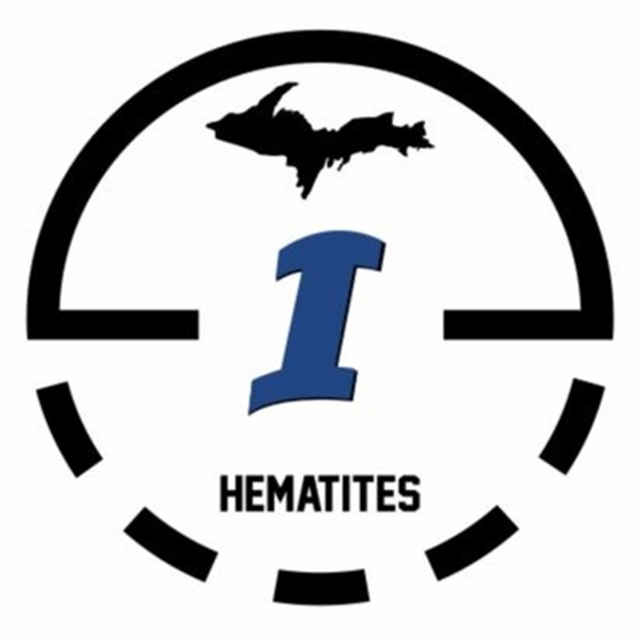

**HEMATITE MADNESS**

**BOYS BASKETBALL TOURNAMENT**

APRIL 4th - 5th, 2025

* **GRADES:** BOYS 3rd - 8th
  + TEAMS MUST CONSIST OF PLAYERS WHO ATTEND THE SAME SCHOOL
* **WHERE:** ISHPEMING MIDDLE/HIGH SCHOOL
* **ENTRY FEE:** $175.00 PER TEAM
  + CHECKS PAYABLE TO: ISHPEMING PUBLIC SCHOOLS
  + CASH ACCEPTED
* CONCESSIONS AVAILABLE EACH DAY

**PLEASE SEND REGISTRATION AND ENTRY FEE TO:**

PAIGE YOHO (ATTN: HEMATITE BASKETBALL)

613 N. 4th STREET

ISHPEMING, MI 49849

*\*\*PLEASE RESERVE YOUR SPOT BEFORE SENDING REGISTRATION/ENTRY FEE\*\**

**FOR MORE INFORMATION:** PAIGE YOHO @ 906-869-2675 or yohopaige@gmail.com