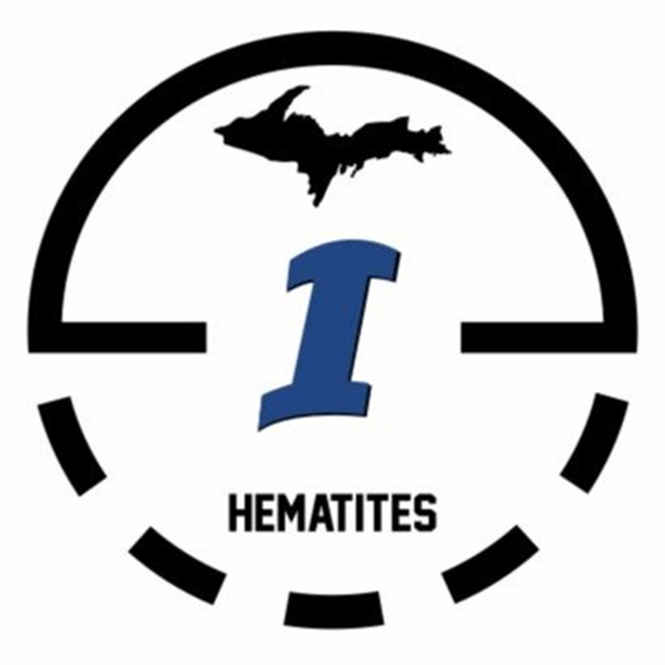

**HEMATITE MADNESS**

**BOYS BASKETBALL TOURNAMENT**

TEAM: __________________________________________________________

COACH NAME: _________________________________________________

NUMBER/EMAIL: ______________________________________________

GRADE: 3 4 5 6 7 8

|  |  |
| --- | --- |
| PLAYER NAME | JERSEY # |
|  |  |
|  |  |
|  |  |
|  |  |
|  |  |
|  |  |
|  |  |
|  |  |
|  |  |
|  |  |
|  |  |
|  |  |
|  |  |

**CHECKS PAYABLE TO: ISHPEMING PUBLIC SCHOOLS**

**CONTACT: PAIGE YOHO (906) 869-2675**