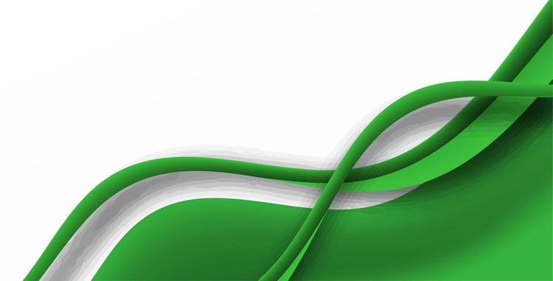
Tommy Hill Trustee Business Development

Mick Halsall
Chair of Trustees
(Safe Guarding )

Richard Beale
Trustee – Sport
Laura Beale
Trustee –
Education
Sandra Halsall
Trustee - Health

Mike Turl
Trustee- Finance
Charlie Fogarty
Trustee – C&YP & Disability Sport
Mark Fogarty - CEO
YOUR TITLE HERE
Name: ______
Role: _________

Coaches

Mentors

Volunteers
Accountant (Jerroms)
Fund Raising Consultant
The Charlie Fogarty Foundation

