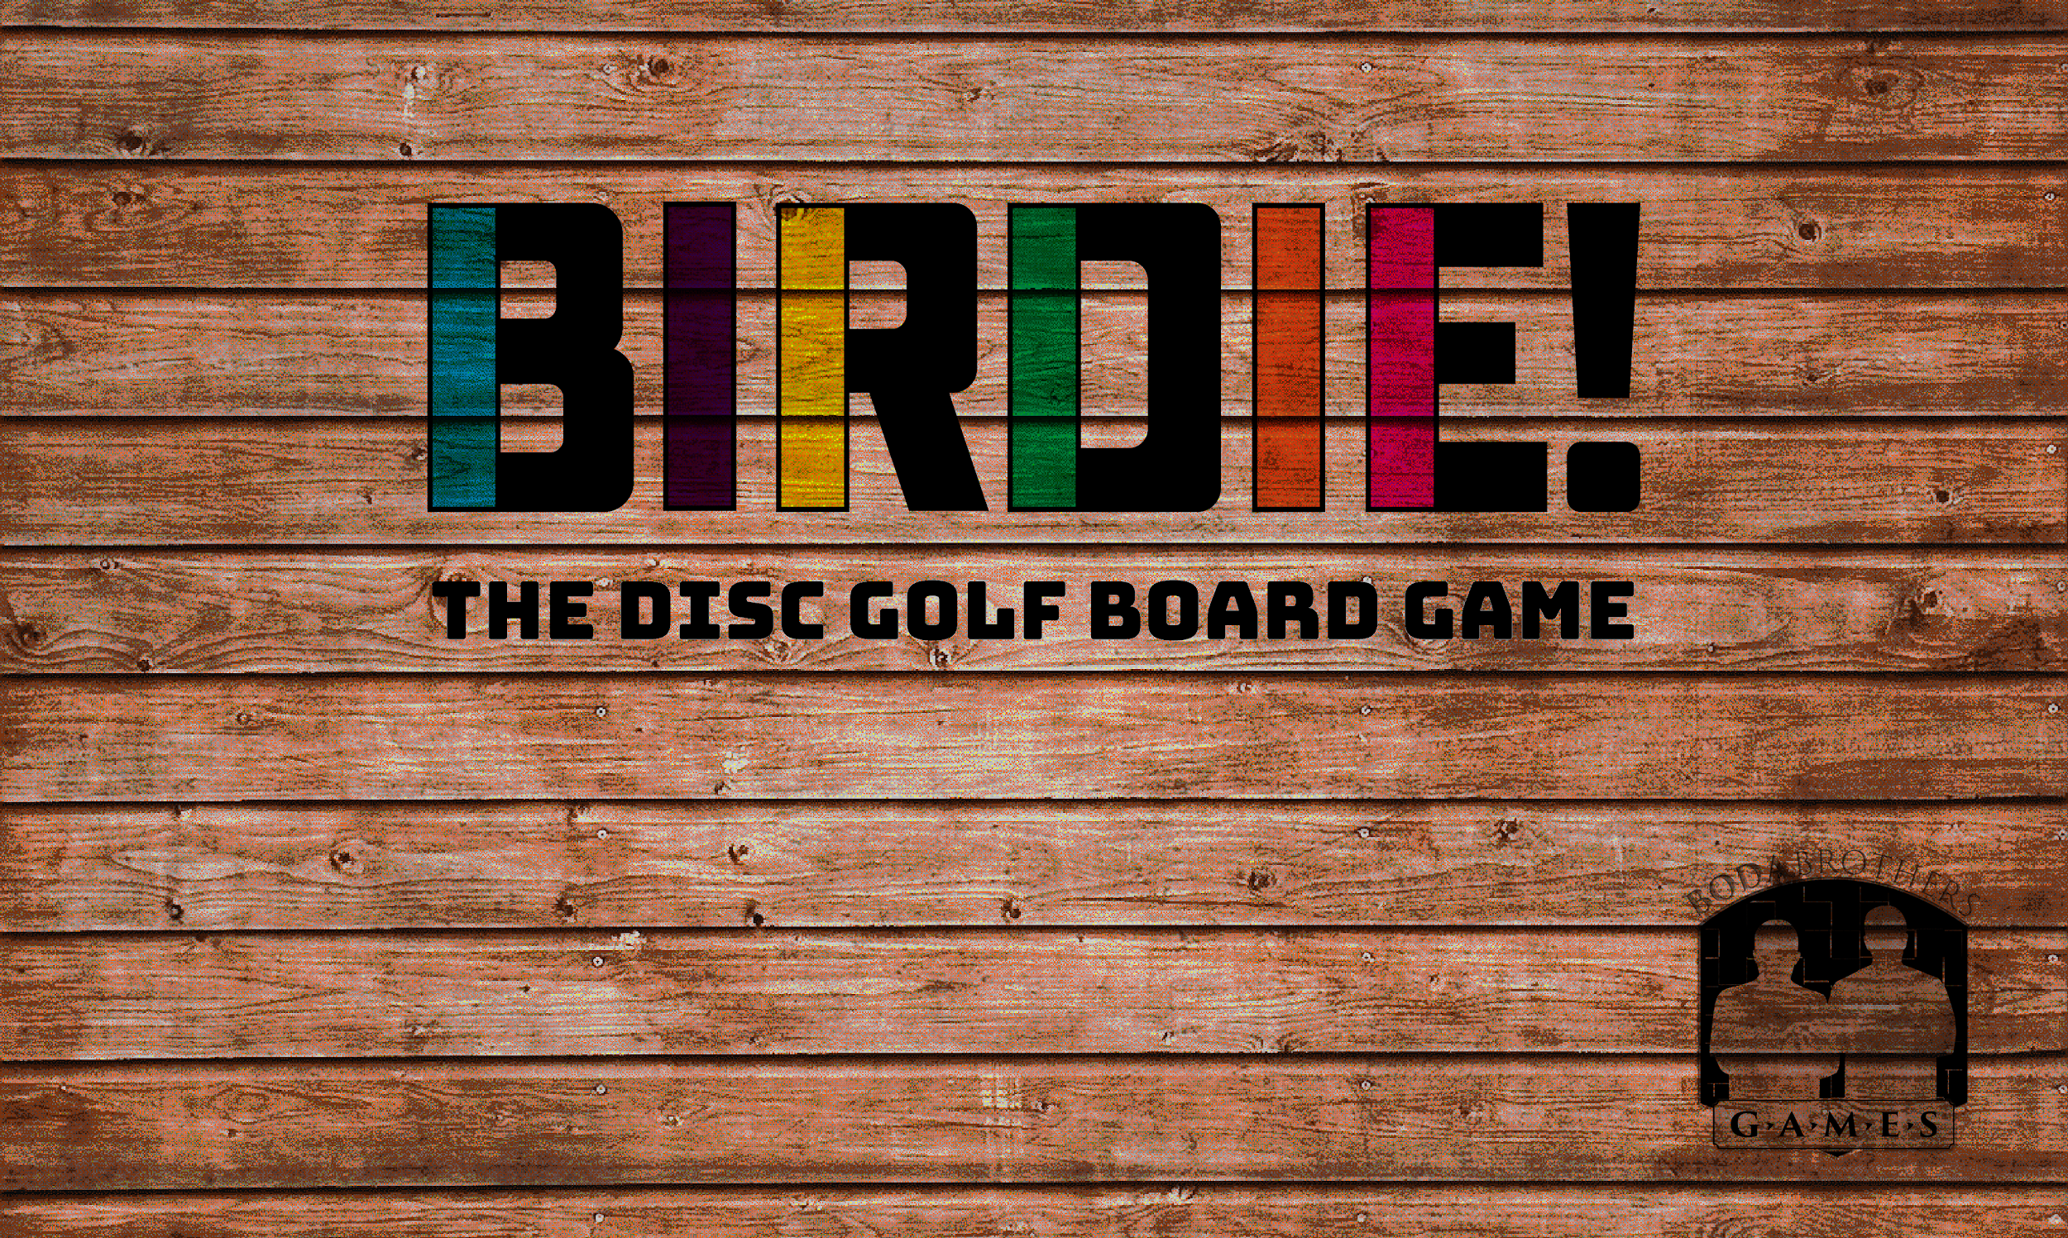

I backed the BIRDIE! disc golf board game Kickstarter as your Christmas present.

This game is played on Maple Hill’s Gold Course. It uses player skills, karma, strategy and has tons of fun player interaction. Invite me over to play! Anticipated arrival date is Spring 2020.

Kickstarter Video

