Inland Empire Bonsai Society
Club Meeting Notes, June 16th, 2024

Members present: Caleb, Cass, David, Dotty, Ed B, Emily, Jeffrey, Jerry, John B, John K, Karen, Kurt, Mark, Marty, Mitch, Roger, Zach
New Members: Helene

Items of Discussion:
- Introduction of members present.
- Reminder of the upcoming Pacific Bonsai Exhibition happening this fall in the bay area.
- Roger led a discussion about our upcoming annual club show & sale next month. Meeting runs from 10-4. Will need help with set up starting at 8 am. Everyone is welcome and encouraged to show a tree. Needs to be in a clean bonsai pot (can be in Mica pots, but not plastic ones or training boxes). Soil should be weed free and debris free. Roger will send out an email with solicitation for trees to show from club members. See email from Marty about the PBE for a link to a video regarding tree show prep for informational purposes.
- Can bring items to sell, club takes a 10% fee. Bring your own table.
- Marty has a 1 page flyer for advertising the club show & sale. Let him know if you are willing to distribute some.
- Kurt reported on the upcoming Interstate Fair display. Will need volunteers, talk to Kurt. Can bring and show trees as well but we will need to watch over them. We are going to display on one day only. September 6th.
- Akadama order is in. If you have not already done so, contact and pay Roger for your order.
- Silent auction for donated pots. The club raised $283 with this sale.
- Marty did a styling demonstration with a Japanese Maple. First step with nursery stock is to re-pot the tree. This will give you better/finer growth, lets you know the quality of the roots, and lets you take the most dangerous step before you put much effort into the tree. Discussed determining the “front” of a tree. Factors for deciding the front include the base/nebari, trunk movement, and special features. Showed decision making for branch selection pruning. Now is not the best time for wiring. Leaves are in the way and the branches will be more brittle.
- Members’ trees presentation & discussion:
  - Japanese Maple (Marty) - developmental tree, used by Marty for a styling demonstration in meeting today.
  - 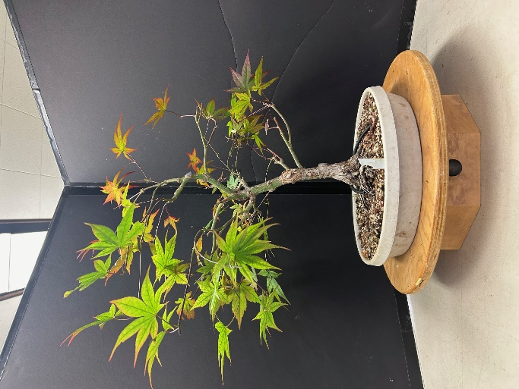
b. Japanese Maple (Marty) - now 3-4 weeks s/p partial defoliation, showed push of second flush that is occurring.
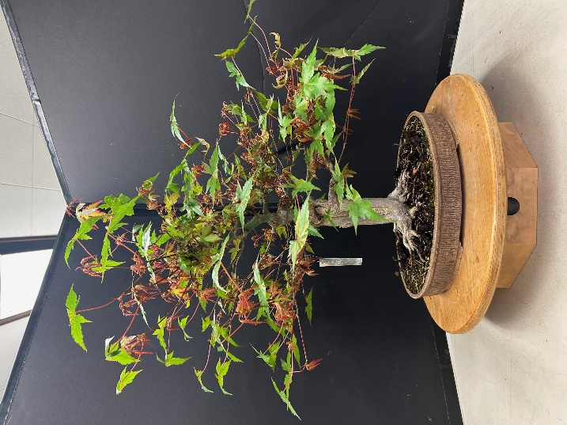
c. Japanese Maple (Marty) - showed progress of recovering from nearly being killed during heat and lack of watering last summer.
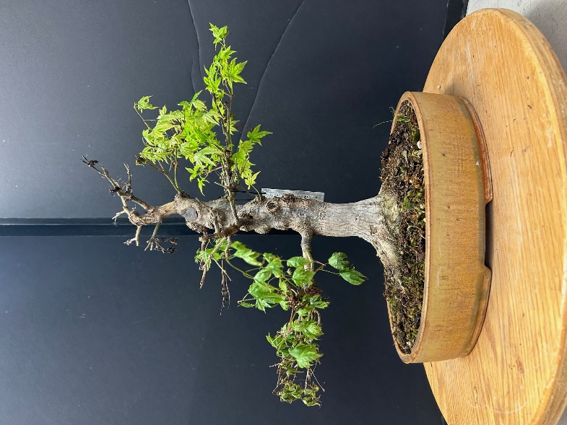
d. Elm (Mitch) - dug up in his sister’s yard in Nevada 15+ years ago. Last repotted a couple of years ago.
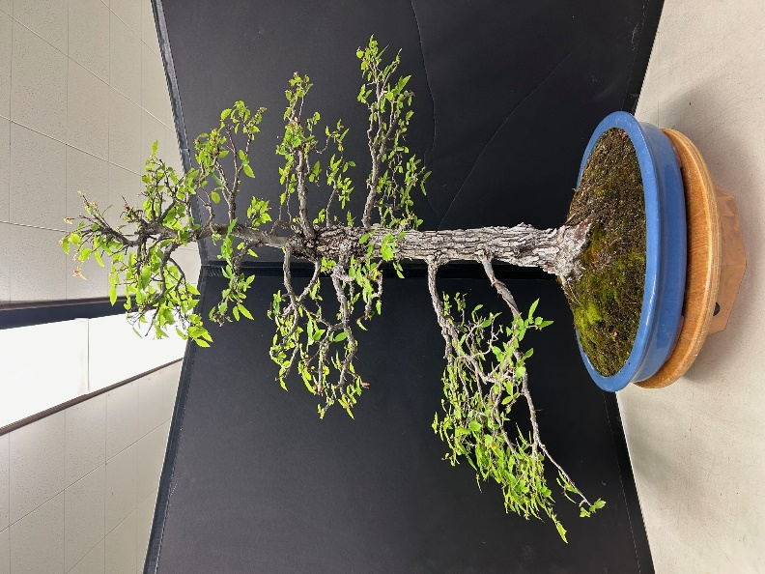
e, Black Spruce (Mitch) - just dug up in Alaska last week. Will just be recovering for now.
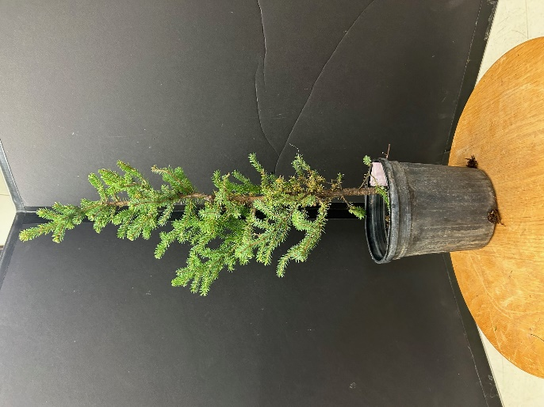
f. Procumbens Juniper (Ed R) - his mother started working on this tree back in the 1970’s. Was repotted and re-wired about 1.5 years ago in San Diego. Learning how to take care of it.
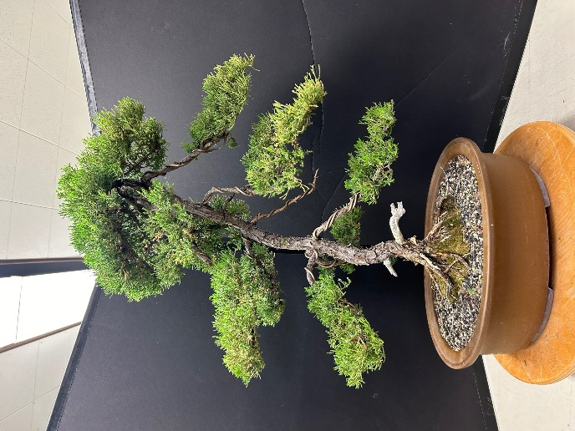
g. Amur Maple (Cass) - fused 3 trunks together over time. Will keep trimmed back to keep from getting bigger. Discussed pruning back strategy.
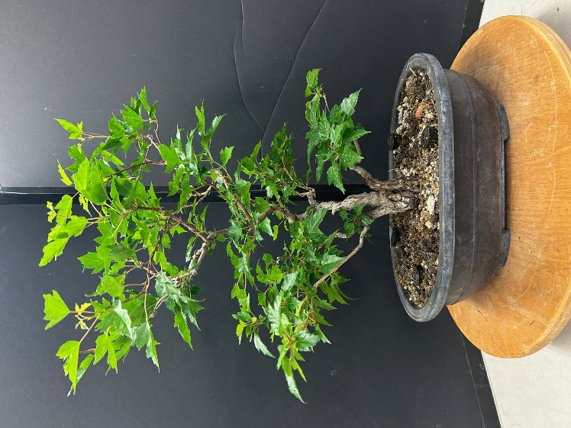
h. Crabapple cuttings (Kurt) - put in a pot 2 years ago. High survival rate. Will get potted up individually in the future.
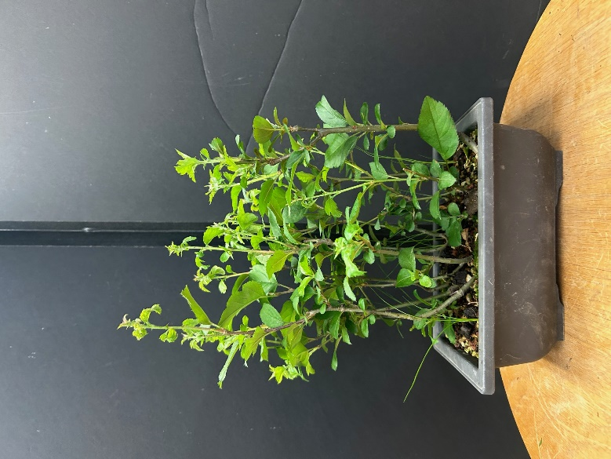
i. Japanese Black Pine (Kurt) - wired and branch select pruned.
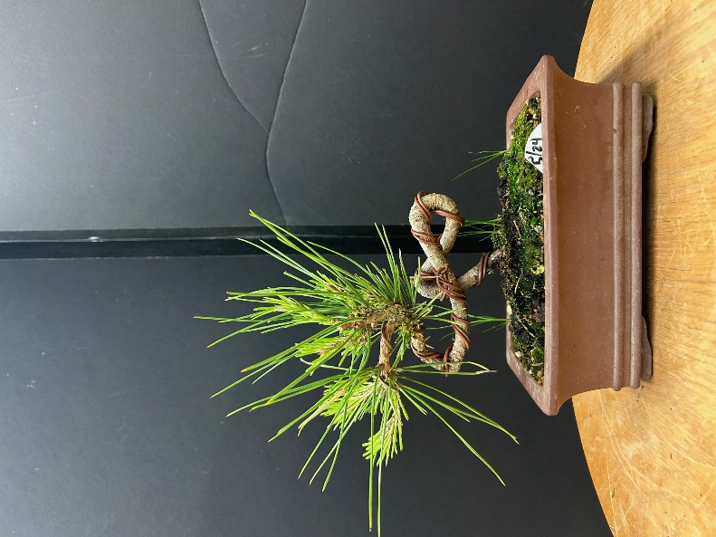
j. Shimpaku Juniper (Kurt) - root over rock project. Has Mountain Ash and White Cypress volunteers. Planning on reducing the soil over next 4 years.
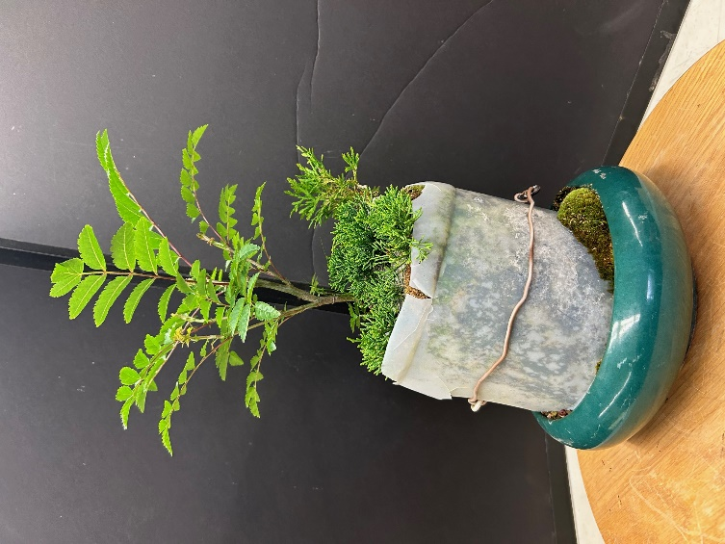
k. Trident Maple (Roger) - recently partially defoliated. Got repotted this Spring. Repots every 3 years. Had this tree since 2006. Field grown material. Starting to move into tertiary refinement. Will need to re-wound the callus on the large wound and use epoxy to get it to continue to heal over.
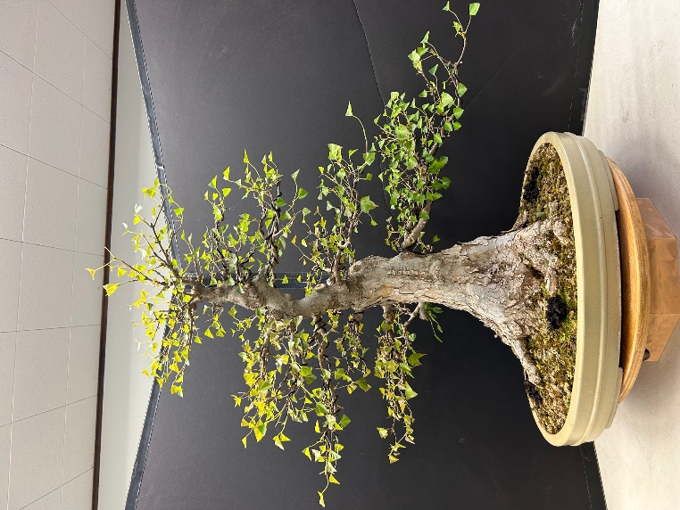
l. Potentilla (Jeffrey) - nursery stock. Planning to show next month.
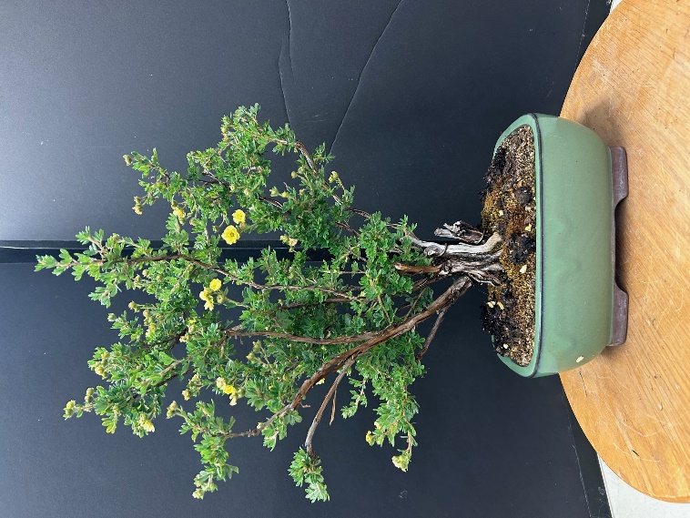
m. Siberian Cypress (Jeffrey) - cascade stye, nursery stock, planning to show next month.
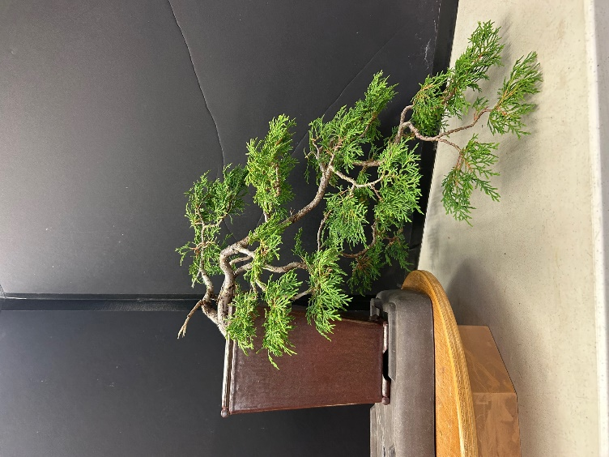
n. Japanese Maple (John B) - purchased in Astoria in 2019. Top died off, will make a nice shohin now. Will start developing branches.
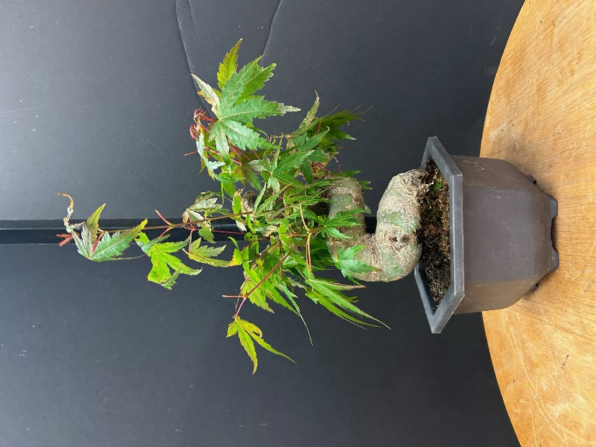

Next Club “Meeting”: July 21, 10am - 4 pm, Manito Room, Manito Park. Club Show & Sale. Set-up starts at 8 am!

