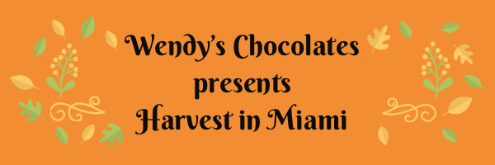
Harvest in Miami Registration
Event Info:
November 18 and 19, 2023
Saturday 8 am to 5 pm. Sunday 10 am to 4 pm
Event Address:
Miami-Dade Fair Expo
10901 SW 24th Street (Coral Way)
Miami, Florida 33165
Contact us at (305-251-8989)
Events@Wendyschocolates.com

APPLICATION PROCESS;
Please provide 3 pictures of your items either by email or a link to your website. Limited numbers per category will be picked to obtain an amazing show. If you change products prior to the show, you will need to be reapproved. Fill out the application and submit application, pictures and form of payment.
PAYMENT AND CANCELLATION POLICY;
Show fees are listed on the application. Please provide payment at the time of applying. Once approved and notified payment will be processed. Cancelations within 30 days of the event will not be refunded. Deposits are nonrefundable.

BOOTH DISPLAY;
All tables must be draped to the floor on all 4 sides. Canopy frames are allowed however no covers. If requesting electrical please bring 50 foot cords. All boxes, coolers, totes or carts should not be visible. Vendors should always stay within their designated area. NO sale signs will be permitted within your booth. Remember this is a family friendly event.
SET-UP AND BREAKDOWN;
Upon arriving, please check in for your space assignment. Set up will begin on Friday November 17th at 10 am and go until 8 pm. Saturday at 7 am. If you are unable to make it to the event please call and let us know. My phone is on 24 hours a day. Early bird shopping will begin at 8 am on Saturday morning. You MUST stay set up for the entire show hours. No packing up until the show has been announced as closed on Sunday. This is IMPORTANT so please follow the rule. I know everyone is in a hurry for the show to end but until customers are no longer in the building you must stay set up.
VENDOR RESPONSIBILITIES;
Vendors should keep a professional appearance for themselves and their booths. You are responsible for all clean up at the end of the event. Trash areas will be provided throughout the facility. All booths should be attended. No pets or alcoholic beverages. Please pack a sweater. This building can be warm or cold on any given day.
RV parking will be available on the grounds for $35.00 a night to be collected when you check in.
Vendor breakfast will be held Sunday morning in the building starting at 8:30 am come and join us

Vendor Information Required * (Please print clearly)

Name*_____________________________________ Phone*____________________________

Email*

Company Name*
Facebook or Instagram
Address*

Referred By:

Vendor Type:
Tell us what you make/sell:

Space Size:

- 10ft x 10ft space.... $250 ea ____qty

- (optional) 8' Table rental.... $15 ea ____ qty
- (optional) Chair rental..... $3 ea _____qty

- Corner space additonal $40 ea _____qty
- Electrical (limited spaces available) $50 ea

I understand that I will have to pay $____________ (total amount) *
- I have read ,understand and agree to all terms in this agreement.
- Form of payment: Visa, Mastercard, Discover, or American Express
- Checks: Payable to “Wendys Chocolates” 11032 SW 166th Terr Miami,Fl. 33157
- Card number ________________________________

- Expiration date__________________ CVV __________________

- Signature________________________________ Date_______________

WENDY'S CHOCOLATES is the PROMOTER for this Harvest event. If you have any questions or need more answers please reach out to me 305-251-8989 or thru email at Events@Wendyschocolates.com

