If your organization seeks cogeneration sales leads in your market, consider sponsoring World Cogeneration Day, the world’s largest global outreach platform for CHP and cogeneration. Submit CHP stories about projects and people to celebrate your organizations success during the month of September.
World Cogeneration Day - September 4 – bigger than ever!
During September celebrate the annual World Cogeneration Day events. It's certainly another triumphant global celebration of the benefits of cogeneration and CHP. Share on your social networks: Twitter, LinkedIn

THE LATEST NEWS IN COMBINED HEAT AND POWER

Cogen equipment eligible for Inflation Reduction Act tax credits
https://www.bioenergy-news.com/news/tecogen-chp-equipment-enables-tax-credits-under-inflation-reduction-act/
Wynn Resorts releases ESG report - hotelbusiness.com
Defines company's important milestones in 2021 Wynn Resorts. ... balancing solar energy production, combined heat and power co-generation, ...

edie launches new business guide on combined heat and power (CHP) edie
Drum for generator steam of HRSG boilers systems (Heat recovery steam generator) during construction in Combined-Cycle Co-Generation Power Plant.

Summit Utilities, Support RNG Biogas Plant Resilience with CHP - PR Newswire
Clarke Energy USA, Inc., a KOHLER Company, has secured a project to supply Peaks Renewables, LLC, a subsidiary of Summit Utilities, ..
Tecogen Receives Order for Two InVerde Systems and Components GlobeNewswire
... a clean energy company providing ultra-efficient and clean. ... ultra-clean cogeneration products, including combined heat and power systems, ...
Capstone Green Energy to Provide 1.2 MW of Microturbine Energy Systems for Leading ...
Business Wire
Two ICHP C600S Microturbines Will Power an On-Site Cogeneration Power Plant ... The systems will be installed in a combined cooling heat and power ...
MOEA amends cogeneration regulation in line with efforts to reduce carbon emissions
DigiTimes
Viewing that most of the cogenerators use coal to produce heat, the amendment adds a pricing mechanism for the sale of co-generated electricity ...
Ford 'combined heat and power plant' plans submitted - Sussex Express
Residual derived fuel from the site is currently sent to mainland Europe for use as a fuel in energy generation.

Tecogen Receives Repeat Order from New York Developer - GlobeNewswire
Tecogen Inc. designs, manufactures, installs, and maintains high efficiency and ultra-clean cogeneration products, including combined heat and power ...
The Global Combined Heat and Power Market worth USD 52.30 billion by 2030, registering ...
Travel Adventure Cinema
The COVID-19 outbreak has had a negligible impact on the micro-cogeneration industry in terms of workforce reduction and limited industrial operations ...
Tecogen Receives Tecochill Order for Arizona Cultivation Facility - GlobeNewswire
... a clean energy company providing ultra-efficient and clean. ... ultra-clean cogeneration products, including combined heat and power systems, ...
Ministers visit Pembroke Refinery | tenby-today.co.uk
Wales' Minister for the Economy Vaughan Gething visited Valero Refinery Pembroke's Combined Heat and Power (CHP) Cogeneration Unit recently.
Forward thinking, innovative solutions at Fort Leonard Wood impress Army Assistant ... - U.S. Army
The implementation of combined heat and power, also commonly known as cogeneration, increases energy efficiency by allowing heat that would ...
Capstone Green Energy Applauds the New Inflation Reduction Act That Has Been ... - Business Wire
... the tax credit available to microturbine combined heat and power (CHP) ... Energy Generation Technologies (EGT) are driven by the Company's ...

MICRO-GRIDS, NATURAL GAS, RNG, and HYDROGEN NEWS

Biogas plant in Maine partners with Clarke Energy USA

https://www.bioenergy-news.com/news/summit-utilities-support-rng-biogas-plant-resilience-with-chp/

How to implement healthcare microgrids in California Microgrid Knowledge
... energy storage systems and fuel cells bring to the table, and how cogeneration or combined heat and power can be integrated into a microgrid.
SSE and Equinor purchase Triton Power for £341m - Utility Week
Triton Power operates the Saltend power station – a 1.2GW combined-cycle gas turbine (CCGT) and combined heat and power plant to the north of the ...
Waste not, want watts – turning waste into energy - Modern Diplomacy
Combined heat and power is an old idea for saving fuel with. ... and heat in what is called “combined heat and power” (CHP), or cogeneration.
UPCOMING EVENTS (please let us know of any upcoming events that we should share)

2022 MCA Fall Conference: Exploring Energy Decarbonization and Resiliency Solutions for Your Business and Organization. September 19 @ 6:00 pm - September 21 @ 2:00 pm

- Smart Energy Decisions 2022 event Lineup Announced

- Eurasia Cogeneration Conference (ECC) on Sep 22nd.

- COGEN Europe is holding its 2022 Annual Conference on October 11-12th. Learn more and register here.

- Energy Solutions Center (ESC) is hosting a virtual CHP workshop on October 18th, titled “Strategies to Increase Customer Use of CHP.” Agenda and register info here.

- This year’s National Summit on Combined Heat and Power will take place in Washington D.C. from November 2nd-3rd! Learn more about the #CHPSummit2022 and register now at
https://bit.ly/CHPSummit2022

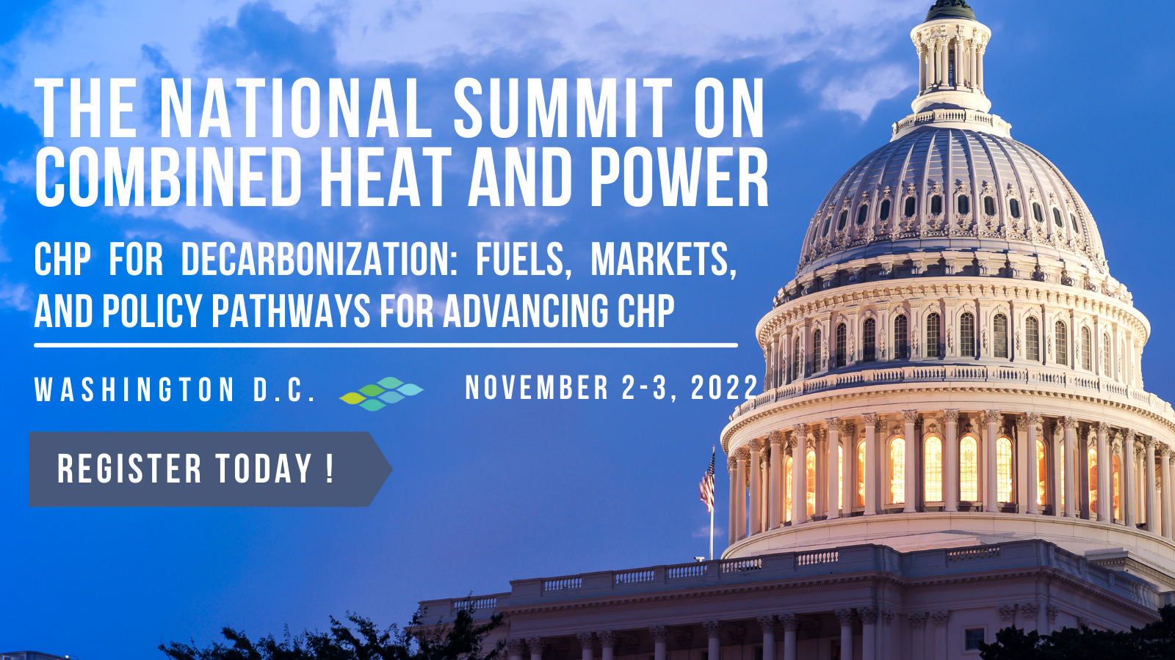

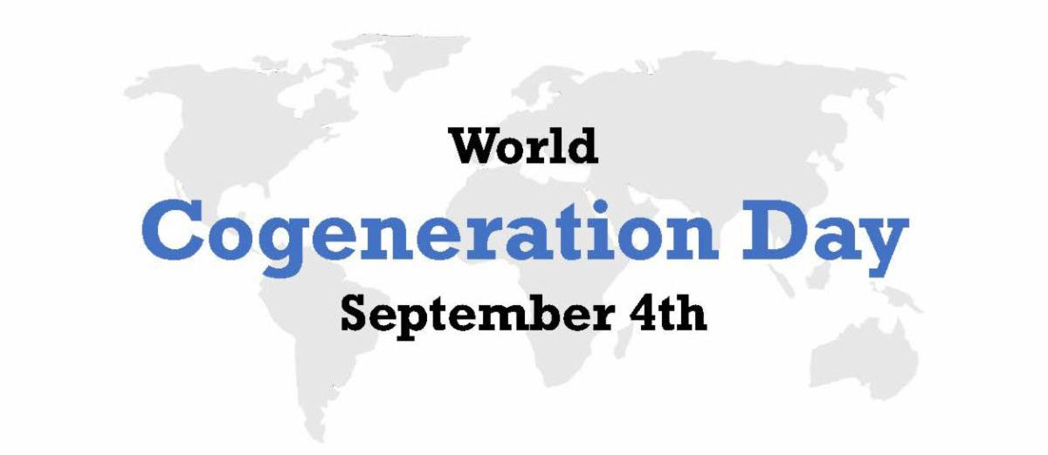
Happy World Cogeneration Day! Contribute to the success of World Cogeneration Day
Help Make this "Day Event" Even Bigger

During September are the annual World Cogeneration Day events; and it's certainly another triumphant global celebration of the benefits of cogeneration and CHP. Through your social media posts, e-mails and financial donations, please help us tell the world about how Cogeneration is one of the best energy sources of all time!

World Cogeneration Day is organized by a coalition of business, contractor, non-profit, and educational institutions who share the vision that CHP can make global businesses more competitive, reduce energy costs, enhance grid reliability, and reduce emissions. Participants in World Cogeneration Day focus on improved educational outreach options for CHP thus increasing demand for these valuable technologies. Further, our outreach efforts help to make citizens and policymakers more aware of CHP and ensure that their economic, reliability, and environmental benefits are recognized. We'd like to help the world appreciate that CHP can be more than twice as efficient as the separate generation of heat and electricity and that this greater efficiency translates to both lower energy costs and reduced emissions.

Breaking Records
Your social media posts, e-mail messages, events, celebrations, and financial donations help achieve the educational goals and outreach objectives for this one-day celebration of the benefits of cogeneration, and the people who make it happen.

Each year your positive, factual messages reach more people and through our social media and marketing channels we hope to triple our upcoming results with a bigger megaphone.

If you have a Case Study, story, or event that you are celebrating, please send it to us to post on the web site. It's not too late.

Your Donations will Help:
o Amplify the cogeneration message on more social media channels
o Bring a wider global audience to the party
o Accelerate our success from the prior year
o Increase the number of speakers, webinars and Zoom Events
o Target the blogs, tweets, likes, posts and social footprint
o Build on our reputation for excellence
o Help us Stand Out within a crowded internet

We help solve the problem of misinformation and faulty messages by bringing light, energy, and fun to a celebration of the world of cogeneration; Cogeneration Reimagined.

Increasing Awareness
People love this new "Day Celebration" of Cogeneration and have given accolades, testimonials and pats on the back. We appreciate your kind words and contributions; they give us the motivation to break all records this year.

Donate - To donate, simply press the "Donate Now" button on the web site or by using the PayPal link below using any credit/debit card. A receipt is provided. We thank you for your generous donation.

Donate in Honor of Someone Who Leads the way in Cogeneration.
Do you know someone who deserves to be recognized and honored for their work in the field of cogeneration leadership? Do you wish to honor and recognize a "future leader" of Cogen; the Next Generation? Consider donating in their honor.

Donate Here Button on PayPal
https://www.paypal.com/donate/?hosted_button_id=C5ZARXCDBLTU8

Donors and Volunteers - If you wish to be more involved in the project, please reach back to us with ideas and thoughts. We are eager to have volunteers, sponsors, donors, and leaders. Request a Zoom call, and we'll jump on it.

Supporters - If you wish your Logo on the site as a supporter, please provide one back to us via e-mail.
Click Here to Use the LinkTree Social Media Dashboard for Contributions and Posts
Check out this link to get a deep dive into contributions of money or social media posts with hashtag #WorldCogenerationDay https://linktr.ee/worldcogenerationday

World Cogeneration Day celebrates an invaluable global resource, and your donation helps bring the message to its international audience. Thanks for bringing this day to life...

Regards,

Jim Scherrer & Steve Krug,
Coordinators of World Cogeneration Day events

