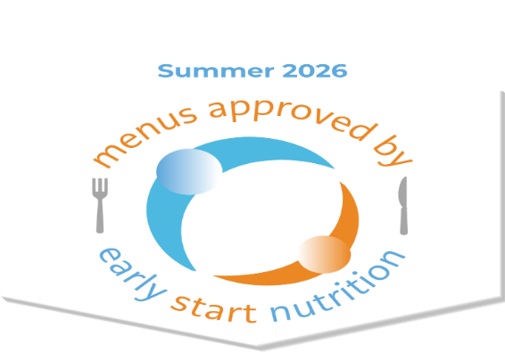

Mini Uni Nursery’s Summer Menu meets the Early Years Foundation Stage Nutrition Guidance and has received approval from Early Start Nutrition. Our menu provides children with meals, snacks and drinks that are healthy, balanced and nutritious while reflecting dietary and cultural requirements.

