*****February Newsletter***

Dear Parents,

Please find your February 2023 Newsletter!

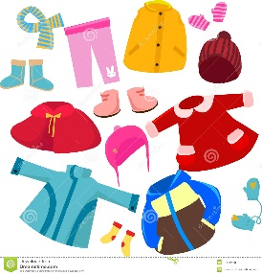

Children’s Clothes/Items:

Please can parents ensure that their children’s clothes are all labelled. We are hoping to avoid any lost clothes and property.

Toys that are brought from home will not be the responsibility of the nursery if the toy becomes lost, broken or missing. Please try to avoid toys from home.



Half term:

Children who are term time only will enjoy one week off from Monday 13th February – Friday 17th February 2023.

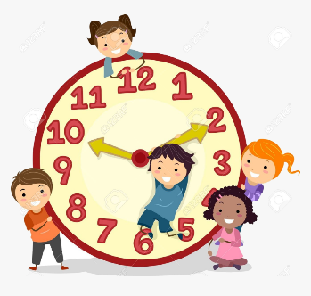Feedback:

We appreciate that parents’ days are busy. However, if parents would like feedback or to talk to their child’s key person, please ensure you arrive 10mins prior to your child’s session ending so that you are given quality time to liaise with your key person.

Nursery Session times:

Please can I remind all parents and carers of your child’s session times. We can not let parents enter before their child’s session times to ensure that ratio, health and safety and duty of care are covered. Thank you for your cooperation.

Absences:

Please can parents ensure that their child comes to the nursery for their session times and days. As a nursery setting, we want to be able to provide the best for your child. Mini Uni Nursery is not a drop off centre. Parents need to be consistent on days and times. If there is a level of inconsistency, the nursery has the right to withdraw your child from the setting. If your child is absent for any reason, please ensure that you notify the nursery either by phone, text or message through Eylog.

Parent Questionnaire:

Attached with the Newsletter is our Parent Questionnaire, we would deeply appreciate if parents could spend a few minutes to complete and return the questionnaire via email.



What will we be learning this month:

* Healthy Eating
* National story telling week

Cultural Celebrations:

* 14th Valentine’s Day
* 21st Shrove Tuesday

Things to do this half term:

* 14th Feb – 16th Feb: Explore, build, and play at the National Gallery
* 12th – 19th Feb: Sailing out at the National Maritime Museum
* 11th – 23rd Feb: Be a Vet for the day at ZSL London Zoo
* 8th – 18th Feb: Imagine Children’s Festival
* Play children’s floor games in Canary Wharf
* 12th – 18th Feb: Head to Shakespeare Globe for acting workshops