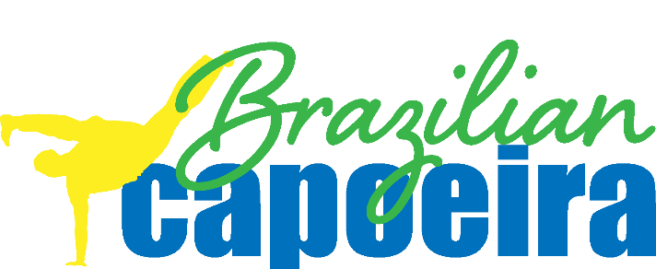

INTEGRITY

“Integrity is doing the right thing, even when no one is watching.”   
*C. S. Lewis*

“No man has a good enough memory to be a successful liar.”  
*Abraham Lincoln*

“Real integrity is doing the right thing, knowing that nobody’s going to know whether you did it or not.”   
*Oprah Winfrey*

“Today I shall behave as if this is the day I will be remembered.”   
Dr. Seuss

APRIL INTEGRITY CHALLENGE

PART 1:

Commit to doing your best in class; training with integrity.

Part 2:

Do 4 Secret acts of kindness in or out of the studio.

*Report to your instructor and claim your prize!*