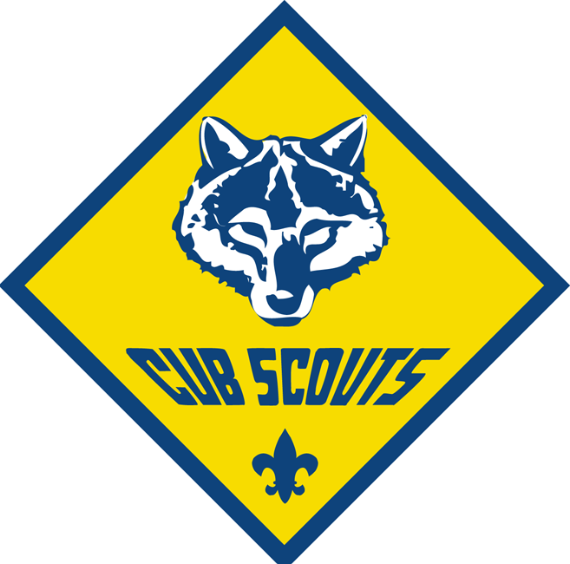

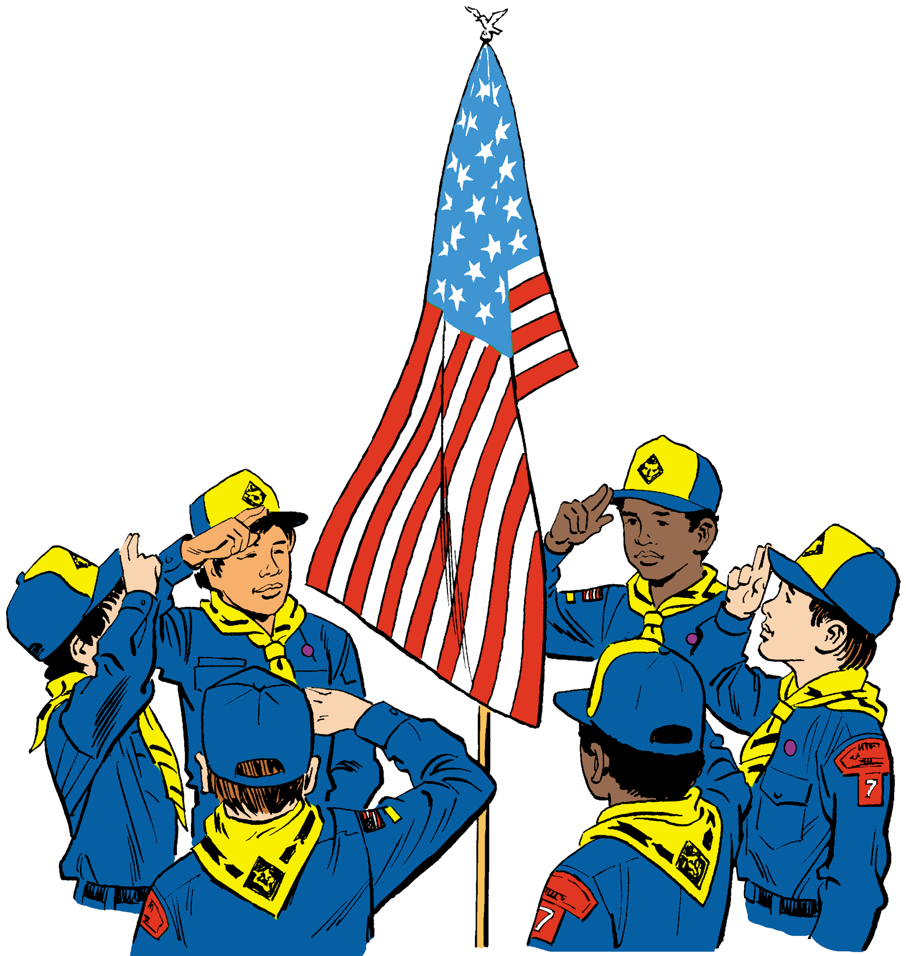

Cub Scout Orientation

My son is 8...now what does he need?
- yellow neckerchief
- slide (if wanted - we also make some)
- Wolf book
- Blue Cub Scout web belt
- Wolf Hat (if wanted)
- Scout Shirt
To go on the shirt he will need -
Utah National Parks Council Emblem
Pack Numerals 1162
World Crest Patch
These can be purchased at:
* Orem Scout Office
748 N. 1340 W. 437-6222
* Christenson’s in American Fork
56 W. Main 756-4741
* Used - Craig McDaniels
414 E. 775 N. AF 756-7364
* Used - Willard Spykes
756-7743

What do the Cub Leaders do?
The cub scout leaders plan weekly Den Meetings trying to pass off requirements for belt loops, academics and sports pins, patches, and arrow point electives. Some wolf requirements will be worked on, but we will focus mainly on belt loops, academics and sports pins, and patches. Once a month we will hold Pack meetings where families are invited to watch the scouts receive awards.

What can parents do?
First, parents can work with their Cub Scout to earn their Bobcat Rank. It is a very simple and easy rank to earn.
Next, it would really help the leaders if parents will work on wolf requirements at home with their boys and report back to leaders of finished requirements. Once wolf requirements are done, parents can also work on patches, belt loops and academics and sports pins as the boys want.
Please help your scout keep his scout uniform current with all of the awards he receives placed in the right place on the shirt, belt, and red vest.

What can the Cub Scout do?
First, the cub scout can work with their parents to earn their Bobcat Rank. It is a very simple and easy rank to earn.
The Cub Scout should attend all Den and Pack Meetings. He should read through his book on a regular basis finding things he can do on his own or with the help of a family member, then make sure it is signed off in the book.
The Cub Scout should wear his uniform (shirt, neckerchief, and slide) to all Den and Pack Meetings. Shirt should be buttoned and tucked in, and he should “Do his Best” at whatever is asked of him.

Den Doodle
Our Den made a Den Doodle, and the boys earn beads and other fun stuff to put on the den doodle every week. On one string they will get up to 8 beads a week. They are for:
1. Being on time. Be in the room by 4:00.
2. Wearing their Cub Scout Shirt.
3. Bringing their Wolf Book
4. Wearing their Neckerchief
5. Wearing the (Neckerchief) Slide of the Month
6. Wearing the Red Vest
7. Cub Scout Den Hat
8. Passing off something during the week. (Please write it on the post it note inside the front cover. Then I won’t have to look through every page every week.)
When they get 50 beads, they will be able to trade them in for a large candy bar and a feather to put at the top of their string. Then they will start all over.
On another piece of leather, they will be getting popsicle sticks to put on for every requirement they have passed off at home during the week. They will get one for every requirement you have written on the post it note at the front of their book.

What is the red vest?
At den meetings we work on patches, and pins and a lot do not go on the cub scout shirt. Those that do not can be worn on the red vest.

Den Meetings
Den Meetings are held every Tuesday (except when we have pack meetings) at 4:00 in the Relief Society room.

Pack Meetings
Pack Meetings are held every 4th Tuesday at 5:45 in the Primary Room.

Bobcat Badge
To earn the Bobcat badge, 8 things must be done at home with the family. In cub scouting, parents can and should pass off things at home. Please write them in your book.

Wolf Badge
After you have earned the bobcat badge, you should work on the Wolf badge. To earn the Wolf badge, there are about 50 requirements that must be done. Some of them they can only work on at home with their family. They are listed on another page. Please work on those with your cub scout and then start on the others.

Boys Life
This is a magazine for Cub Scouts and the boys really enjoy reading it. Boys can earn a Boys Life patch by reading the magazine and doing a few other things.

