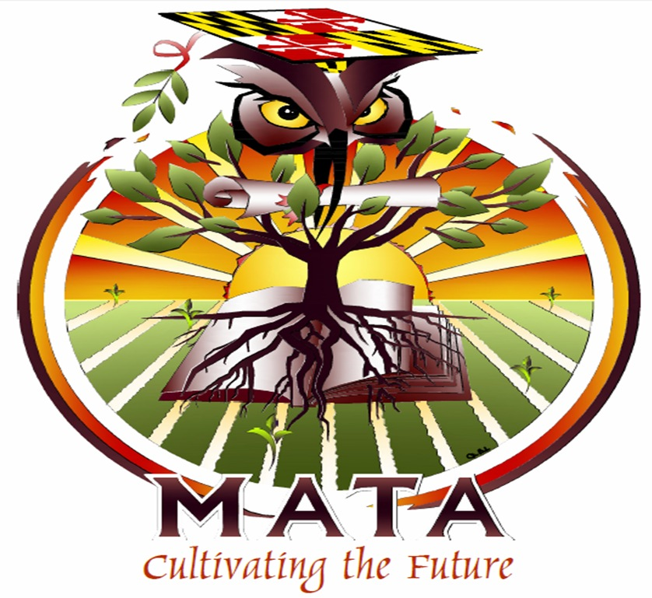
Maryland Agriculture Teachers Association
Board Meeting Minutes

November 15, 2017

------------------------------------------------------------------------------------------------------------

The MATA Board meeting was held at Winters Mill High School on Wednesday, November 15, 2017. President Mike Harrington called the meeting to order at 5:30 PM. Those in attendance were:
- President – Mike Harrington
- Past President – Diane Safer
- Secretary – Quinn Cashell
- Treasurer – Roy Walls
- Reporter – Tom Mazzone
- Membership Chair: Bridget Nicholson (via conference call)
- Guest: Naomi Knight

Reflections were provided by Tom Mazzone.

Secretary’s Report
Quinn provided a copy of the minutes from the October meeting. Bridget Nicholson moved to accept the minutes as presented. Diane Safar second, motion passed.

Treasurer’s Report
Roy Walls provided his detailed report.

Total Income: $10,121.12
Total Expenses: $10,751.76
Fiscal Year Total: -$630.64
Overall Total: $30,641.12

Diane Safar moved to file for audit, Tom Mazzone seconded, motion passed.

Membership Report
Roy Walls sent the membership update:

MATA Active: 28
MATA Affiliate: 1
MATA Associate: 1
MATA Life: 20

NAAE Active: 18
NAAE Life: 19
ACTE Active: 5
NAAE Magazine: 3

Committee Reports

Summer Conference
Naomi Knight reported on the 2018 Summer Conference, which will be held July 9-11, 2018. She provided a detailed draft schedule. Diane Safar is working on submitting MSDE credit approval. We reviewed the drafted schedule.

Mentoring Committee
Quinn Cashell provided and update on the mentorship program.

Unfinished Business

NAAE National Convention
Tom Mazzone and Aaron Geiman are going to represent Maryland at NAAE National Convention, held in Nashville, TN fom December 5-9, 2017. Aaron Geiman will have six specific responsibilities for MATA while at NAAE Convention and upon return from the Convention. Bridget Nicholson moved to reimburse Aaron Geiman up to $300 for NAAE Convention expenses, Tom Mazzone seconded, motion passed. Diane Safar moved to nominate Tom Mazzone our second delegate, Bridget Nicholson seconded, motion passed.

Farm Bureau Convention
Convention is held on December 3 – 5, 2017 in Ocean City, Maryland. We are looking for a member to attend. Registration is due October 26, 2017. Naomi Knight will represent MATA at this Convention.

New Business

Mayland Council for Ag Ed (MCAE)
Mike Harrington will reach out to to Lifetime MATA members to seek representation for MATA on the Maryland Council for Ag Education.

12 Month Employment Committee
We discussed the relevance of the extended contract committee. We decided to table the committee at this time.

Strategic Plan Review
Mike Harrington wanted everyone to review the Strategic Plan at the January meeting.

Taste of Maryland Dinner
We have budgeted for two representatives to attend the Taste of Maryland Dinner on February 1, 2018 at Michael’s 8th Avenue. Tom Mazzone and Lori Mayhew will be attending.

Bridget Nicholson moved to adjourn, Tom Mazzone seconds, motion passed. Motion adjourned at 7:24 PM.

Respectfully Submitted,
Quinn Cashell
MATA Secretary

