Maryland FFA State Convention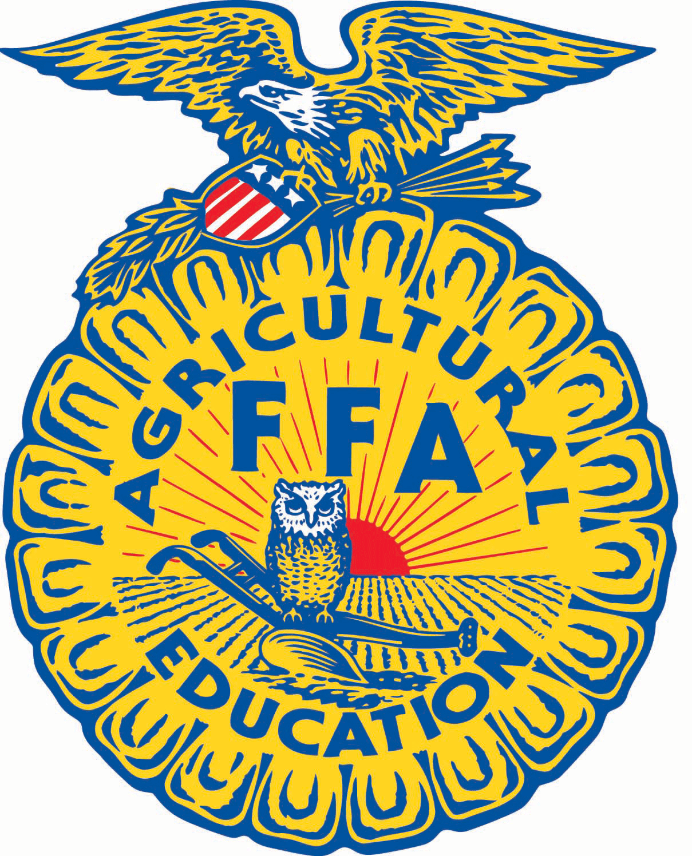

Garrett College

McHenry, MD

Dear Parents/Guardians:

On Monday, June 23rd through Wednesday, June 25th, 2024, the __________________ FFA will be participating in the Maryland FFA State Convention at Garrett College in McHenry, Maryland. Students should arrive at ____________________ by ______________ on June____________. Students can be picked up around _________________ from_____________ on June ________________ . The last session is scheduled to end at 3:00pm, however they may run a little under or over their estimated time. Please see advisors for further instructions if needed. Lunch and Dinner will be provided for registered students for the day(s) of their attendance. Food during travel times is not included in the registration fee.

__________________________ County Public Schools makes every effort to assure student and staff safety on field trips. We do not anticipate unusual travel risks. However, due to security concerns in our nation, we are requiring that all students return the permission slips below inclusive of providing contact information.

Your child must wear **FFA OFFICIAL DRESS** on all days of convention. Please bring some casual attire for when it is appropriate. Official dress consists of the following: Boys – black dress slacks, white button-up collared shirt, black socks, black DRESS SHOES, FFA jacket and FFA tie; Girls – straight black dress skirt to the knees, white button-up collared shirt, black hose (extra pairs), black dress shoes (closed toe and heel), FFA jacket and FFA scarf. **If your child does not own an FFA jacket they should see an advisor prior to the last day of school for a jacket to borrow.**  Students may want to bring some spending money for the FFA Mall and study materials for their contest.

A remaining balance of $__________ towards their trip to the Maryland State FFA Convention is due.

The attached forms need to be filled out and returned by_____________________________. Call or email if you have any questions. **Please complete and return the MD FFA Waiver along with this permission slip by _________________________________________.**

Best regards,

____________________________

___________________________

------------------------------------------------------------------------------------------------------------

______________________ has my permission to participate in the Maryland FFA Convention Monday, June 23rd through Wednesday, June 25th, 2025, at Garrett College, McHenry, MD. I understand that the _________________________ County Public Schools/Board of Education and its employees, agents and volunteers cannot be held responsible for events or conditions beyond their control. I am aware that all Board of Education student conduct policies are in effect for this activity.

Parent Signature: _________________________ Student Name: _________________

Home Phone: ____________________________ Cell Phone: ____________________

Employer/Company Name: _________________ Work Phone: __________________

Date: ________________