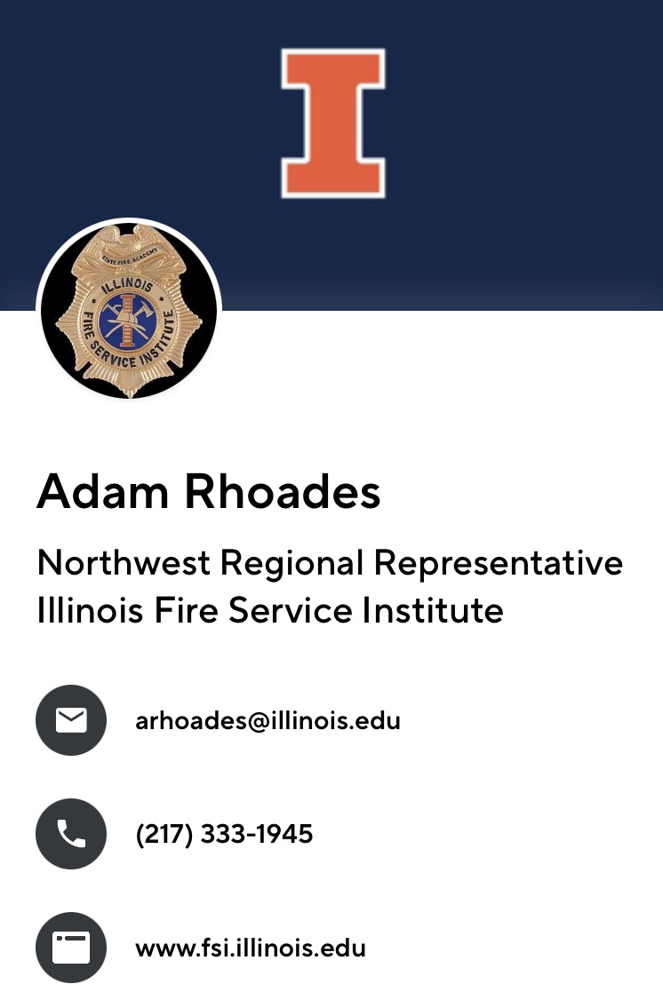

All

IFSI Cornerstone classes that have been scheduled in the Northwest Region. If any of you are interested in attending and need help with registration, please let me know.

Thanks

Adam Rhoades
Illinois Fire Service Institute I University of Illinois
Northwest Regional Representative
LP Program Manager - Interim
217-333-1945
arhoades@illinois.edu



https://www.fsi.illinois.edu/content/information/regions/detail.cfm?region_id=3

This link should take you directly to ALL classes scheduled in the NW region.

CLASS | DATE(S) | HOST-LOCATION | TIMES
Fire Origin and Cause Awareness | Tuesday February 18, 2025 | Blackhawk FPD  102 3rd St W  Milan, IL 61264 | 1800-2200
Basic Company Officer | Saturday February 22, 2025 | Colona Community FPD  401 1st St  Colona, IL 61241 | 0800-1700
Hazardous Materials Awareness | Sunday February 23, 2025 | Central Warren FPD  405 E Walnut St  Kirkwood, IL 61447 | 0800-1700
Wildland Fire Training for Structural Firefighters | Friday February 28, 2025  Saturday March 1, 2025  Sunday March 2, 2025 | Knoxville Community FPD  137 N Public Square  Knoxville, IL 61448 | Friday 1800-2200  Saturday and Sunday 0800-1700
iPumps | Session 1 Saturday March 8, 2025  Session 2 Sunday March 9, 2025 | Quincy FD Training Site  1900 Seminary Rd  Quincy, IL 62301 | 0800-1200  Each Day
Routine Emergencies | Saturday March 8, 2025 | Knoxville Community FPD  137 N Public Square  Knoxville, IL 61448 | 0800-1700
Company Officer Fire Officer 1  Blended | Session 1 March 10, 2025  Session 2 March 10 – April 5, 2025  Session 3 April 7 – 11, 2025  Session 4 April 21-25, 2025 | Moline FD  1630 8th Ave  Moline, IL 61265 | Session 1, 3, 4  0800-1700  Session 2  Online
Routine Emergencies | Tuesday March 11, 2025 | Blandinsville-Hire FPD  110 E Jefferson St  Blandinsville, IL 61420 | 1800-2200
All Hazards Planning Section Chief | Tuesday March 11, 2025  Through  Friday March 14, 2025 | Henry County Office of Emergency Management  4424 US Highway 34  Kewanee, IL 61443 | 0800-1700  Each Day
Hazardous Materials Awareness and Operations | Saturday March 15, 2025  Sunday March 16, 2025  Saturday March 22, 2025  Sunday March 23, 2025 | Cordova FPD  906 Main Ave  Cordova, IL 61242 | 0730-1830  All Sessions Mandatory
Wildland Fire Training for Structural Firefighters | Friday March 14, 2025  Through  Sunday March 16, 2025 | RSP&E FPD  571 IL 116  Roseville, IL 61473 | Friday  1800-2200  Sat/Sun  0800-1700
All Hazards Liaison Officer | Monday March 17, 2025  Through  Tuesday March 18, 2025 | Henry County Office of Emergency Management  4424 US Highway 34  Kewanee, IL 61443 | 0800-1700  Each Day
Instructor I | Monday March 17, 2025  Through  Friday March 21, 2025 | Monmouth FD  601 Industrial Park Dr  Monmouth, IL 61462 | 0800-1700  Each Day
Fire Behavior and Reading Smoke | Tuesday March 25, 2025 | Osco Community FPD  201 S Washington St  Osco, IL 61274 | 1800-2200
Essentials III | Saturday March 29, 2025  Through  Sunday March 30, 2025 | Little York FPD  105 E Main St  Little York, IL 61453 | 0800-1700  Each Day
Essentials IV | Saturday April 5, 2025  Through  Sunday April 6, 2025 | Little York FPD  105 E Main St  Little York, IL 61453 | 0800-1700  Each Day
Leadership so Everyone Goes Home | Wednesday April 23, 2025 | Williamsfield FPD  200 E Gale St  Williamsfield, IL 61489 | 1800-2200
Traffic Incident Management | Wednesday May 14, 2025 | Williamsfield FPD  1479 Knox Rd 1725 N  Dahinda, IL 64128 | 1800-2200

