NORTHWEST
CORNERSTONE REGION

Training Opportunities

For additional information about all cornerstone classes go to the IFSI web site website at www.fsi.illinois.edu

https://www.fsi.illinois.edu/content/courses/programs/cornerstone/

UPDATED 2/27/2023

For NW region training check out:

https://www.fsi.illinois.edu/content/information/regions/detail.cfm?region_id=3

This link should take you directly to ALL classes scheduled in the NW region.

CLASS | DATE(S) | HOST-LOCATION | TIMES
Anhydrous Ammonia Emergencies | Saturday  March 4th | Toulon FD  STARK COUNTY | 0800  To  1400
Courage to be Safe | Monday  March 20th | Camp Point FD  ADAMS COUNTY | 1800  To  2200
Traffic Incident Management | Monday  March 20th | Colona FD  HENRY COUNTY | 1800  To  2200
Essentials I | Saturday & Sunday  March 25th and 26th | Williamsfield FPD  KNOX COUNTY | 0800  To 1700  Each Day
Pre-Fire Planning | Wednesday  April 5th | Williamsfield FPD  KNOX COUNTY | 1800  To  2200
CLASS | DATE(S) | HOST-LOCATION | TIMES
Hazardous Materials Awareness | Saturday  April 22nd | Cordova FD  ROCK ISLAND COUNTY | 0800  to  1700
LP | Tuesday  May 9th | Industry FD  MCDONOUGH COUNTY | 1800  To  2200

Don’t forget to check out Team
IFSI Training Resources
At
https://fsi.illinois.edu/resource_center/department/team_ifsi.cfm?
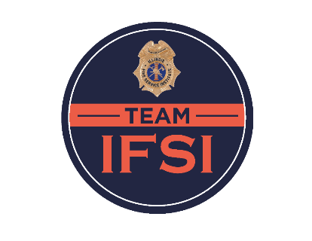
- IFSI has developed a basic three-year cycle training plan, to include support materials that allow a training officer or company officer to provide a fundamental and comprehensive training program for their department or crew. This training program takes into account annual training requirements that a department is expected to meet and includes a broad spectrum of training subjects.
- Team IFSI supporting materials are packaged in an easy-to-use lesson plan. They include access to PowerPoint presentations, skill sheets, drill plans, and supporting video materials that are needed to deliver quality and effective training. All Team IFSI resources are available at no-cost to departments. IFSI student or staff login is required to access the materials through the IFSI Student and Staff Resource Center.
- We invite your department to take advantage of all of the Team IFSI Training resources

For more information on Team IFSI Training, contact Tom Shubert tshubert@illinois.edu

