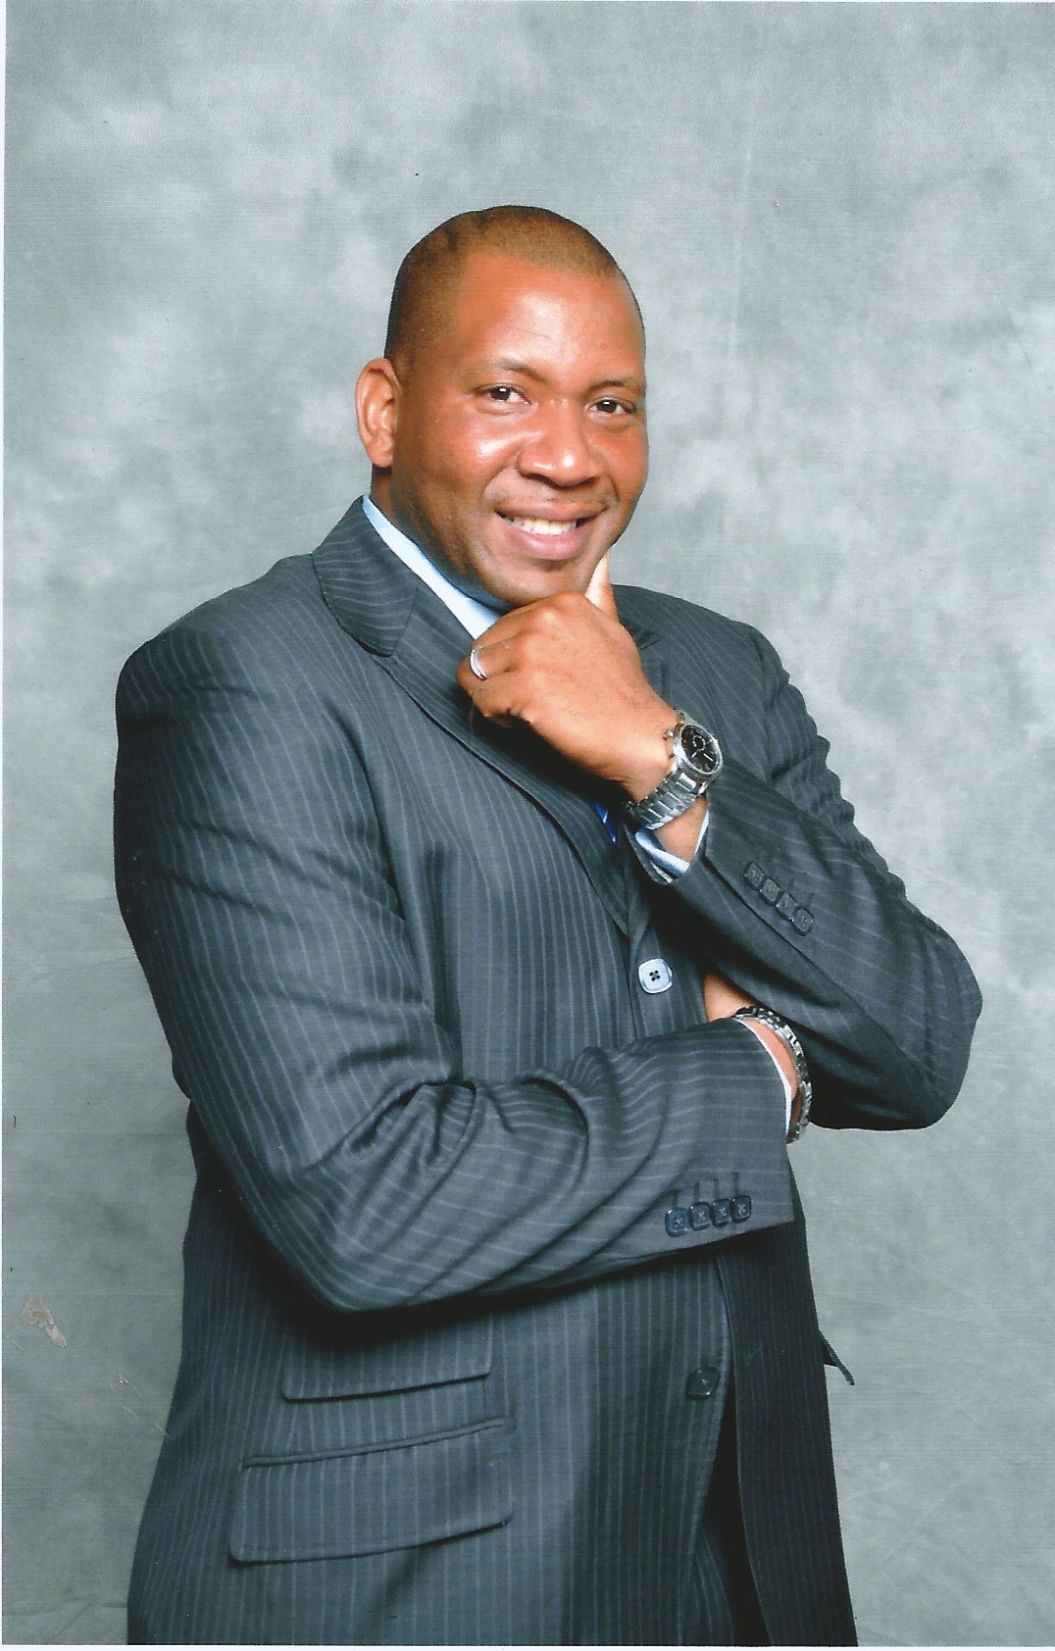

Biography of Rev. Dr. Johnnie D. Brooker

Rev. Dr. Johnnie D. Brooker, Jr. is a graduate of Rutgers University in New Brunswick, NJ and Drew University Theological School in Madison, NJ. He received a Bachelor of Arts degree in Psychology and Criminology from Rutgers and a Master of Divinity and Doctor of Ministry Degree from Drew. He also received two ministerial certificates from the accredited Divinity Bible Institute in East Orange, NJ.

When Rev. Dr. Brooker graduated from college, he began taking pre-med classes at Kean University with the expectation of attending a medical school in the near future. However, God had other plans for his life. On January 12, 2002, he became a licensed preacher under the leadership of Rev. Bennett Johnson of the Greater Mt. Moriah Missionary Baptist Church in Newark, NJ. On Friday March 23, 2007, he was ordained by the New Hope Missionary Baptist Association, which would help him fulfill all that comes with Christian ministry. On April 1, 2007 (Palm Sunday) he began his first Sunday as Senior Pastor of the Mt. Zion Baptist Church of Dover, NJ.

In September 2000, he found himself a good thing, his wife, Ayanna. On October 12, 2002, the two united in holy matrimony. Although his wife is an attorney and works full time for Liberty, she is dedicated to working closely with her husband in the ministry as an associate minster of the Mt. Zion Baptist Church. Together, they have one son, Johnnie Elisha, III, and one daughter, Annaya Kai.

Lastly, but certainly not least, Rev. Dr. Brooker strongly believes and stands on Ephesians 3:20, “Now, unto Him who is able to do exceedingly, abundantly above all that we ask or think according to the power that works in us. Amen”

