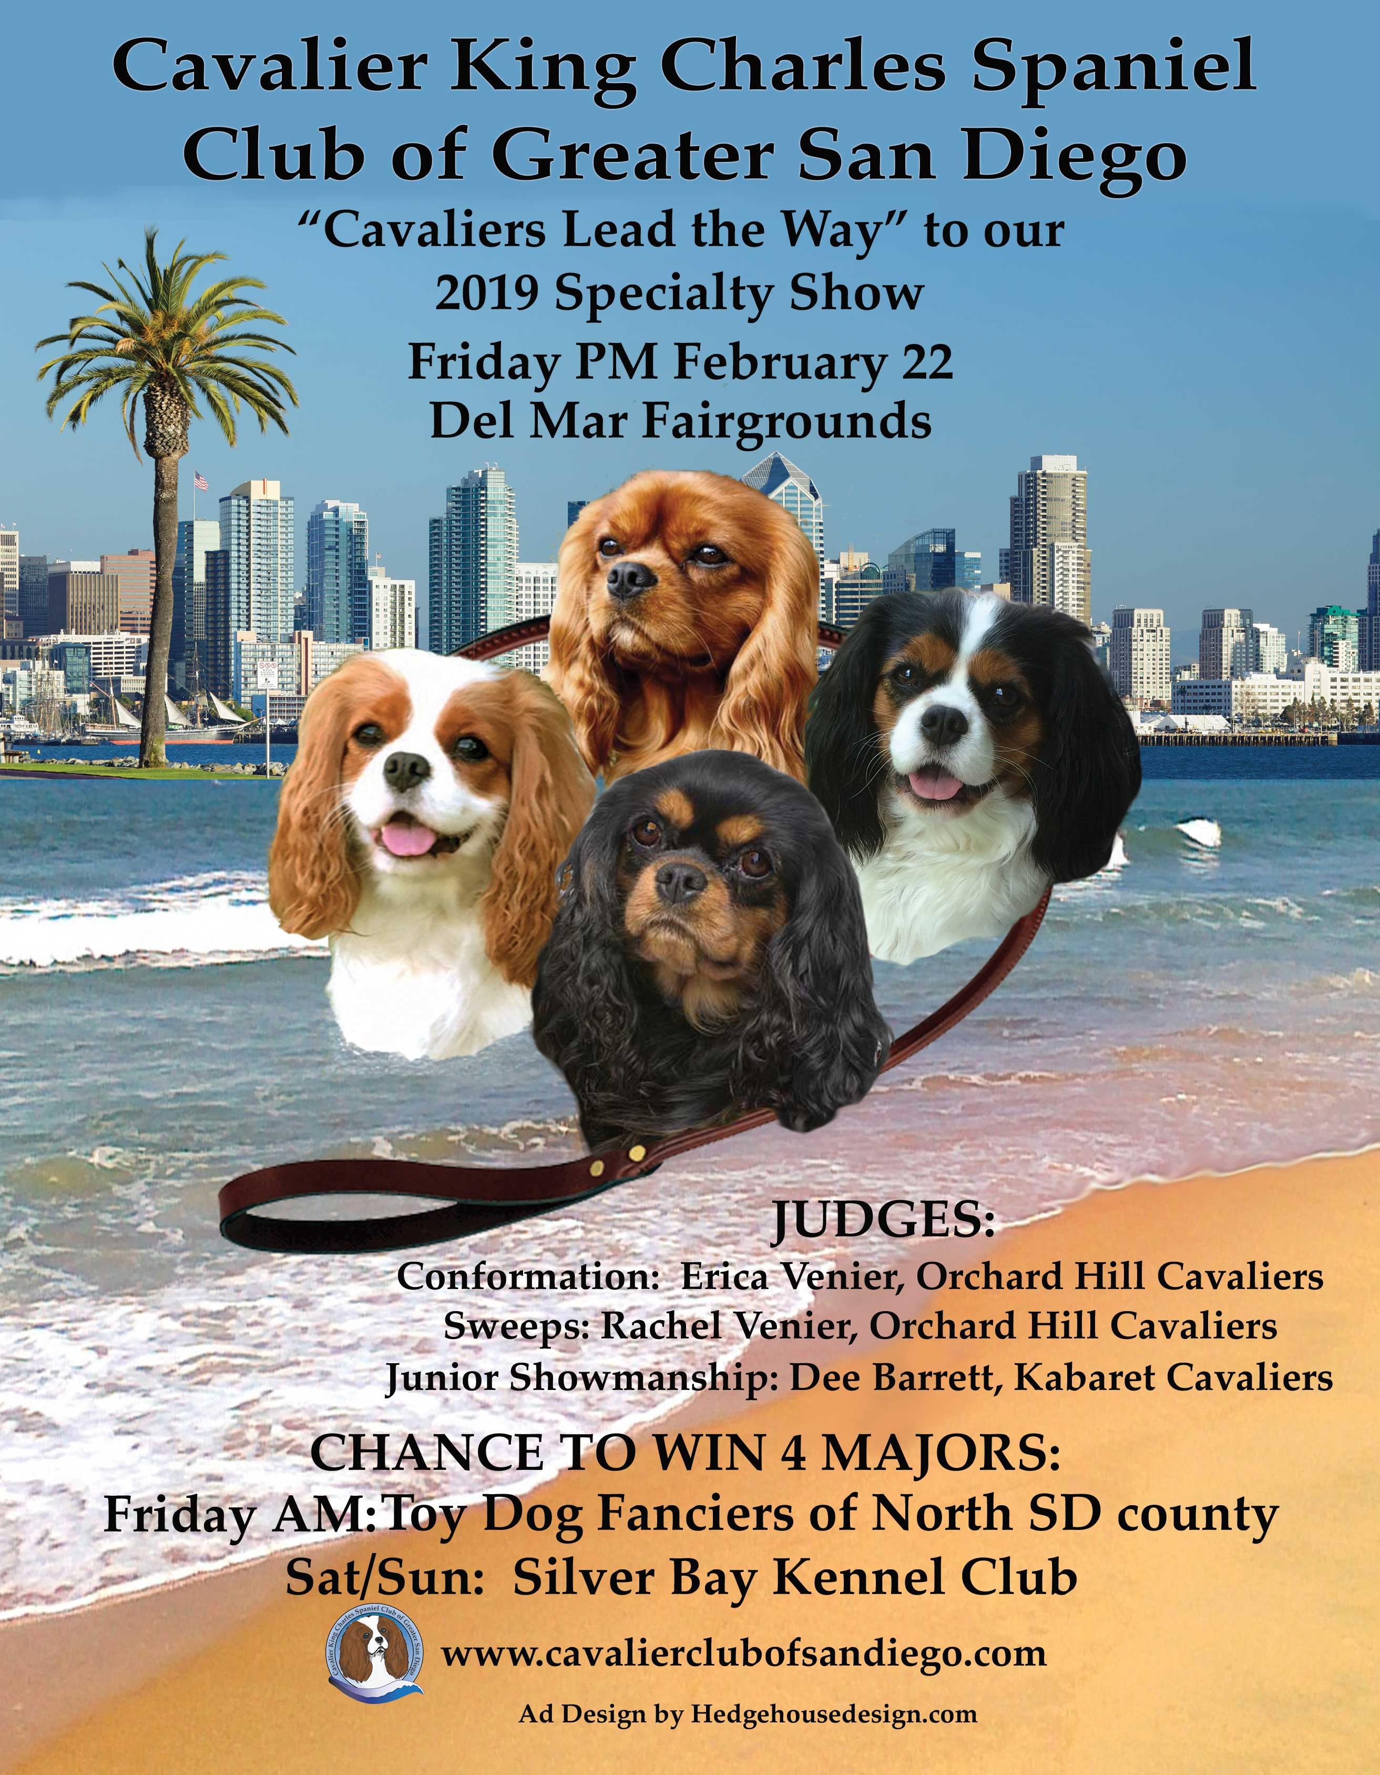

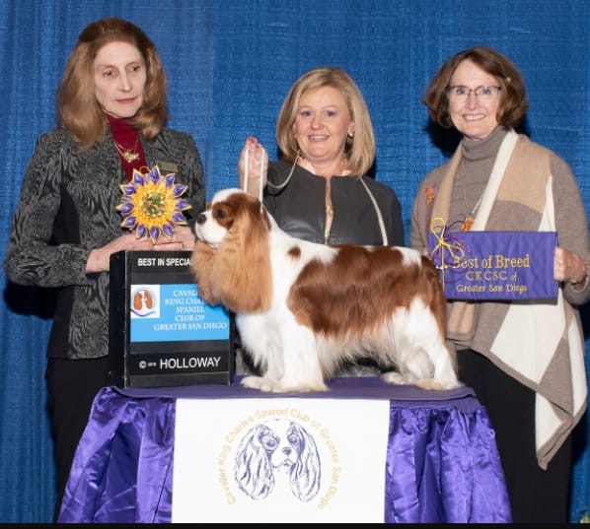

2019 BEST IN SPECIALTY WINNER
GCHG Brookhaven Here Comes Hogan, Owners Susan Savage Green, Paula Ayers and Brenda Martz, Breeders Paula Ayers & Brenda Martz, Judge Erica Venier

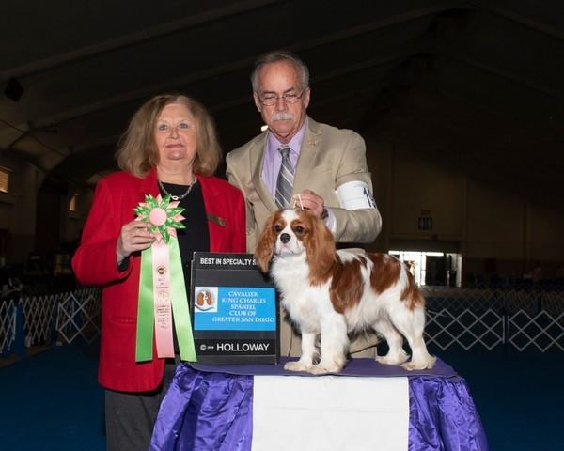

2019 BEST PUPPY IN SWEEPSTAKES WINNER
Cottfordcourt Venetian (Gwen Crawford & Sue Miller owners & Breeders) Judge Janice McClary
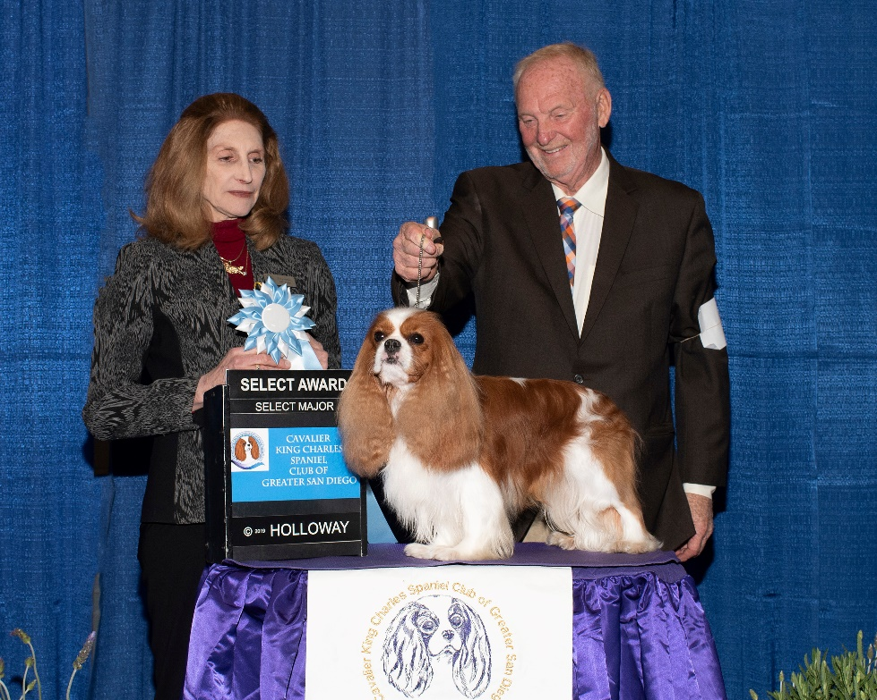
2019 SELECT DOG
GCH Forestcreek Grayton (Owners Jeff & Tami Doniere-Byroads & Dr. Kevin & Debra Cline; Breeders Dr. Kevin & Debra Cline) Handled by Bruce Schultz, Judge Erica Venier

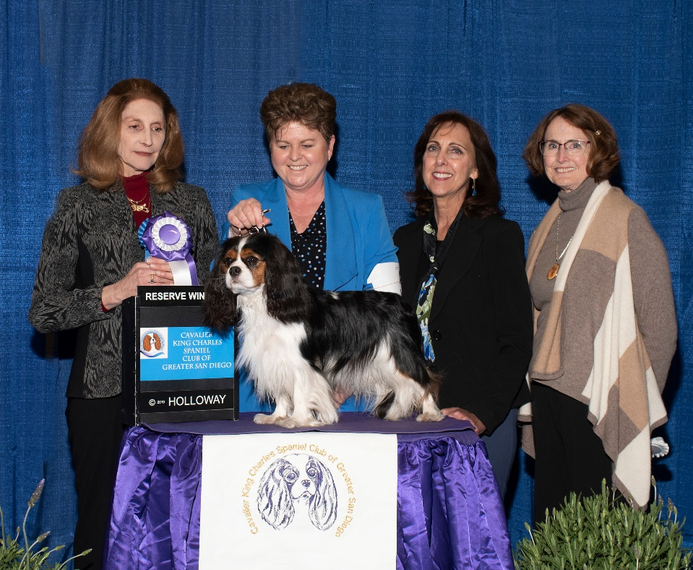

2019 RESERVE WINNERS BITCH
Compatible Sky’s The Limit (Owners & Breeders Marian Palmieri & Janice Hochstetler) Shown by CJ Brogan, Judge Erica Venier
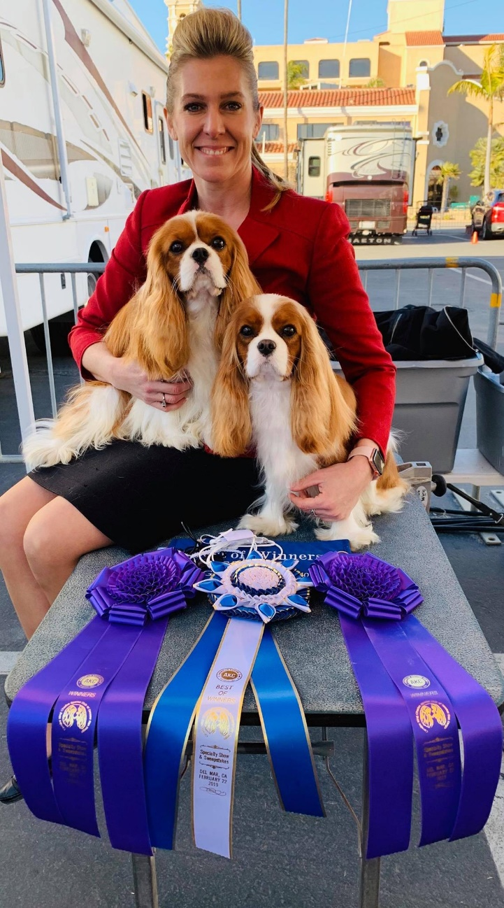
2019 BEST OF WINNERS
Ivyline Go-Go Girl (Owner & Breeder Ivy Giampapa ) Judge Erica Venier
And
2019 WINNERS DOG:
Ivyline Rhinestone Cowboy (Owner/Breeder Ivy Giampapa) Judge Erica Venier
Both Handled by Janice Hays

