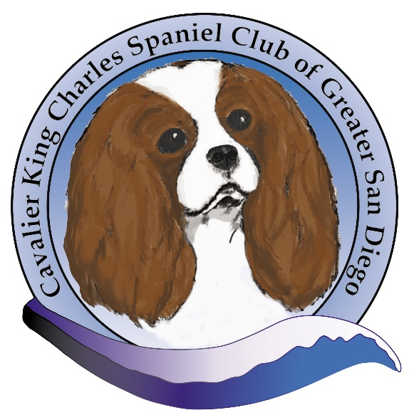

**CAVALIER KING CHARLES SPANIEL CLUB OF GREATER SAN DIEGO THANKS THE FOLLOWING FOR SPONSORING OUR TROPHIES FOR OUR 2021 SPECIALTY:**

**Best of Breed: Tami & Jeff Byroads**

**Best of Opposite Sex: Audrey & Kent Johnson**

**Best of Winners: Lisa Falchetti**

**Best of Opposite Sex: Dr. Kevin & Mary Sharp**

**Grand Champion Select Dog: Dr. Kevin & Mary Sharp**

**Grand Champion Select Bitch: Audrey & Kent Johnson**

**Winners Dog: Shirley Wilson**

**Winners Bitch: Topmeadow Cavaliers**

**Best Puppy: Audrey & Kent Johnson**

**Best Bred by Exhibitor: Jody Sutton**

**Best Veteran: Margaret Mazotta**

**General Trophy Donations: Margaret Mazotta, Topmeadow Cavaliers**