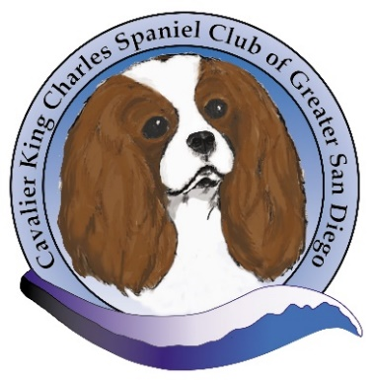

CAVALIER KING CHARLES SPANIEL CLUB OF GREATER SAN DIEGO
2021 SPECIALTY, MRS. PATRICIA TROTTER JUDGING
CONGRATULATIONS TO THE FOLLOWING
BEST OF BREED
GCHB CASTLE PEAK FIELD OF DREAMS CGC
Owned by Rebecca Lofholm & Patricia Johnson
BEST OF WINNERS
SPICE RACK INDICA FREDDY
Owned by Kelly Collins, DVM & Rani Max
BEST OPPOSITE
SPICE RACK SUFIN SAFARI
Owned by Kelly Collins, DVM, &William Junk
SELECT DOG
GCH ROSERIVER DENALI AT COTTFORDCOURT
Owned by Sue Miller & Gwen Crawford
SELECT BITCH
SPICE RACK ESCAPE THE MAZE
Owned by Kelly Collins, DVM
BEST OF BRED BY OWNER HANDLER
CH DEL SOL MAGIC CARPET
Owned by John Macrae & Mary McHenry

