CONGRATULATIONS TO OUR WINNERS OF OUR FEBRUARY 21ST 2020 SPECIALTY!

BEST OF BREED and BEST OF OWNER HANDLER
GCH MILBU JIM-DANDY
Owned by Jill K. Sherrin

BEST OF WINNERS
SWEETGOLD BRADLEY
Owned by Susan Green

BEST OF OPPOSITE SEX
GCH SHEEBA HENRIETTA
Owned by Suzanne Robinson & Karin Ostmann & Danna Robinson-Saathoff

SELECT DOG
GCHP BROOKHAVEN HERE COMES HOGAN
Owned by Susan savage Green & Paula Ayers & Brenda Martz
SELECT BITCH
CH STARRING ALL THE CATS MEOW
Owned by Jennifer Flowers Foster

BEST PUPPY IN SWEEPS
KELL’S BESAME MUCHO
Owned by Christian Alejandro Diaz

BEST OPPOSITE PUPPY IN SWEEPS
MAISON DU NICOLE
Owned by Jill & William Schuberth

BEST VETERAN IN SWEEPS
GCH BRIARCREST BURBERRY CGCA CGCU RE CDX THDN TKN
Owned by Gail Katz

TO SEE DETAILS ON ALL WINNERS AND CLASSES CHECK JACK BRADSHAW DOG SHOW SUPERINTENDENT WEBSITE.

Scroll down to view the Candid photos of the 2020 Specialty!

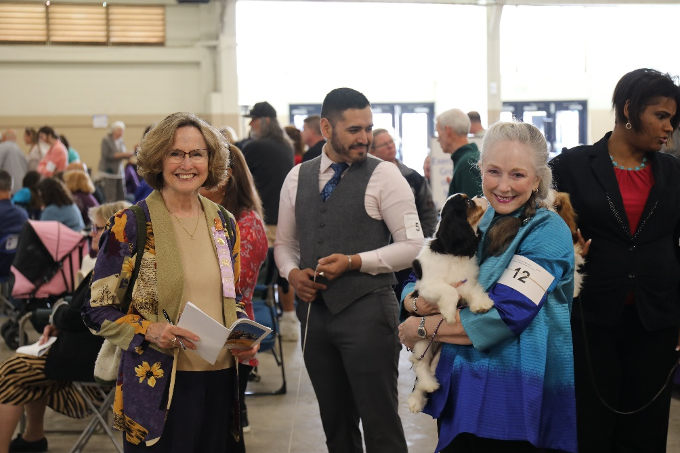
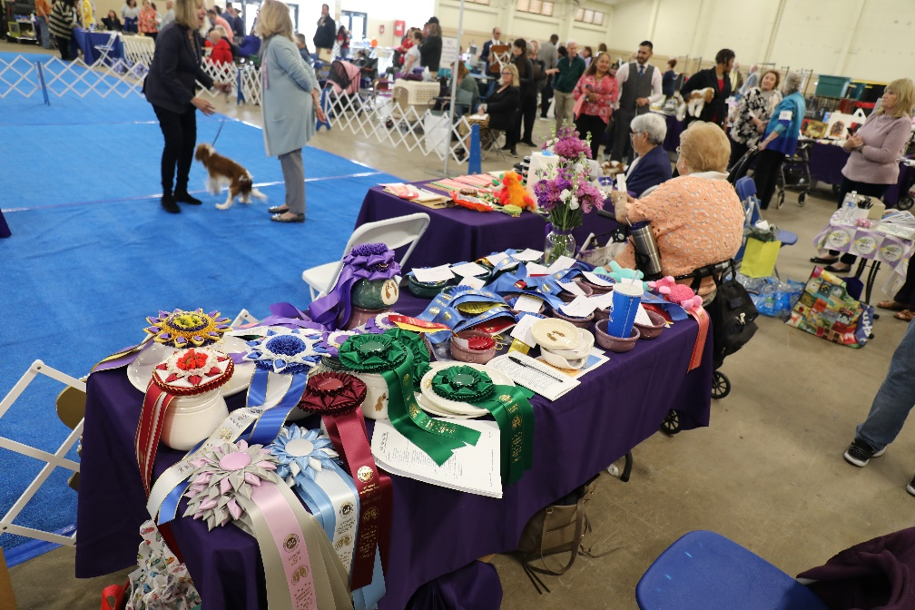
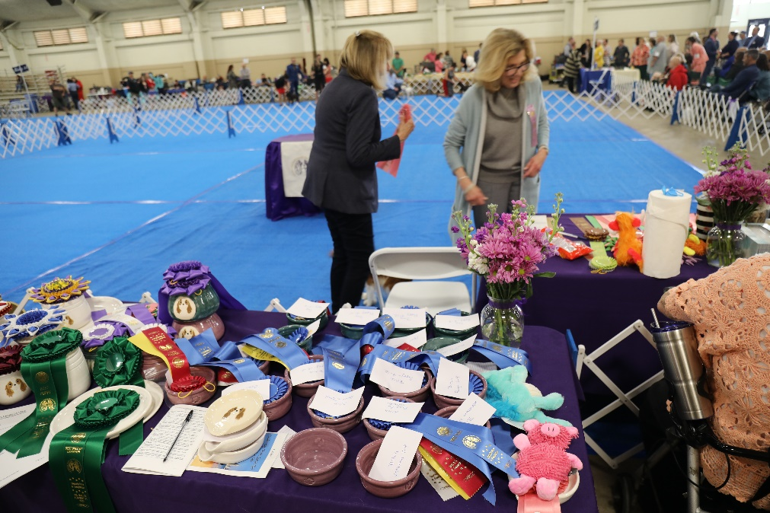
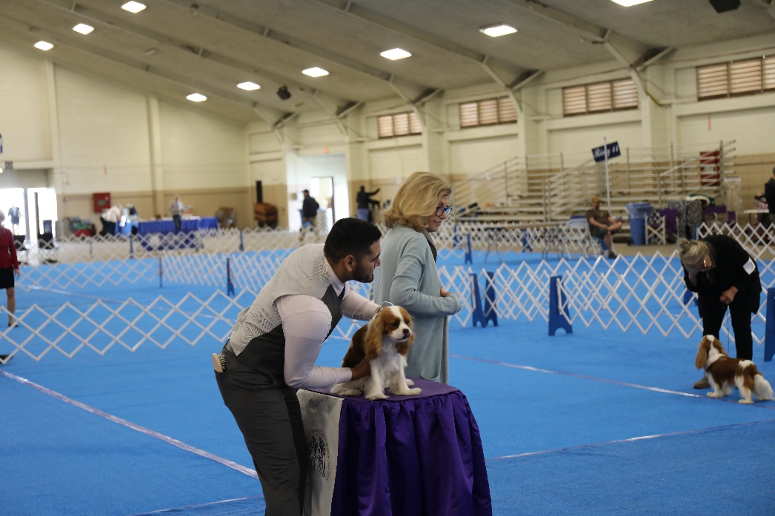
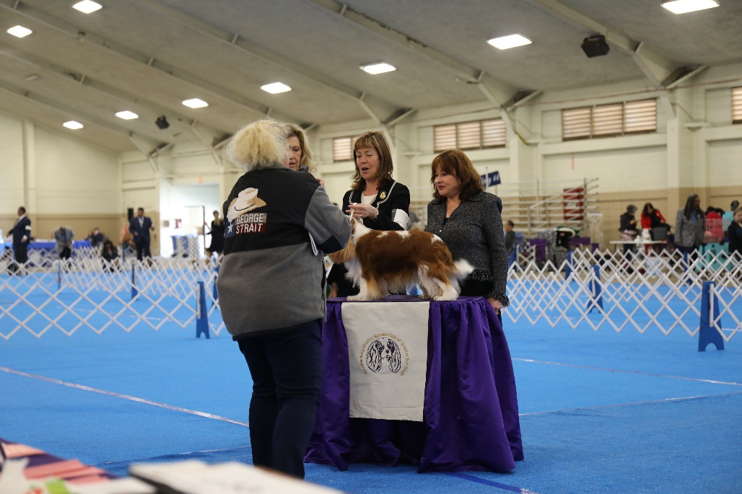
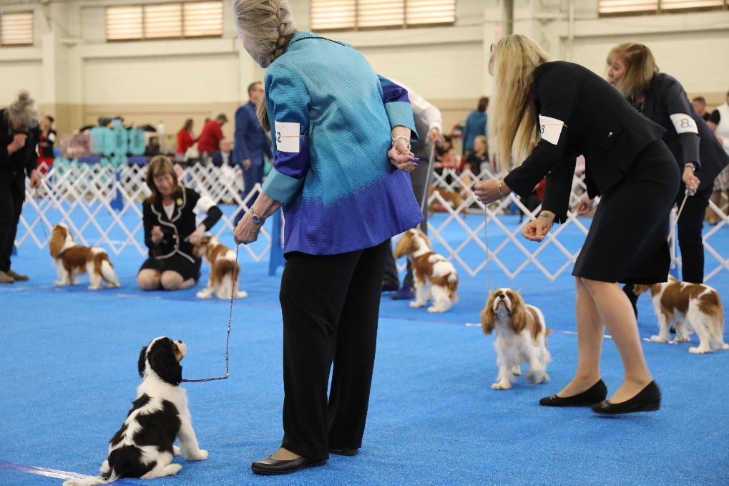
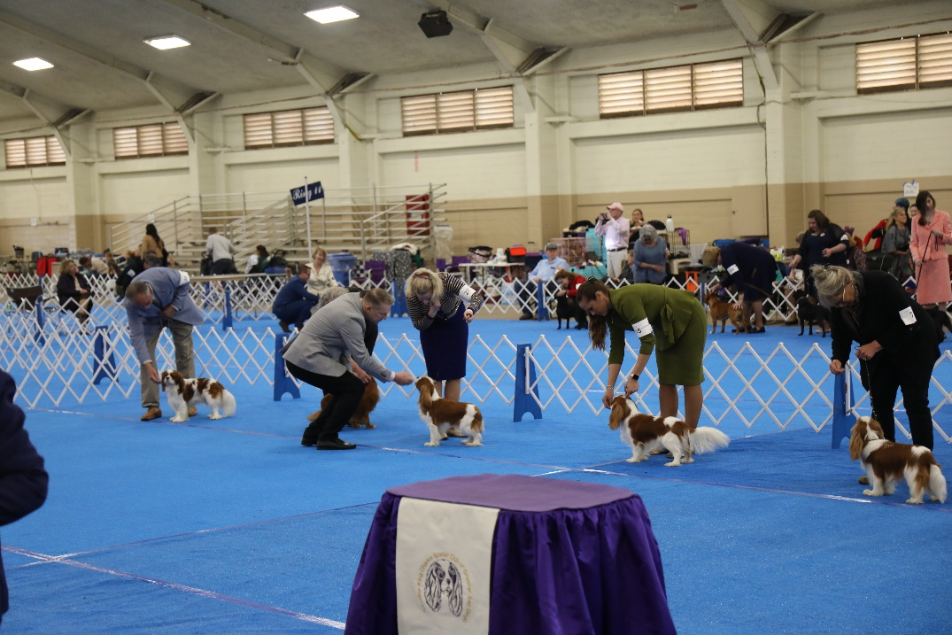
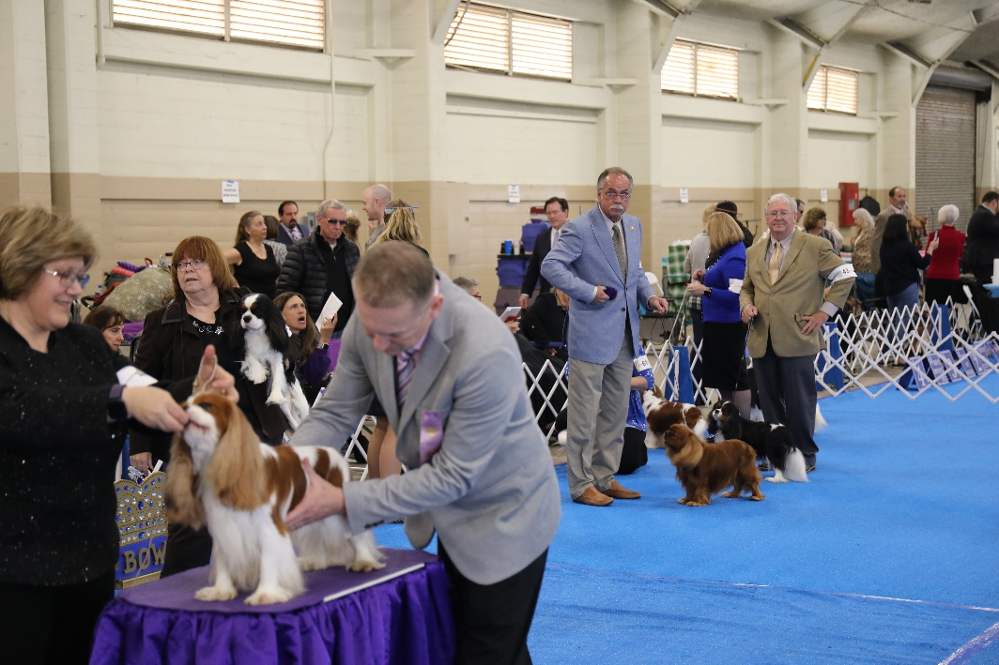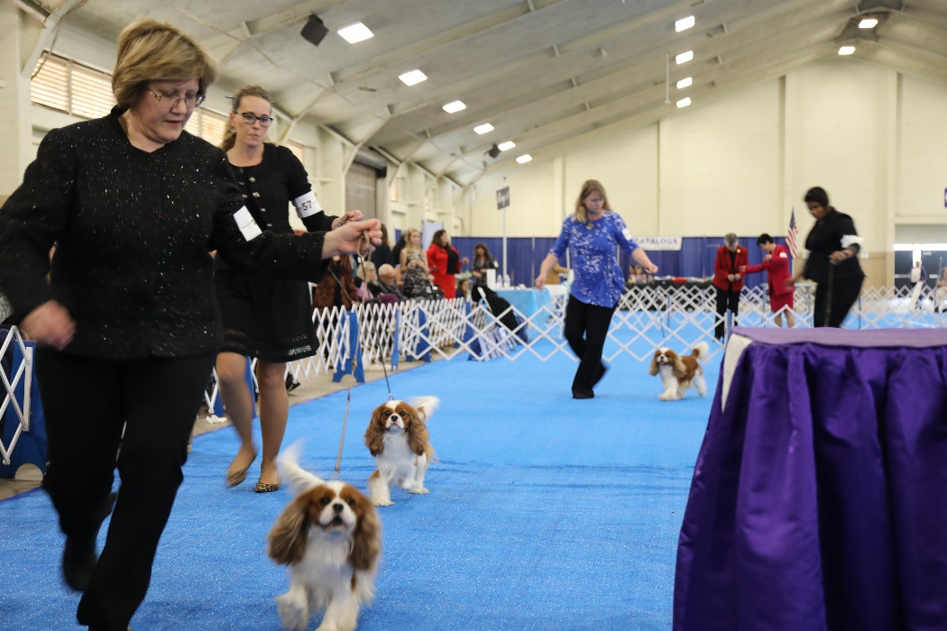
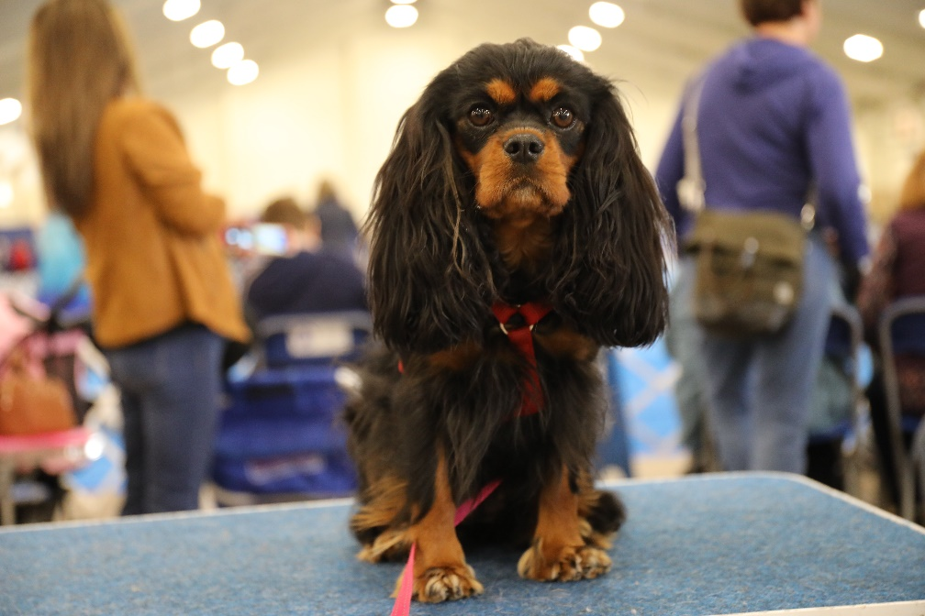
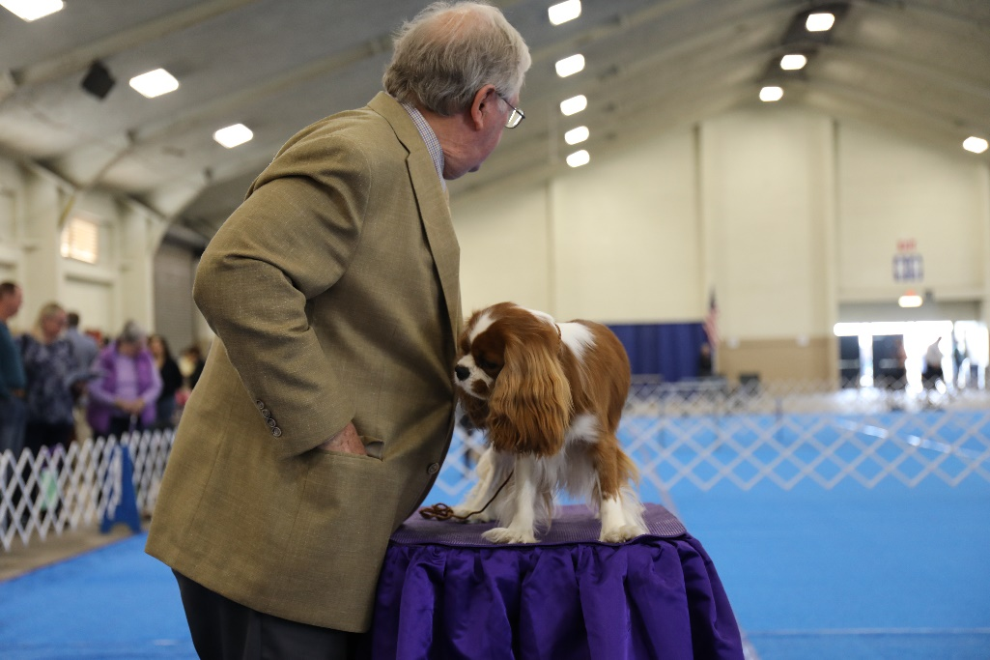
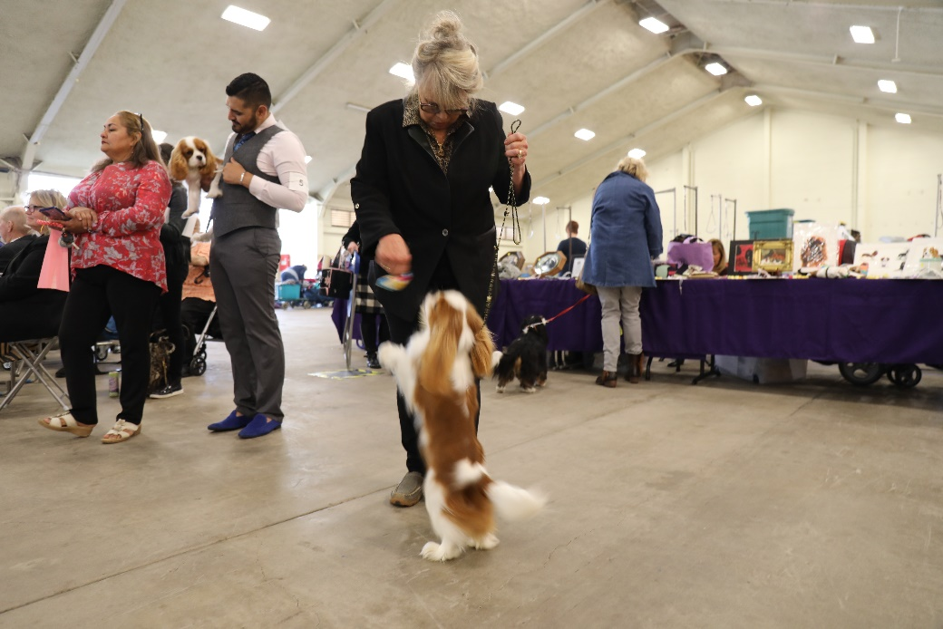
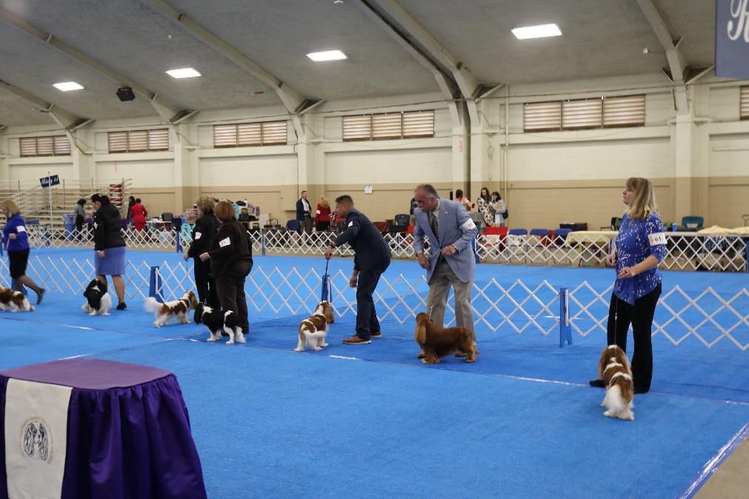
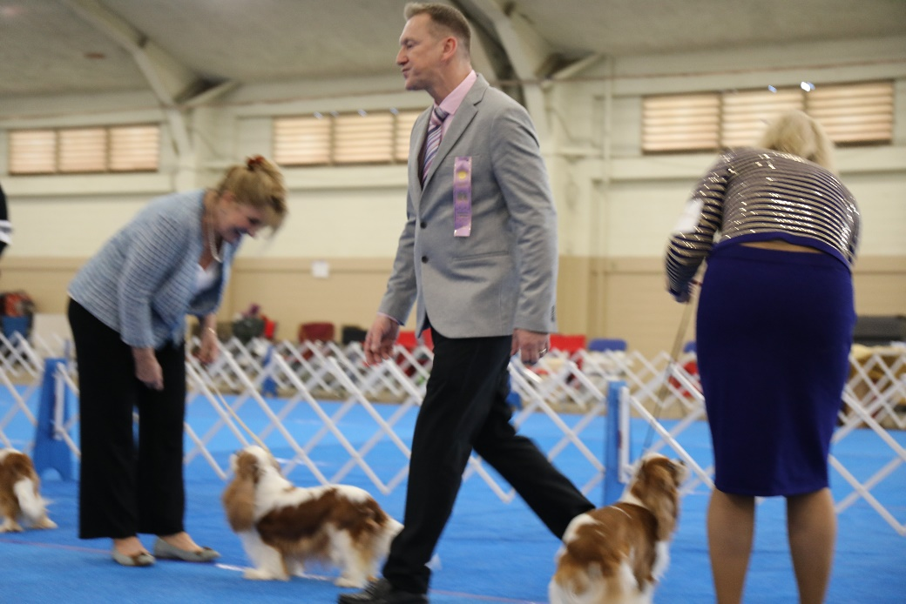
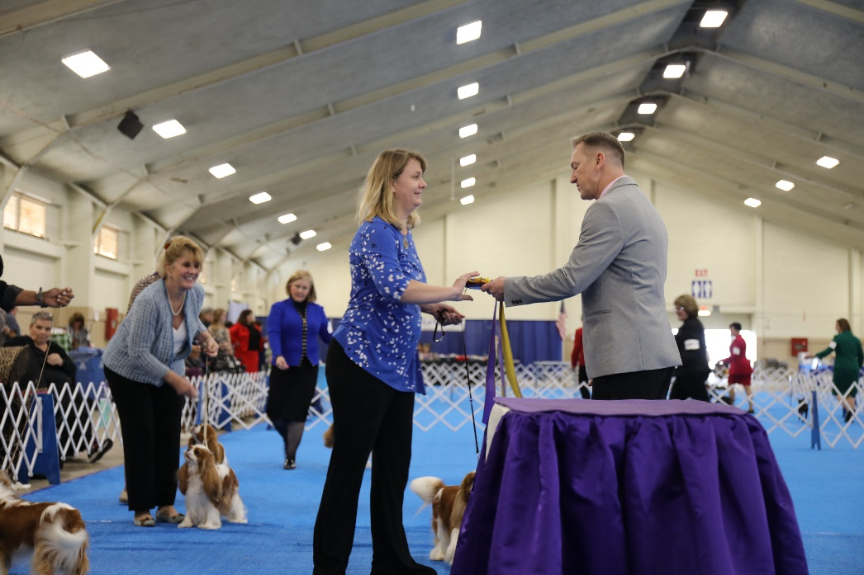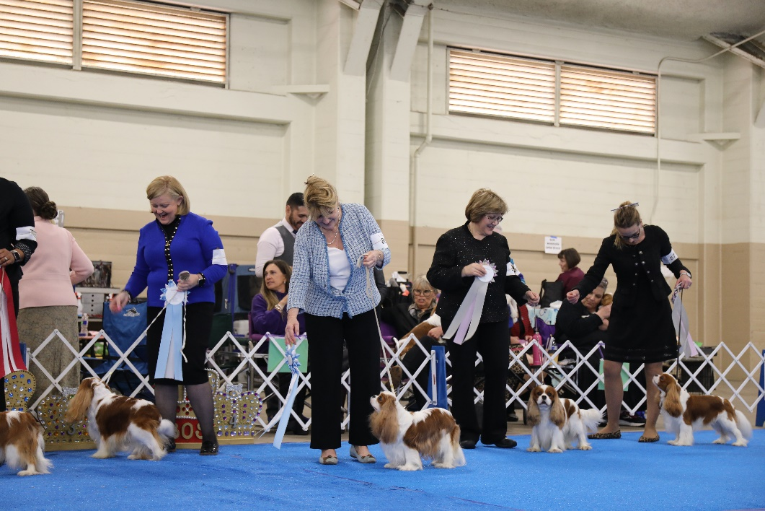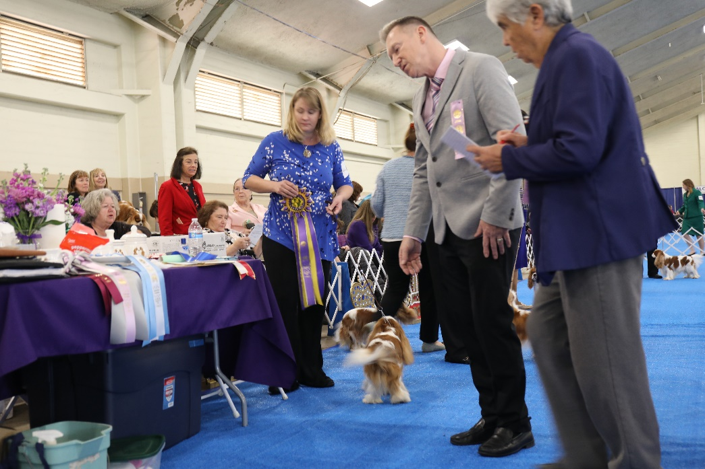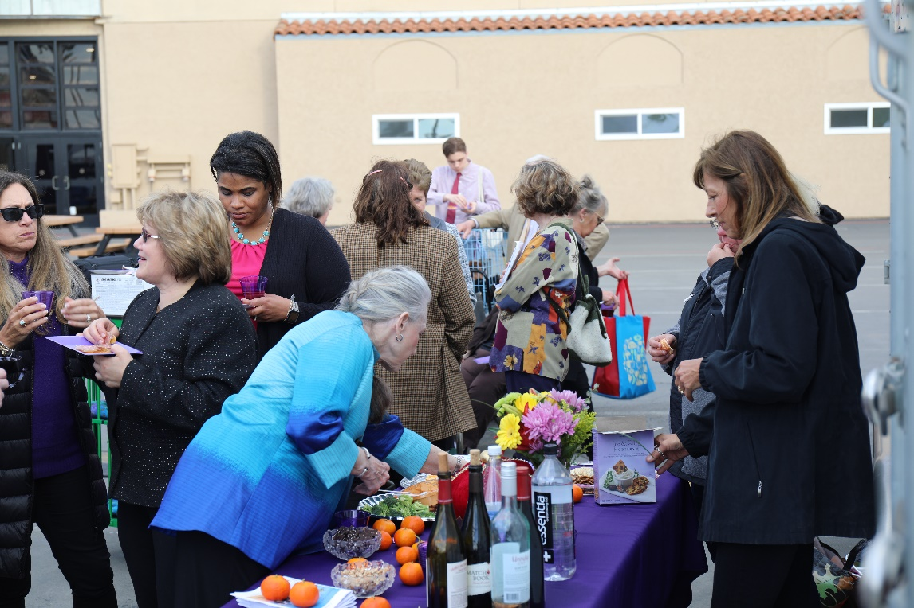

Thank you to all our Exhibitors for making our 2020 Specialty so special!

