Catering 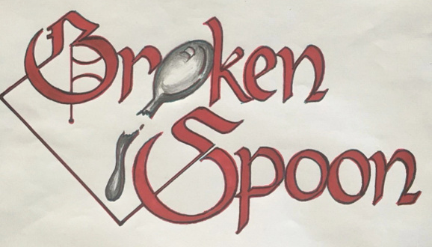

COLD APPETIZERS
50 person minimum required

Traditional Deviled Eggs* - $250 (150 pieces)

Stuffed Cucumbers* - $250 (80 pieces)
Stuffed with cream cheese and roasted red pepper,
$250 - crab or smoked salmon

Tomato Bruschetta - $150 (80 pieces)

Sliders* - $150 (80 pieces)
Egg salad, tuna salad or chicken salad

Stuffed Cherry Tomatoes - $150 (80 pieces)
Stuffed with chopped vegetables, cream cheese and herbs

Chicken Mini Phyllo - $150 (80 pieces)
Filled with chicken salad
Vegetable Spring Rolls* - $200 (100 pieces)

Caprese Skewers* - $200 (100 pieces)

Crab Mini Phyllo* - $250 (100 pieces)
Filled with crab salad

Prosciutto Melon Balls* - $250 (100 pieces)

Antipasto Skewers* - $250 (100 pieces)
Salami, olives, tomatoes, tortellini, fresh basil and mozzarella

Shrimp Cocktail* - $280 (100 pieces)

Crab Deviled Eggs* - $250 (100 pieces)

Smoked Salmon Deviled Eggs* - $250 (100 pieces)

HOT APPETIZERS
50 person minimum required

Cheddar Stuffed Red Potatoes - $150 (125 pieces)

Potato Latkes & Sour Cream - $150 (125 pieces)

Raspberry Puff Brie - $150 (125 pieces)

Sausage Stuffed Mushrooms* - $200 (150 pieces)

Mini Beef Empanadas - $200 (150 pieces)

Thai Chicken Skewers* - $200 (150 pieces)

Buffalo Chicken Rangoons - $200 (150 pieces)

Swedish Meatballs* - $200 (150 pieces)

Italian Meatballs in Marinara* - $200 (150 pieces)

Chicken Wings - $200 (150 pieces)

Mini Smoked Chicken Quesadillas - $200 (150 pieces)

Crab Stuffed Mushrooms* - $280 (125 pieces)

Sliders* - $250 (75 pieces)
Pulled pork, BBQ chicken or BBQ short rib

Mini Beef Wellingtons - $280 (100 pieces)

Fried Oysters* - $325 (100 pieces)

Bacon Wrapped Shrimp* - $300 (125 pieces)

Bacon Wrapped Scallops* - $325 (125 pieces)

Blue Crab Cakes* - $350 (125 pieces)
With remoulade sauce

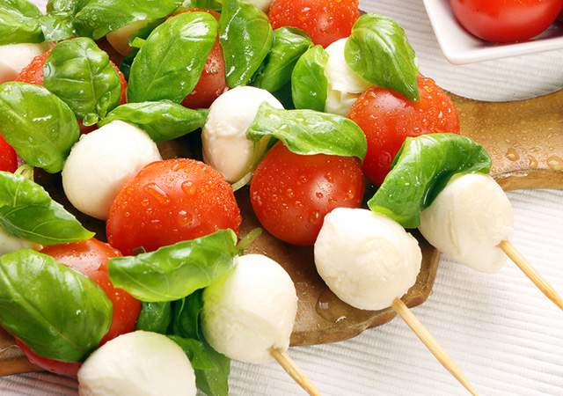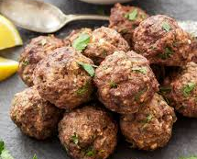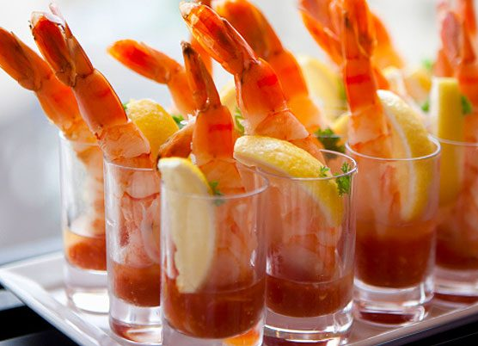

*House-made dishes. Available for pick-up and off-premises catering services only. Prices subject to service charge and applicable sales tax; pricing subject to change without notice. Consuming raw or undercooked meats, poultry, seafood, shellfish or eggs may increase your risk of foodborne illness, especially if you have certain medical conditions.

CHIPS & DIPS
50 person minimum required

Chili & White Cheddar Queso - $100 (serves 50)
Served with tri-colored tortilla chips
Black Bean Chipotle* - $100 (serves 50)
Served with tri-colored tortilla chips
Garbanzo Bean Hummus* - $100 (serves 50)
Served with toasted pita chips
Pico de Gallo* - $100 (serves 50)
Served with tri-colored tortilla chips
Guacamole* - $185 (serves 50)
Served with tri-colored tortilla chips
Roasted Vegetable Queso* - $150 (serves 50)
Served with toasted pita chips
Spinach & Artichoke* - $150 (serves 50)
Served with toasted pita chips
Hot Sausage Dip* - $150 (serves 50)
Served with house-made potato chips
Blue Crab & Artichoke* - $185 (serves 50)
Served with tri-colored tortilla chips
Blue Crab Dip* - $175 (serves 50)
Served with house-made potato chips

PLATTERS
50 person minimum required

Seasonal Vegetable Crudité - $100 (serves 50)
Fresh vegetables with ranch and roasted red pepper dip

Seasonal Fruit - $185 (serves 50)
Fresh fruit with a honey yogurt dip

Fruit & Cheeses - $225 (serves 50)
Fresh fruit with imported and domestic cheeses

Antipasto - $225 (serves 50)
Cut deli meats, cheeses, marinated vegetables and olives

Gourmet Cheese & Crackers - $225 (serves 50)
Imported and domestic cheeses with gourmet crackers

Deli Meats & Cheeses - $275 (serves 50)
Classic cuts of deli meats and cheeses with breads and spreads

Baked Brie - $225 (serves 50)
Gluten free or wrapped in puff pastry with your choice of filling or topping: pecan praline, mixed berries, roasted grapes and cherries, or apricot and fig

Seafood Raw Bar - $325 (serves 50)
Shrimp, oysters, clams and mussels on the half-shell with cocktail sauce, lemons and hot sauces

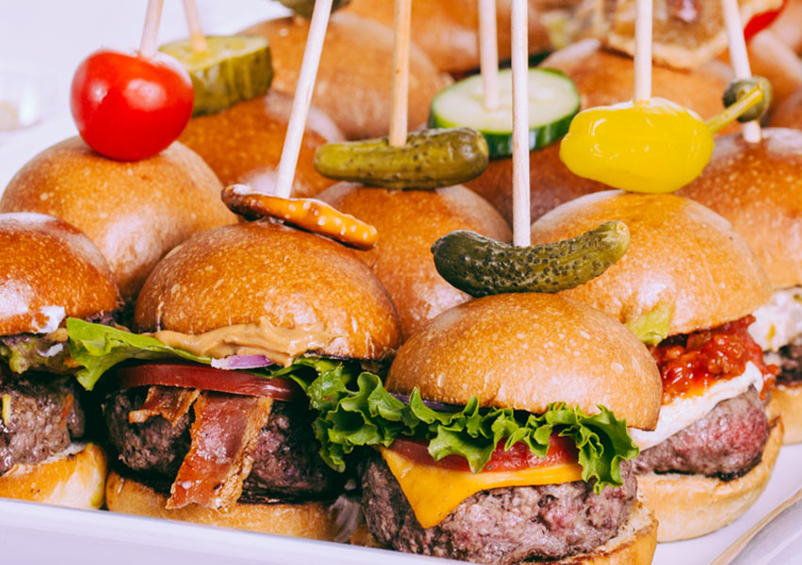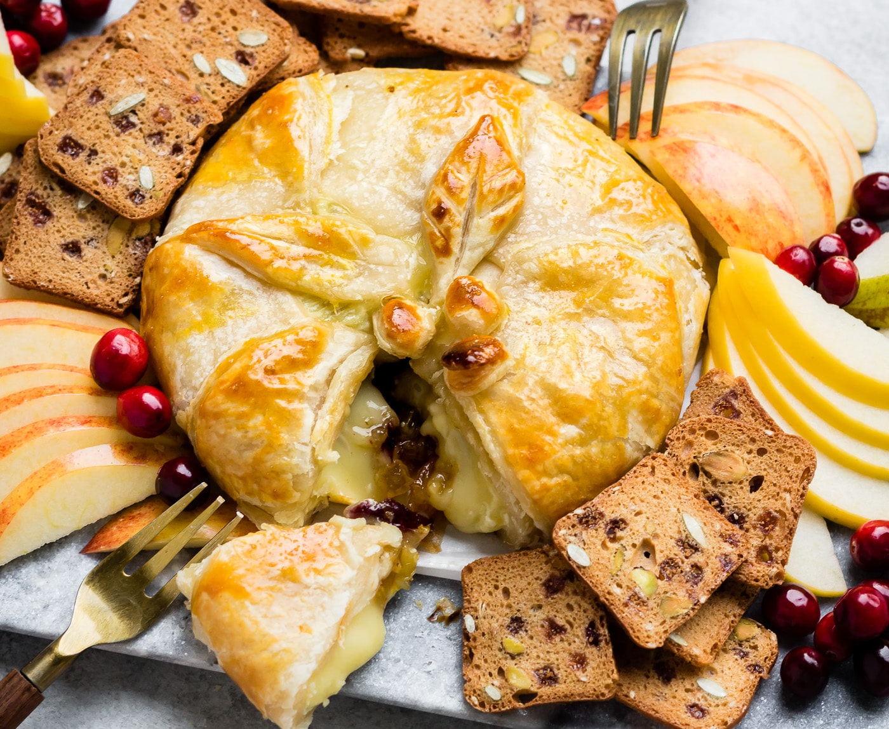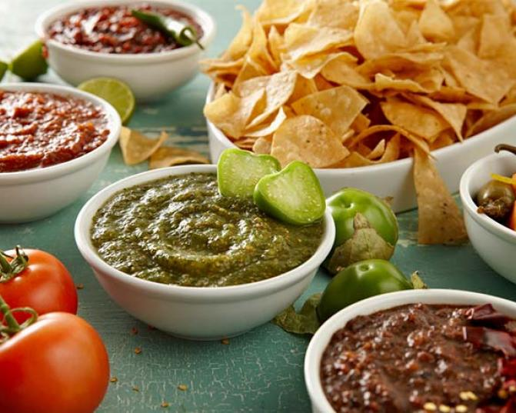

*House-made dishes. Available for pick-up and off-premises catering services only. Prices subject to service charge and applicable sales tax; pricing subject to change without notice. Consuming raw or undercooked meats, poultry, seafood, shellfish or eggs may increase your risk of foodborne illness, especially if you have certain medical conditions.

CHEF ATTENDED CREATIVE TABLES
50 person minimum required | $50 Chef Attendant Fee

Gourmet Popcorn Martini Bar - $150 (serves 50)
Unsalted, salted, buttered, kettle corn, cheese and caramel popcorn with toppings such as nuts, trail mix, dried coconut, chocolate candy, wasabi peas, miniature marshmallows, chocolate chips, yogurt pretzels, parmesan cheese, kosher salt, flavored salt, dried herbs, mesquite seasoning, Tabasco sauce, chocolate sauce, garlic oil and truffle olive oil

Oriental Bar - $400 (serves 50)
Sesame crusted salmon, beef, chicken or shrimp (choose two) with a wide selection of Chinese vegetables, stir fried rice, Chinese BBQ ribs, sushi (Nigiri and fresh Maki rolls), fried vegetable egg rolls, steamed vegetable spring rolls, soy, wasabi and ginger sauce and fortune cookies

Mac & Cheese Martini Bar - $325 (serves 50)
Chorizo, jalapenos, bacon, caramelized onions, green onions, olives, peppers, sour cream, pico de gallo and shredded cheddar cheese
Mashed or Baked Potato Bar - $300 (serves 50)
Seasoned ground beef, ground chicken, broccoli, sour cream, pico de gallo, green onions, diced yellow onion and melted cheddar cheese

Nacho or Taco Bar - $350 (serves 50)
Soft flour, corn and crispy corn tortillas, jalapenos, green onions, diced onions, avocado, refried beans, pico de gallo, tomatillo salsa verde, thick and chunky salsa, guacamole, cheddar and pepper-jack cheese, sour cream, limes and tri-colored tortilla chips

Ice Cream Sundae Bar - $295 (serves 50)
Hot fudge, caramel sauce, chocolate sauce, strawberry sauce, butterscotch sauce, whipped cream, Oreo cookies, M&Ms, gummy bears, chocolate chips, mini marshmallows, graham cracker crumbs, Reese’s Pieces, chopped candy bars, berries, bananas, pineapple, cherries, shredded coconut and assorted nuts

CHEF ATTENDED ENTRÉE TABLES
50 person minimum required | Priced Per Person | $50 Chef Attendant

Pasta Bar - $14.95
Penne, cavatappi and cheese tortellini pastas with marinara, alfredo and basil pesto sauces, with meatballs, grilled chicken, Italian sausage, parmesan and mozzarella cheese and garlic bread

Caesar Salad Bar - $9.95
Chopped romaine lettuce, grilled chicken, creamy
Caesar dressing, garlic croutons and white anchovies

Mixed Greens Salad Bar - $9.95
Chopped romaine lettuce, cucumbers, tomatoes, croutons, shredded cheese, red onion, diced egg, bacon crumbles and black olives
Add chicken or salmon +2 per person

Oriental Wok Bar - $16.95
Grilled chicken, tofu, marinated beef tips, snow peas, bean sprouts, water chestnuts, zucchini, squash, broccoli, carrots, sweet chili sauce, gluten free soy sauce, teriyaki and hoisin
Add shrimp +3 per person

Taco Bar - $14.50
Soft flour, corn and crispy corn tortillas, choice of two proteins: mojo roasted pulled pork, ground beef with green chilis, or chipotle grilled pulled chicken, with assorted toppings: jalapenos, green onions, diced onions, avocado, refried beans, pico de gallo, tomatillo salsa verde, thick and chunky salsa, guacamole, cheddar and pepper-jack cheese, sour cream, limes and tri-colored tortilla chips
Add tequila lime shrimp +1.5 per person

CHEF ATTENDED CARVING TABLES
50 person minimum required | Priced Per Person | $50 Chef Attendant Fee

Leg of Lamb - $19.95
Mint jelly and rosemary jus

Whole Tom Turkey - $19.95
Sage and roasted garlic aioli, turkey gravy and cranberry sauce

Roasted Turkey Breast - $12.95
Sage and roasted garlic aioli, turkey gravy and cranberry sauce

Smoked Beef Brisket - $14.95
Chimichurri and chipotle aioli

Cherry Glazed Pork Loin - $12.95
Black cherry mustard sauce and Hawaiian dinner rolls

Honey Ham - $12.95
Dijon mustard, brown sugar, cinnamon and raisin sauce

Prime Rib – MARKET PRICE
Served with horseradish cream and natural jus

Beef Tenderloin – MARKET PRICE
Natural jus, grain mustard, horseradish sauce and dinner rolls
New York Sirloin – MARKET PRICE
Grain Dijon mustard, horseradish cream and rosemary aioli

Available for pick-up and off-premises catering services only. Prices subject to service charge and applicable sales tax; pricing subject to change without notice. Consuming raw or undercooked meats, poultry, seafood, shellfish or eggs may increase your risk of foodborne illness, especially if you have certain medical conditions.

PLATED ENTRÉE PACKAGES
25 person minimum required | Priced Per Person

Served with house salad, ranch and balsamic dressing, warm rolls, butter, freshly brewed iced tea,
water and a coffee bar. Dining room table linens, napkins and cutlery provided.

Broken Spoon Classic | Starting at $38
Select two entrées, one starch, one vegetable and one dessert

Pork Chop
Topped with a maple mustard sauce

Pork Scaloppini
Topped with a roasted apple and sage butter sauce

Chicken Parmesan
Topped with roasted Roma tomato and sweet
basil marinara with mozzarella cheese

Chicken Breast
Skinless, boneless all-natural chicken, marinated in fresh rosemary and thyme, served with a roasted garlic natural jus

Flat Iron Steak
Topped with a roasted shallot demi-glace
Grilled Flank Steak
Marinated in honey and soy sauce, sliced thin
and served with a ginger ponzu sauce

Shoulder Bistro Tender
Topped with a cracked peppercorn demi-glace

Atlantic Cod
Topped with lemon and basil pesto

Fillet of Salmon
Topped with lemon and chive cream sauce

Blackened or Fried Catfish
Served with a side of roasted red pepper
and caper cream or remoulade

STARCHES
Rice Pilaf | Mashed Potatoes | Baked Potato | Roasted Red Skinned Potatoes | Potatoes Au Gratin

VEGETABLES
Broccoli & Cauliflower | Asparagus | Seasonal Vegetable Medley | Green Beans, Red Peppers & Carrots

DESSERTS
Carrot Cake | Lemon Cake | Chocolate Cake | Assorted Cookies

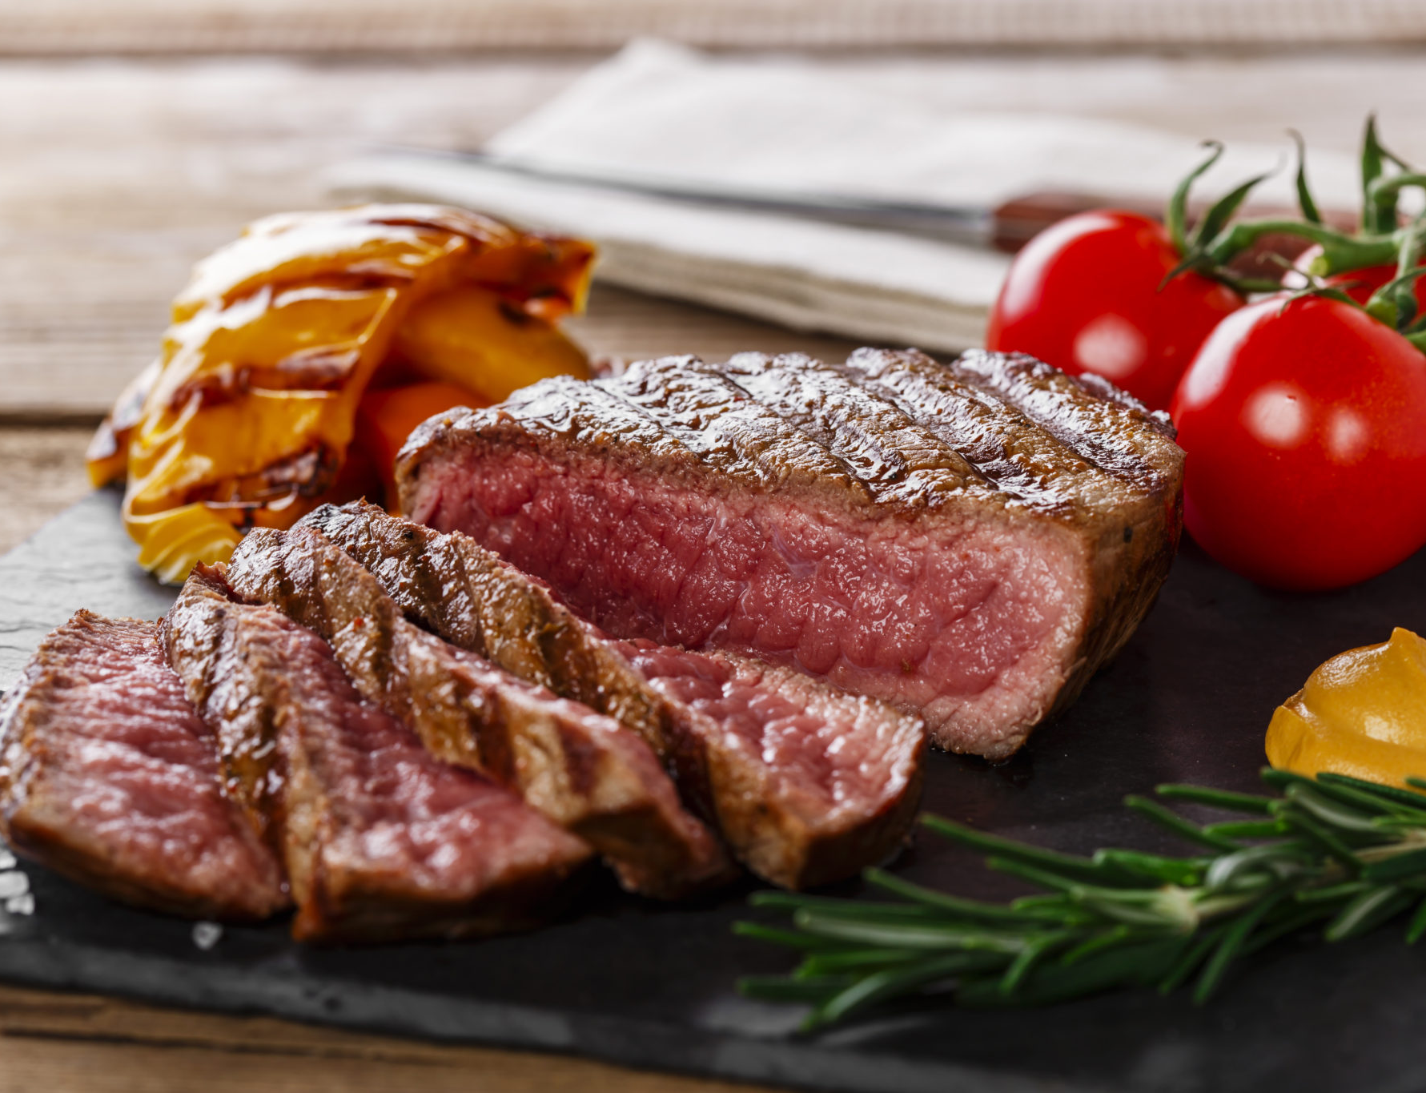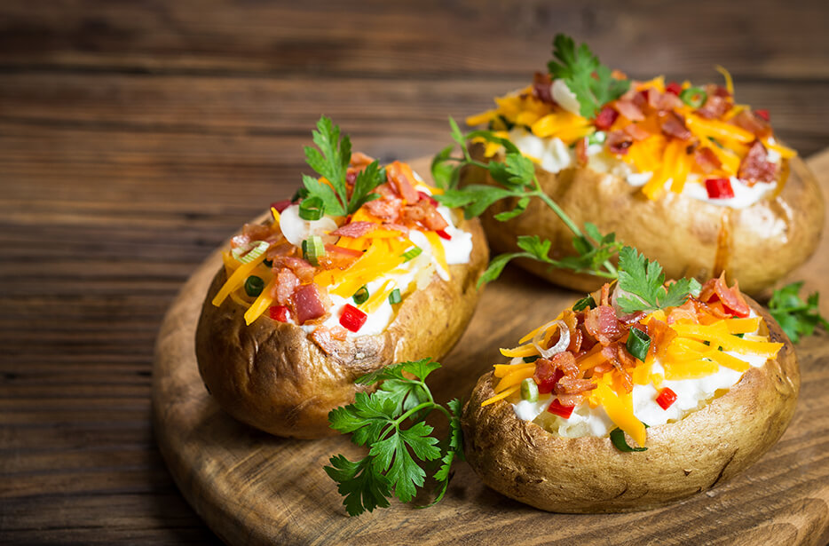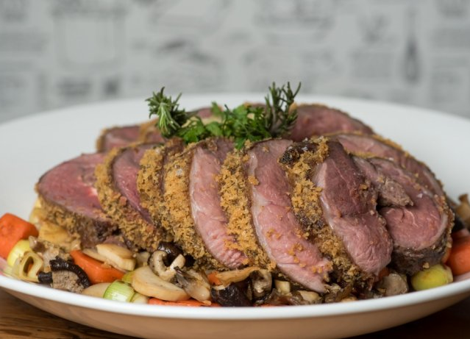

Available for pick-up and off-premises catering services only. Prices subject to service charge and applicable sales tax; pricing subject to change without notice. Consuming raw or undercooked meats, poultry, seafood, shellfish or eggs may increase your risk of foodborne illness, especially if you have certain medical conditions.

PLATED ENTRÉE PACKAGES
25 person minimum required | Priced Per Person

Served with house salad, ranch and balsamic dressing, warm rolls, butter, freshly brewed iced tea,
water and a coffee bar. Dining room table linens, napkins and cutlery provided.

Broken Spoon Premium | Starting at $45
Select two entrées, one starch, one vegetable and one dessert

Pork Tenderloin Filet
Topped with a sage and garlic demi-glace

Chicken Saltimbocca
Chicken breast wrapped with prosciutto, sage and
lemon, topped with a caper and white wine butter sauce

Chicken Breast
Boneless all-natural chicken breast, served
with fresh thyme and black truffle oil

Beef Tenderloin Filet - MARKET PRICE
Topped with a cracked peppercorn demi-glace

Ribeye Steak - MARKET PRICE
Topped with a roasted shallot demi-glace

Sirloin Steak
Topped with a tarragon and green peppercorn demi-glace

Pan-Seared Snapper Fillet
Topped with citrus butter cream

Salmon Saltimbocca
Topped with a lemon, caper and white wine butter sauce

Mahi Mahi
Topped with grilled pineapple and coconut cream

Jumbo Shrimp Skewers - MARKET PRICE
Six jumbo shrimp, topped with a garlic and parmesan sauce

Lobster Tail* - MARKET PRICE
Served with drawn butter, fresh lemons and paprika oil

STARCHES
Rice Pilaf | Mashed Potatoes | Baked Potato | Roasted Red Skinned Potatoes | Potatoes Au Gratin

VEGETABLES
Broccoli & Cauliflower | Asparagus | Seasonal Vegetable Medley | Green Beans, Red Peppers & Carrots

DESSERTS
Sorbet | Chocolate Cake | Flourless Chocolate Cake | Carrot Cake | Key Lime Pie
Tiramisu | Apple Crisp Caramel Cake | Lemon Cake | Lemon Raspberry Cheesecake

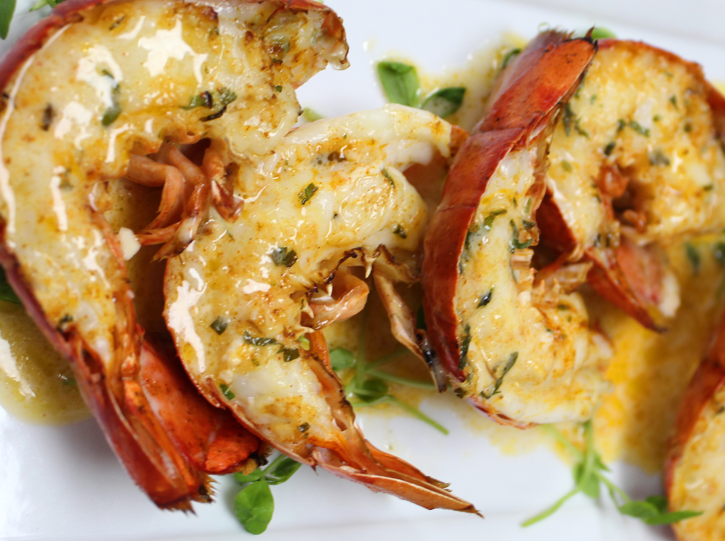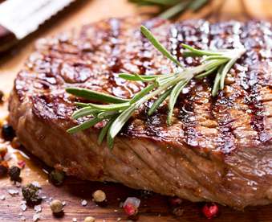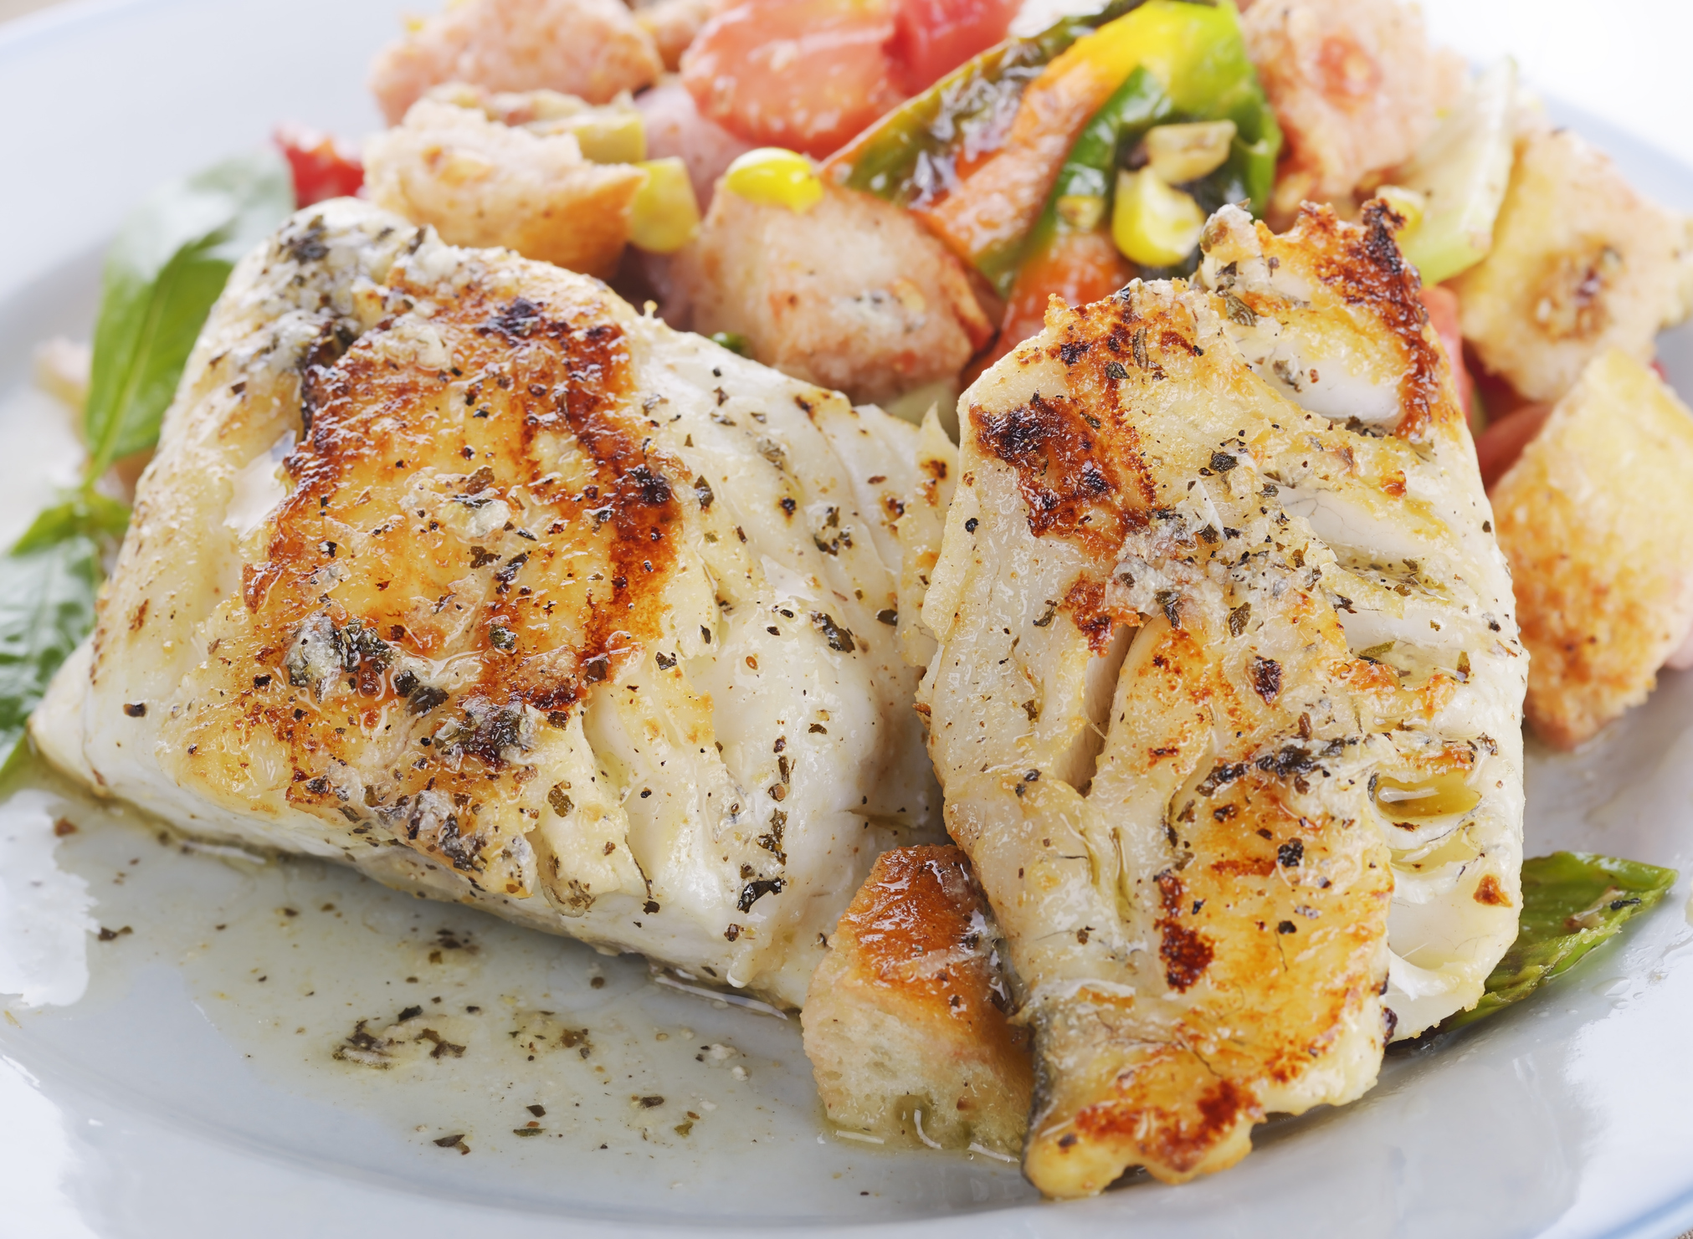

Available for pick-up and off-premises catering services only. Prices subject to service charge and applicable sales tax; pricing subject to change without notice. Consuming raw or undercooked meats, poultry, seafood, shellfish or eggs may increase your risk of foodborne illness, especially if you have certain medical conditions.

BUFFET PACKAGES
25 person minimum required | Priced Per Person

Served warm rolls, butter, freshly brewed iced tea, water and a coffee bar.
Dining room table linens, napkins and cutlery provided.

BROKEN SPOON CLASSIC | $32
Select one entrée, one starch, one vegetable and one dessert.
Add one additional item +$6 per person.

Herb Marinated Chicken Breast
Topped with a light lemon and chive cream sauce

Chicken Piccata
Topped with a caper, lemon and white wine butter sauce

Chicken Stir Fry
Teriyaki marinated chicken strips and stir-fried
vegetables, dusted with toasted sesame seeds

Chicken Marsala
Topped with roasted baby Portobello mushrooms
and a marsala wine sauce

Bacon Wrapped BBQ Chicken Thighs
Topped with a honey-chipotle BBQ sauce

Lemon Pepper Baked Salmon
Topped with a roasted tomato cream

Blackened Mahi Mahi
Topped with a mango white wine butter sauce

Cod Casino
Breaded with buttery bread crumbs, topped
with chopped bacon and chives

Blackened or Fried Catfish
Served with a side of roasted red pepper and
caper cream or remoulade

Pan-Seared Flounder
Topped with a light lemon and chive cream sauce
Country Fried Chicken Breast
Topped with chicken and sage gravy

STARCHES
Rice Pilaf | Mashed Potatoes | Baked Potato | Roasted Red Skinned Potatoes | Potatoes Au Gratin

VEGETABLES
Broccoli & Cauliflower | Asparagus | Seasonal Vegetable Medley | Green Beans, Red Peppers & Carrots

DESSERTS
Sorbet | Chocolate Cake | Flourless Chocolate Cake | Carrot Cake | Key Lime Pie
Tiramisu | Apple Crisp Caramel Cake | Lemon Cake | Lemon Raspberry Cheesecake

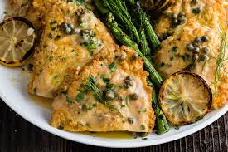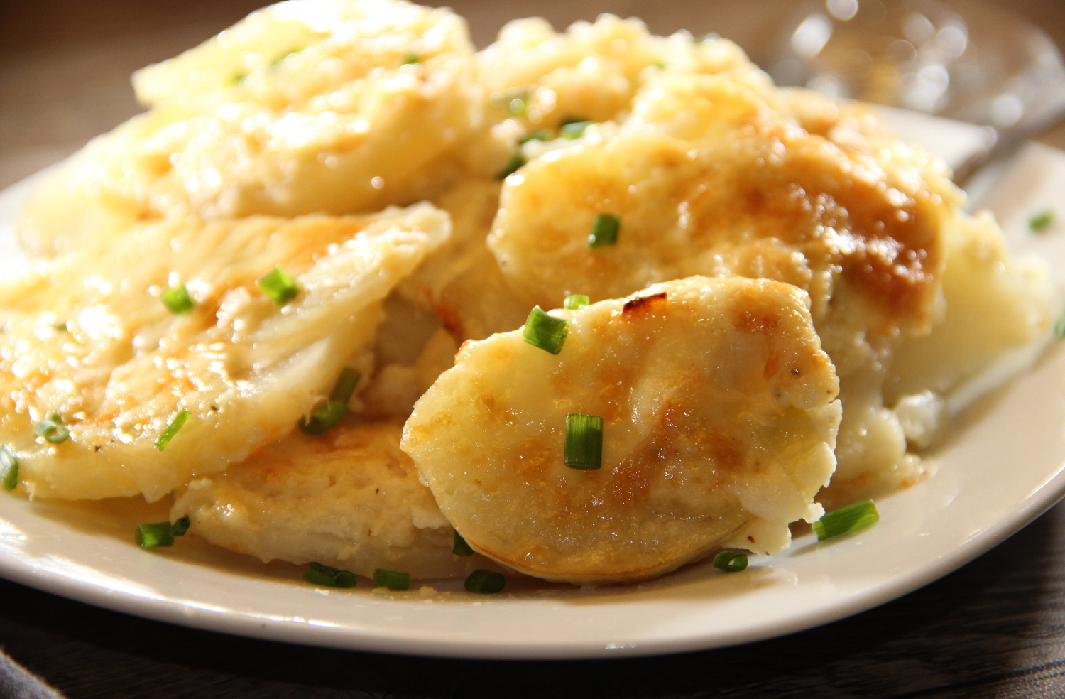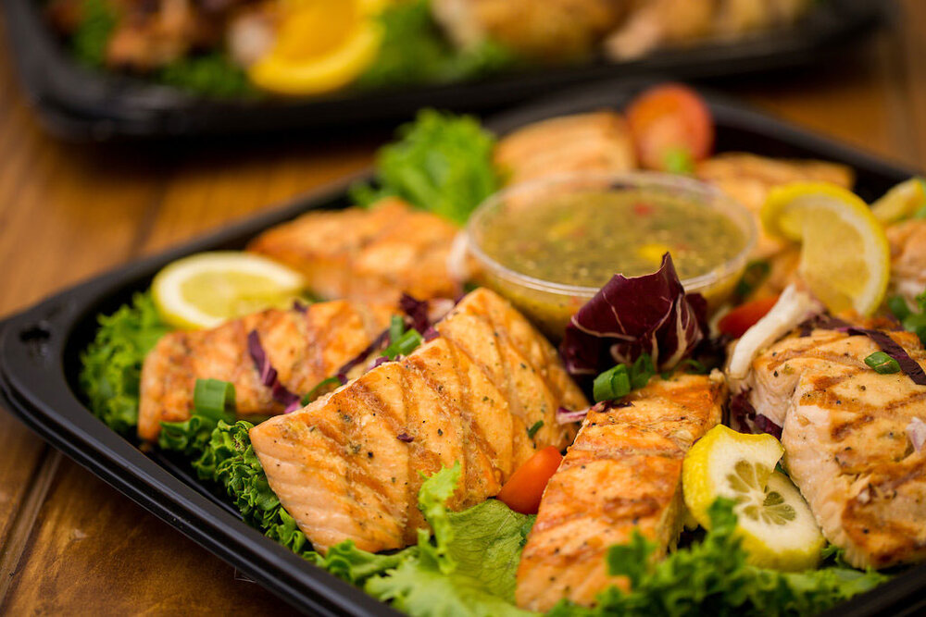

Available for pick-up and off-premises catering services only. Prices subject to service charge and applicable sales tax; pricing subject to change without notice. Consuming raw or undercooked meats, poultry, seafood, shellfish or eggs may increase your risk of foodborne illness, especially if you have certain medical conditions.

BUFFET PACKAGES
25 person minimum required | Priced Per Person

Served warm rolls, butter, freshly brewed iced tea, water and a coffee bar.
Dining room table linens, napkins and cutlery provided.

BROKEN SPOON PREMIUM | $36
Select one entrée, one starch, one vegetable and one dessert.
Add one additional item +$6 per person.

Bacon Stuffed Chicken Breast
Stuffed with bacon and cheddar cheese, topped
with a plum tomato and sweet basil sauce

Chicken Cordon Bleu
Topped with a white wine butter sauce and fresh chives

Mushroom Stuffed Chicken Breast
Stuffed with wild mushroom and goat cheese,
topped with a roasted red pepper cream sauce

Sausage Stuffed Chicken Breast
Stuffed with sausage and topped with
caramelized onions in a chicken gravy

Poached Mahi Mahi
Poached with a coconut and ginger, topped
with a white wine butter sauce, soy and honey

Stuffed Porkloin
Stuffed with wild mushrooms and walnuts

Pan-Seared Pork Scaloppine
Stuffed with dried fruit and topped with
a roasted apple and sage butter sauce

Beef Tenderloin
Natural jus, grain mustard, horseradish sauce and dinner rolls

Shaved Prime Rib
Topped with fresh herbs and natural jus

Sliced New York Strip Loin
Topped with a roasted shallot demi-glace

Sliced Leg of Lamb
Topped with a rosemary demi-glace

Pan-Seared Red Snapper
Topped with a white wine butter sauce and fried capers
Coq au Vin
Braised with red wine, caramelized onions and wild mushrooms

Salmon Saltimbocca
Topped with a white wine butter sauce and fresh chives

Crab Stuffed Flounder
Topped with lemon, white wine butter sauce and fresh chives

Blackened Salmon
Topped with blue crab claw and a parmesan cream sauce
STARCHES
Rice Pilaf | Mashed Potatoes | Baked Potato | Roasted Red Skinned Potatoes | Potatoes Au Gratin

VEGETABLES
Broccoli & Cauliflower | Asparagus | Seasonal Vegetable Medley | Green Beans, Red Peppers & Carrots

DESSERTS
Sorbet | Chocolate Cake | Flourless Chocolate Cake | Carrot Cake | Key Lime Pie
Tiramisu | Apple Crisp Caramel Cake | Lemon Cake | Lemon Raspberry Cheesecake

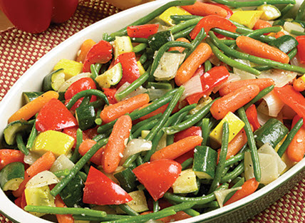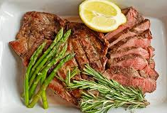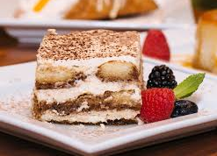

Available for pick-up and off-premises catering services only. Prices subject to service charge and applicable sales tax; pricing subject to change without notice. Consuming raw or undercooked meats, poultry, seafood, shellfish or eggs may increase your risk of foodborne illness, especially if you have certain medical conditions.

BUFFET PACKAGES
25 person minimum required | Priced Per Person

Served with warm rolls, butter, freshly brewed iced tea, water and a coffee bar.
Dining room table linens, napkins and cutlery provided.

Italian | $29.95
Select one salad, two vegetables and one dessert.
Vegan and Vegetarian entrée substitutions available.

SALADS
Mixed Green Salad
Mixed lettuce, tomatoes and cucumbers with ranch and balsamic dressings

ENTRÉE

Broken Spoon Chicken Parmesan
Tender chicken breast dipped in Italian
breadcrumbs, topped with house-made
marinara, mozzarella cheese and fresh herbs
Penne Pasta
Served with your choice of house-made
marinara or alfredo sauce

VEGAN SUBSTITUTIONS
Roasted Carrots, Brussels Sprouts & New Potatoes over Quinoa
Roasted Broccoli and Cauliflower | Zoodles with Vegetable Marinara

VEGETARIAN SUBSTITUTIONS
Vegetable Pot Pie | Vegetable Lo Mein | Eggplant Parmesan | Mushrooms & Curried Yogurt

VEGETABLES
Butter Poached Broccoli | Sautéed Seasonal Vegetable Medley | Steamed Green Beans

DESSERTS
Carrot Cake | Lemon Cake | Chocolate Cake | Assorted Cookies

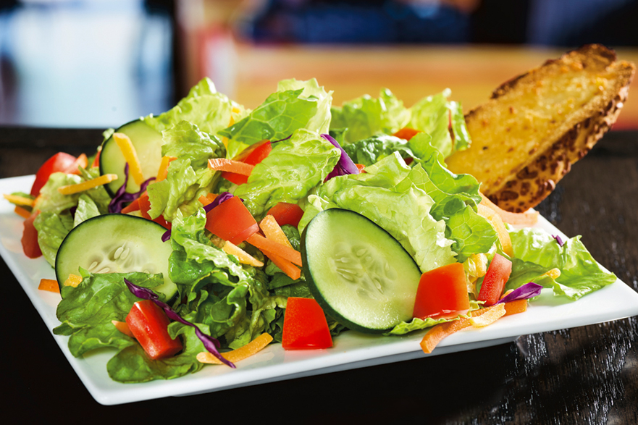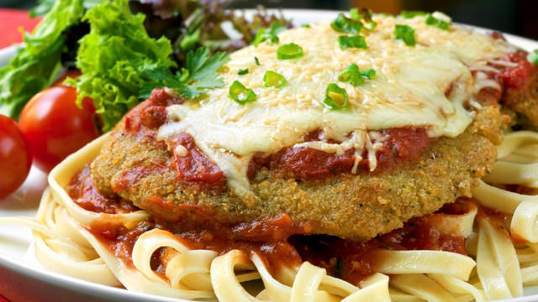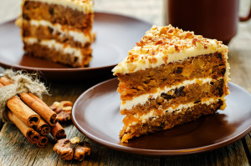

Available for pick-up and off-premises catering services only. Prices subject to service charge and applicable sales tax; pricing subject to change without notice. Consuming raw or undercooked meats, poultry, seafood, shellfish or eggs may increase your risk of foodborne illness, especially if you have certain medical conditions.

BUFFET PACKAGES
25 person minimum required | Priced Per Person

Served with warm rolls, butter, freshly brewed iced tea, water and a coffee bar.
Dining room table linens, napkins and cutlery provided.

SOUTHERN-STYLE ALL AMERICAN | $28
Select one salad, two entrees, two sides and one dessert.
Add one additional item +$6 per person.

SALADS

Mixed Green Salad
Mixed lettuce, tomatoes and cucumbers with ranch and balsamic dressings

ENTRÉE

Baby Back Ribs
House-smoked BBQ ribs

BBQ Chicken Breast
Boneless, all-natural chicken breast

Burger

Pulled Pork

Beef Brisket

SIDES
Mac & Cheese | Corn on the Cob | Baked Beans | Coleslaw
Pasta Salad | Potato Salad | Egg Salad

DESSERTS
Carrot Cake | Lemon Cake | Chocolate Cake | Assorted Cookies

Brought to you by award-winning Chef Detdara Hatsady!
120 International Parkway, Suite 140
Heathrow, FL 32746
(407) 807-7444
brokenspooninfo@gmail.com
dhatsady@gmail.com

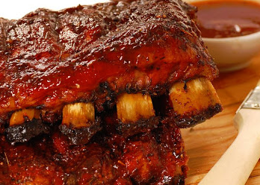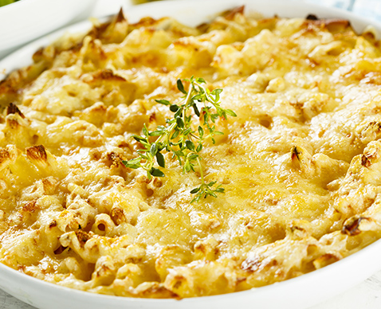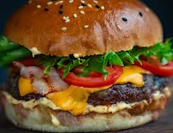

Available for pick-up and off-premises catering services only. Prices subject to service charge and applicable sales tax; pricing subject to change without notice. Consuming raw or undercooked meats, poultry, seafood, shellfish or eggs may increase your risk of foodborne illness, especially if you have certain medical conditions.

